FIREFIGHTER RECRUITMENT

Exercise, Fitness & Nutrition
Preparation Guide

Contents

INTRODUCTION 3
AIM 3
SAFETY POINTS 3
PREPARING FOR EXERCISE 3
AEROBIC TRAINING 4
STRENGTH TRAINING 5
EXERCISES 5
FLEXIBILITY 7
GENERAL PHYSICAL FITNESS PROGRAMME 9
PRACTICAL SELECTION TESTS 11
CARDIOVASCULAR FITNESS:BEGINNER 18
CARDIOVASCULAR FITNESS: INTERMEDIATE 22
CARDIOVASCULAR FITNESS: ADVANCED 27
HEALTHY EATING AND NUTRITION 32

INTRODUCTION

The role of a Fire fighter can be physically demanding. Therefore the entry selection tests are designed to reflect and assess the physical tasks that Firefighters are required to perform. Firefighters are required to be aerobically fit, have good all-round body strength and local muscular endurance.

Please be aware that some of the exercises in this guide will require you to have access to various items of gym equipment. South Yorkshire Fire & Rescue appreciates that not everyone will own this equipment themselves but this guidance anticipates that candidates could access this equipment at a gym should they wish to do so.

AIM

The aim of this document is to assist prospective candidates prepare before applying to be a firefighter with South Yorkshire Fire and Rescue. Candidates are not required to undertake any of the practical advice included in this document should they not wish to do so.

This document has been prepared to highlight exercises that could assist with the various physical activities that are undertaken as part of the Practical selection tests.

SAFETY POINTS

If you are in any doubt about your health or physical ability to exercise, consult your doctor before you commence physical activity. This is especially important if you are pregnant (or think you may be pregnant) or have not exercised for the last six months or had a recent illness or injury.

Good exercise training advice is highly specific to the individual. It should be understood, therefore, that the advice provided here can only be general; prospective applicants that require further information are advised to seek individual advice, specific to their needs, from a qualified fitness professional.

Always warm up before commencing any exercise. Wear the correct clothing and footwear; do not train if you are unwell or injured.

PREPARING FOR EXERCISE

Performing a warm up prepares the body for the activity about to be undertaken. The length of time needed to warm up correctly depends on many factors; however, you should allow at least 10 minutes for this very important activity. In order to reduce the risk of injury in the warm up period, a number of steps should be followed:

Be Specific

Make sure your warm up session is geared towards the activity that you intend to perform. Cardiovascular workouts, for example running, you should start with a brisk walk leading into a light jog. For weight training workouts it is important to warm up the joints and muscles that are involved in the resistance exercise. This will increase blood flow to the muscles which will be utilised during the exercise and activate the nervous system prior to any additional stress being placed on them.

Start Slowly

At the start of your workout your muscles will be relatively cold. Start exercising slowly and build up the intensity throughout the warm up period. This will increase your muscle temperature steadily and keep the risk from injury to a minimum.

Keep Warm

If you are exercising in a cold environment, wear additional clothing during the warm up period and try not to stand still for too long.

Stretching

For many years it was thought that stretching immediately prior to exercise would prevent injuries. However, there is new research with practical application that suggests that this may not prevent muscle or tendon injury. Any form of flexibility or stretching activity should be performed following a warm up period or an exercise session.

AEROBIC TRAINING

Depending on your current aerobic fitness standard, you will need to follow the guidelines detailed below to improve your aerobic fitness.

Frequency of training | 3 to 5 days per week
Intensity of training | 55 to 90 percent of your Predicted Maximum Heart Rate (PMHR)

Heart rate monitors are a useful tool to help ensure that you train at the right intensity. If you have access to a heart rate monitor you can calculate your desired training intensity by using the following equation:

220 - Age = Predicted Maximum Heart Rate (PMHR)
PMHR x 0.55 = 55% of EMHR and PMHR x 0.90 = 90% of EMHR

Duration of training

20 to 60 minutes of continuous or intermittent aerobic activity in a minimum of 10 minute bouts accumulated throughout the day. Duration is dependent on the intensity of the activity, lower intensity activity should be conducted over a longer period of time; 30 minutes or more and individuals training at higher levels of intensity should train for at least 20 minutes or longer.

Type of activity

Any activity that uses large muscle groups, which can be maintained continuously, and is rhythmical and aerobic in nature e.g. walking-hiking, running-jogging, cycling-bicycling, cross-country skiing, aerobic dance/group exercise, rope skipping, rowing, stair climbing, swimming, skating, and various endurance game activities or some combination thereof.

Specificity

To maximise the efficiency of your training you should focus on exercises that are similar to those in the test. These include running-jogging, stepping, stair climbing and other weight bearing activities.

STRENGTH TRAINING

In order to improve your strength and/or muscular endurance you will need to exercise against a resistance. This resistance can be your body weight, for example a press up, or the use of specifically designed equipment such as dumbbells, barbells or resistance machines.

Resistance training should be progressive in nature, individualised, and provide a stimulus to all the major muscle groups that is sufficient to develop and maintain muscular strength and endurance. You should follow the subsequent guidelines to improve your muscular strength and endurance.

Frequency of training | 2 to 3 days per week

At least one set of 8 to15 repetitions of 8 to 10 exercises that condition the major muscle groups of the body. Multiple set regimens may provide greater benefits if time allows.

The effect of exercise training is specific to the area of the body being trained. For example, training the legs will have little or no effect on the arms, shoulders, and trunk muscles, and vice versa. Therefore a whole body approach should be adopted. Muscles should also be worked in balance and as such the following exercises are recommended; chest press, seated row, shoulder press, lat pull down, squats, lunges, step up’s, abdominal crunch, back extensions.

Rest

If performing multiple sets, adequate rest should be given to allow the muscles to recover before performing another ‘set’.

Individuals should not perform the same resistance exercise on consecutive days. At least 24 hours rest should be allowed before repeating the exercise.

EXERCISES

Chest Press

Whilst lying flat on the bench with feet planted firmly on the floor either side of the bench with your arms extended. Slowly lower the weight to chest level. Push the weight back to the start position.
Tips: Ensure that back is flat on the bench and not arched. Perform slowly and in control.

Seated Row

From a seated position, with arms extended in front of the body and knees slightly flexed, draw the hands into the abdominal area squeezing the shoulder blades together.
Tips: Look straight ahead and maintain the natural curve of the spine. Keep elbows tucked close to the body throughout the movement.

Shoulder Press

From an upright position, with dumbbells overhead, slowly lower the weight to shoulder level. Push the weight back up to the start position.
Tips: Ensure the back is flat on the bench. Perform slowly and in control. Look straight ahead.

Lat Pull Down

From a seated position, grasp the overhead bar just wider than shoulder width. Lean back slightly and draw the elbows in towards the side of the body so that the bar rests at the top of the chest.
Tips: Do not swing during the exercise.

Squat

From a standing position with feet between hip and shoulder width apart, bend at the knees and flex at the hip until your thighs are parallel with the floor. Push through the heels to return to the standing position.
Tips: Ensure that the knees are aligned with the feet and do not pass beyond the toes.

Lunge

From a split leg position, with one foot in from of the other, lower the back knee towards the floor so that the front thigh is almost parallel with the ground. Push off the front leg to return to the start position.
Tips: Look straight ahead. Ensure the front knee is aligned with the foot and does not pass beyond the toes.

Abdominal crunch

Lie face up on a soft surface, bend knees and bring feet close to the buttocks. Fold your arms across your chest, or place the hand lightly behind the head. Draw your belly button towards your spine by contracting your lower abdominal muscles. Whilst holding this contraction with normal breathing, slowly raise your shoulders towards your thighs while keeping the lower back on the floor.
Tips: Lower your shoulders and upper body slowly and with control.

Back extension

Lie on your stomach on a mat. Place your arms at your sides so that your hands are by your hips. Raise your head and shoulders off the mat as high as comfortably possible. Hold for 1 to 2 seconds. Lower the head and shoulders.
Tips: Do not tense your shoulder muscles.

FLEXIBILITY

Flexibility exercises should be incorporated into the overall fitness programme. These exercises may reduce the likelihood of injury, reduce muscle soreness following exercise and may enhance muscular performance. These exercises should stretch the major muscle groups of the body. There are a number of forms of stretching techniques. However those without specific up-to-date knowledge in this area you are advised to adhere to the following guidelines.

Frequency of training | 2 to 3 days per week
Duration | Hold the stretch 1 to 3 times in a static or still position for 10 to 30 seconds.

Below is a list of recommended stretching exercises that could be performed:

Triceps and Upper Back Stretch

- Sit or stand upright with one arm flexed, raised overhead with elbow next to your ear,
and your hand resting on your opposite shoulder blade.
- Grasp your elbow with the opposite hand.
- Inhale and pull your elbow behind your head.
- Hold the stretch and relax.
- You should feel the stretch in the back of the arm.

Rear Deltoid and Upper Back Stretch

- Sit or stand with one arm straight.
- With the other hand grasp the elbow of the straight arm.
- Inhale and pull the elbow across the chest and in towards the body.
- Hold the stretch and relax.
- You should feel the stretch in the back of the shoulder and upper back.

Pectoral and Upper Back Stretch

- Kneel on the floor facing a bench or chair.
- Extend your arms above your head with your hands side by side and bend forward to
rest your hands on the bench or chair with your head in its natural position.
- Exhale and let your head and chest sink towards the floor.
- Hold the stretch and relax.
- You should feel the stretch in your chest and upper back.

Quadriceps Stretch

- Stand upright with one hand against a surface for balance and support.
- Flex the opposite knee to the hand that is outreached and raise your heel to your
buttocks.
- Slightly flex the supporting leg.
- Exhale, reach behind, and grasp your raised foot with the other hand.
- Inhale, and pull your heel towards your buttocks.
- Hold the stretch and relax.
- You should feel the stretch in the top of the thigh.

Hamstring Stretch

- Sit upright on the floor with both legs straight.
- Flex one knee and slide the heel until it touches the inner side of the opposite thigh.
- Lower the outer side of the thigh and calf of the bent leg onto the floor.
- Exhale, and while keeping the extended leg straight, bend at the hip and lower your
extended upper torso from the hips towards the extended thigh.
- Hold the stretch and relax.
- You should feel the stretch in the back of the thigh.

Adductor Stretch

- Sit upright on the floor with your legs flexed and straddled and feet flat against one
another.
- Grasp your feet or ankles and pull them as close to your groin as possible.
- Exhale, and rest your elbows on your knees, pushing them down towards the floor.
- Hold the stretch and relax.
- You should feel the stretch in the inside of the thighs.

Calf Stretch

- Stand upright slightly more than an arms length from a wall.
- Bend one leg forward and keep the opposite leg straight.
- Keep the heel of your rear foot down, sole flat on the floor and feet pointing straight
forward.
- Exhale, and flex your forward knee toward the wall
- Hold the stretch and relax.
- After 10 to 15 seconds slightly flex the knee of the back leg keeping the heel of the
foot down.
- Hold the stretch and relax.
- You should feel the stretch in the back of the lower leg.

Buttocks and Hip Stretch

- Lie flat on your back with one leg crossed over the knee of the straight leg.
- Inhale flexing the uncrossed leg off of the floor in towards the body ensuring that you
head shoulders and back remain on the floor.
- Hold the stretch and relax.
- You should feel the stretch in your bum and back.

GENERAL PHYSICAL FITNESS PROGRAMME

The following programme is 8 weeks long and is an example of how you could go about training. It consists of 3 running sessions, 2 weights sessions and 2 flexibility sessions per week. The programme starts relatively easy and gets progressively harder. You should alternate between your running and weight sessions so that you do not perform the same training on consecutive days, for example:

Mon | Steady run
Tue | Weights
Wed | Fartlek
Thu | Flexibility
Fri | Steady run
Sat | Weights
Sun | Flexibility

If you miss an exercise session, do not attempt to do 2 sessions in 1 day to make up.

If you are unwell or injured then do not train until you have fully recovered.

Make sure you have read and understood the programme before you start training. Where

Below is an explanation of all the sessions included in the programme. The actual details of the workouts are set out on the 8 week plan. When

1.Steady pace running
This should be performed at a comfortable pace i.e. you should be able to hold a conversation throughout your run. This type of exercise will increase your aerobic fitness. This is included 2 times per week in the programme.

2.Fartlek training
This type of running involves changing pace throughout the session. A steady pace of running should be interspersed with faster running, sprints, jogging, uphill running and walking. The aim of the session is to work continuously for about 20 minutes using the various speeds of running whenever you feel like it. There is no set order to this session, however you should begin with about 5 minutes of steady running before you do any faster running. This session will increase your aerobic and anaerobic fitness.

Note: Where possible you should run on grass or trails, try to avoid road running. This will reduce the stress placed on the joints of the body.

3. Resistance training – (Weights)
These sessions will target all the major muscle groups and will help to improve your muscular strength and endurance. The actual weights you use for this training will be specific to your own circumstances, we therefore recommend you to seek individual advice, specific to your needs, from a qualified fitness professional.

4.Flexibility training

This is to help improve or maintain your range of motion. These exercises may also reduce the likelihood of injury, reduce muscle soreness following exercise and may enhance muscular performance.
EXAMPLE 8-WEEK PROGRAMME – PLEASE SEE PAGE 9 FOR EXPLANATIONS OF EACH SESSION

WEEK | SESSIONS | DURATION | INTENSITY | TIMES PER WEEK
1 | Steady pace run | 20 minutes | 55-90 %of PMHR or RPE level 10-17 | 2
 | Weights | 1-2 sets of 12-15 reps |  | 2
 | Fartlek | 20 minutes |  | 1
 | Flexibility | 10-30 seconds |  | 2
2 | Steady pace run | 20 minutes | 55-90 %of PMHR or RPE level 10-17 | 2
 | Weights | 2 sets 12-15 reps |  | 2
 | Fartlek | 20 minutes |  | 1
 | Flexibility | 10-30 seconds |  | 2
3 | Steady pace run | 20 minutes | 55-90 % of PMHR or RPE level 10-17 | 2
 | Weights | 2 sets 12-15 reps |  | 2
 | Fartlek | 20 minutes |  | 1
 | Flexibility | 10-30 seconds |  | 2
4 | Steady pace run | 25 minutes | 55-90 % of PMHR or RPE level 10-17 | 2
 | Weights | 3 sets 10-12 reps |  | 2
 | Fartlek | 20 minutes |  | 1
 | Flexibility | 10-30 seconds |  | 2
5 | Steady pace run | 25 minutes | 55-90 % of PMHR or RPE level 10-17 | 2
 | Weights | 1-2 sets of 12-15 reps |  | 2
 | Fartlek | 20 minutes |  | 1
 | Flexibility | 10-30 seconds |  | 2
6 | Steady pace run | 30 minutes | 55-90 % of PMHR or RPE level 10-17 | 2
 | Weights | 2 sets 12-15 reps |  | 2
 | Fartlek | 20 minutes |  | 1
 | Flexibility | 10-30 seconds |  | 2
7 | Steady pace run | 30 minutes | 55-90 % of PMHR or RPE level 10-17 | 2
 | Weights | 2 sets 12-15 reps |  | 2
 | Fartlek | 20 minutes |  | 1
 | Flexibility | 10-30 seconds |  | 2
8 | Steady pace run | 30 minutes | 55-90 % of PMHR or RPE level 10-17 | 2
 | Weights | 3 sets 10-12 reps |  | 2
 | Fartlek | 20 minutes |  | 1
 | Flexibility | 10-30 seconds |  | 2
Warning: A significant reduction in aerobic fitness occurs after only 2 week of not training.

PRACTICAL SELECTION TESTS

One of the seven different tests that make up the practical selection tests is either the bleep test or The Chester Walk Test. These tests check a candidates physical fitness and you must achieve a minimum level of 8.7 in the bleep test and VO2 > 42mlsO2/kg/min in the Chester Walk Test to demonstrate your physical fitness.

The below information aims to provide candidates with the details of the tests so they can test themselves prior to applying and if required practice to ensure they can meet the right level.

The Bleep Test – Practice Guidance

Level 8.7 = 42 VO2

The bleep test involves continuously running between two lines 20m apart to a series of bleeps. The speed starts at 8kph and progressively increases each level. The test finished when the participant fails to reach 3 consecutive lines in time for the bleep or when level 8.7 is achieved.

To train for the bleep test you need to improve your cardio vascular fitness through running however only performing continuous running in one direction will not adequately prepare you for the test. Practicing turning through exercise such as shuttle runs will also be beneficial.

bleep test apps can be downloaded onto your smart phone if you wish to practice.

The Chester Walk Test – Practice Guidance

Test Protocol:

The Chester walk test involves walking on a treadmill for 12 minutes at the same speed whilst the incline increases every 2 minutes. During the test you are not permitted to run or hold onto the hand rails.
Following a gentle loosening and limbering, the subject is then asked to walk on the treadmill at 0% for a 2-minute warm-up, the speed being gradually increased to 6.2km/3.9mph, when the test is commenced.

- Level 1: 0-2 minutes at 0%
- Level 2: 2-4 minutes at 3%.
- Level 3: 4-6 minutes at 6%
- Level 4: 6-8 minutes at 9%
- Level 5: 8-10 minutes at 12%
- Level 6: 10-12 minutes at 15% End of test.

Participants will not be wearing a heart rate monitor therefore the test does not stop if you reach 80% of your max heart rate.
- The test will be stopped if the participant looks unduly distressed or is struggling to
maintain the set pace.
- If you complete the test you have a VO2 > 42mlsO2/kg/min therefore reached the
required fitness standard.

These sessions are designed with the goal of comfortably completing the Chester Walk Test. The sessions are 20-25 minutes long including a warm up and cool down therefore can be completed before or after another workout. To improve cardiovascular fitness you are advised to train for at least 30 minutes therefore a walk on the treadmill at 60-80% of max heart rate (220-age) following the session may be required.

Warm Up – Prior to Undertaking Chester Walk Test

Before completing any of these sessions you should include comprehensive warm up of the muscles you are going to use.

Complete 3 rounds of the following

- 1 minute walk on treadmill
- 10 Squats- weight through your heels, try to get lower each rep you do, vary your
stance width, spend a few seconds at the bottom of squat on some reps to increase
stretch
- 10 Toe/ floor touches- keeping your legs straight and touch the floor, hang at the
bottom for a few seconds, don’t bounce and aim to get a little lower each rep, vary your stance width
- 10 lunges – alternating legs perform a big step forward, weight through front heel,
back knee bent toward the floor
- 10 walkouts- in a press up position walk your hands towards your feet keeping your
legs straight till you feel a stretch in your calves, walk your hand forward again and repeat

Chester Walk Test - Session 1

Complete the full Chester Walk test as per instruction however at a reduced speed. Keep the speed the same throughout the entire test. Record the speed used and increase each session till you reach 6.2kph/ 3.9mph

Session | 1 | 2 | 3 | 4
Speed

Chester Walk Test - Session 2

Complete the Chester Walk test at correct speed of 6.2kph/ 3.9mph however reduce the incline and increase each session till full test is completed

Session | 1 | 2 | 3 | 4
Time/ incline
0-2 mins | 0% | 0% | 0% | 0%
2-4 mins | 1% | 1.5% | 2% | 2.5%
4-6 mins | 2% | 3% | 4% | 5%
6-8 mins | 3% | 4.5% | 6% | 7.5%
8-10 mins | 4% | 6% | 8% | 10%
10-12 mins | 5% | 7.5 | 10% | 12.5%

Chester Walk Test - Session 3

The aim of this session is to practice walking at maximum incline. The speed on this may again be varied increasing from session to session however complete at 6.2kph/ 3.9mph if possible.

Session | 1 | 2 | 3 | 4
Speed
Time/ Incline | 0-2 mins 0% | 0-2 mins 0% | 0-2 mins 0% | 0-2 mins 0%
 | 2-4 mins 10% | 2-3 mins 12.5% | 2-3 mins 15% | 2-4 mins 15%
 | 4-6 mins 0% | 3-5 mins 0% | 3-5 mins 0% | 4-6 mins 0%
 | 6-8 mins 10% | 5-6 mins 12.5% | 5-6 mins 15% | 6-8 mins 15%
 | 8-10 mins 0% | 6-8 mins 0% | 6-8 mins 0% | 8-10 mins 0%
 | 10-12 mins 10% | 8-9 mins 12.5% | 8-9 mins 15% | 10-12 mins 15%
 | 12-14 mins 0% | 9-11 mins 0% | 9-11 mins 0% | 12-14 mins 0%
 |  | 11-12mins 12.5% | 11-12mins 15% | 14-16 mins 15%

Chester Walk Test - Session 4

This is a slightly longer session and is designed improve your recovery time and again familiarise yourself with walking at an incline. These sessions are very challenging (especially session 3 & 4) and harder than the Chester walk test with the aim that if you are able to complete these sessions the test will then be easy.

Session | 1 | 2 | 3 | 4
Speed
Time/ Incline
0-2 mins | 0% | 2.5% | 5% | 5%
2-4 mins | 7.5% | 7.5% | 7.5% | 10%
4-6 mins | 15% | 15% | 15% | 15%
6-8 mins | 0% | 2.5% | 5% | 9%
8-10 mins | 7.5% | 7.5 | 7.5 | 12%
10-12 mins | 15% | 15% | 15% | 15%
12-14 mins | 0% | 2.5% | 5% | 9%
14-16 mins | 7.5% | 7.5% | 7.5% | 12%
16-18 mins | 15% | 15% | 15% | 15%

Chester Walk Test - Cool Down

After completing a session you should always perform a cool down, this is also the ideal time to stretch. This will reduce muscular soreness and increase mobility a vital aspect for a firefighter. Walk on the treadmill for 5-10 minutes gradually reducing the intensity then perform the following stretches 3x each side for 30-60 seconds minimum.

The following exercises can be utilised as part of your cool down.

Calf/ Soleus Stretch

-Push against the wall leaning slightly forward
-Keep heel on the floor
-Perform with back leg straight and then bent to hit both calf and soleus muscle

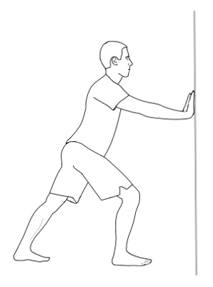

Hamstring Stretch

-Sat on the floor put one leg out straight
-Bend the other knee with the sole of your foot on the inside of your thigh
-lean forward toward and reach towards the toe of outstretched leg
-if possible pull toes towards yourself
-Those that suffer with back pain when walking at an incline spend extra time stretching your
hamstrings and glutes as this will reduce tightness in your lower back.

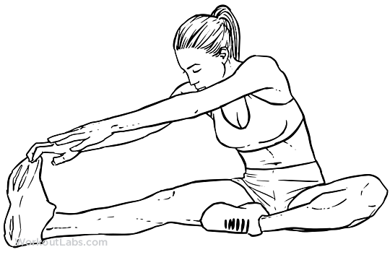

Gluteus Maximus Stretch

-There are a numerous methods to stretch your glutes depends on flexibility
-all include having the bend in the knee off the side you are stretching
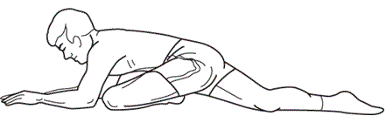
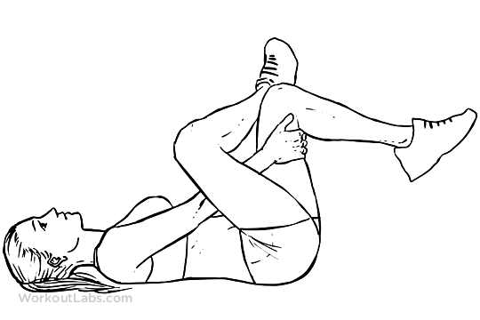

Quadriceps Stretch

-hold foot and pull heel towards your glute
-keep up right, use a wall if needed to balance
-keep knees together and push hips forward for increased stretch
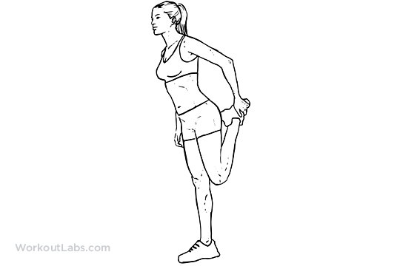

Dumbbell Complex Exercises

These exercises will assist you with grip strength which could assist preparation for the casualty evacuation, ladder lift, equipment assembly and equipment carry elements of the Practical Selection Tests.

A dumbbell complex is two or more exercises performed continuously as one set without putting the dumbbells down or resting between exercises.

E.g. If the complex is Squat, Shoulder Press and Curl for 8 repetitions you perform 8 squats, 8 shoulder presses then 8 curls back to back only putting the weight down after the final rep of your curls. This is the start of your rest time before the next set.

The benefits of dumbbell complexes are:

- Has a greater Cardiovascular benefits than a tradition weights training sessions
- Builds muscle stamina and endurance
- Effective for fat burning
- Does not require a lot of equipment or space which is ideal when training in the gym
- Improves grip strength
- Allows a greater volume of work to be done in a short time
- Can be incorporated into another workout

Before starting dumbbell complex training some important considerations are:

Make sure you have mastered the correct technique. If you are unsure of the technique of any exercise don’t be afraid to ask for help or swap the exercise. Performing weights exercises with the wrong technique will put you at risk of injury.

Use the correct weight. The weights you use may not feel heavy at first but will soon have you working hard, don’t let your ego come into it! I suggest starting light to master technique and working up rather than too heavy and burning yourself out.

Grip will be an issue. You may find that the first few times you complete a complex it is your grip that lets you down before anything else. The programs are designed to be as sympathetic to the grip as possible nevertheless this is still something that is unavoidable. Your grip will improve greatly from doing the complexes and it will become easier the more you do.

Keep good posture and a strong core. As with any exercise it is import to keep a good posture, pull your belly button in and keep your shoulders back trying to squeeze your shoulder blades together.

Work to your fitness level. If you are inexperienced or have low levels of fitness I wouldn’t expect you to jump straight into a difficult dumbbell complex workout. However you can alter the number/ difficulty of exercises, the repetitions, the number of sets and the rest between sets meaning that dumbbell complexes are suitable for any level of fitness.

Be prepared to work hard. The complexes are intense whole body work outs therefore are very physically demanding by nature. Added with the stress on the grip it may take a lot of determination to get through the workout.

Repetitions: Perform 6-10 repetitions per exercise. The number of reps with vary dependant on your fitness level, the exercises included and the number of exercise in that complex.

Sets: Perform 3-6+ sets of the complex. This factor will again vary on depending on the factors mention above. The rest time or activity in between sets may also have an impact on how many sets you can complete.

Rest: 1-3 minutes. The amount of rest required will depend on your fitness level and the difficulty of the complex. Always times your rest period and try to be strict and consistent throughout all the sets. Reducing rest is an effecting way of progressing your training.

Active Rest: If your fitness level is higher instead of resting you may include a cardiovascular option between sets. For example complete a 500m run on the treadmill or 3 minutes on the exercise bike. You could also use your rest time work on your core, stretch or perform mobility movements.

Dumbbell Complex 1- Whole Body

6-10 repetitions per exercise

Complete 3-6 sets of the following:

- Squat (holding the DBs on your shoulders, palms facing in)
- Shoulder Press (standing with palms facing forward)
- Upright Row
- Press Ups (keep hold of the DBs)
- Curl
- Squat/ Squat Jumps (DBs by your side palms facing in)

2 minute rest or 400m Run/ 1km bike.

Dumbbell Complex 2- Upper Body

6-10 repetitions per exercise

Complete 3- 6 sets of the following:

- Curl
- Shoulder Press
- Bent over row
- Press ups (keep hold of the DBs)
- Upright row
- Chest press (Laying on a weights bench)

2 minute rest or 2 minute run/ bike/ cross training completing as much distance as possible

Dumbbell Complex 3- Whole body

Pyramid Reps of 12, 10, 8, 6, 4, 2 (for set 1 complete 12 reps of each exercise, for the 2nd set complete 10 reps of each, the 3rd set 8 reps, etc.)

Complete 6 sets of the following
- Squat (Hold DBs on shoulders, palms facing in)
- Shoulder Press
- Curl
- Lunge
- Up Right Row
- Press Ups
- Bent Over Row
- Squat (DBs by your side)

2 minutes rest

Dumbbell Complex 4- Whole body (advanced)

6-10 repetitions per exercise

Complete 3-6 sets of the following:
- Squat and Press (hold DBs at shoulders palms facing in)
- Standing Lunge (DBs by side, alternate legs, perform set amount of reps each leg)
- Spiderman Press ups (as you perform the press up one knee goes out to the side
towards your elbow)
- Clean and Press (use your legs to help you on both the clean and the press above
your head)
- Squat to Upright Row (hold the DBs by your side as your squat and bring them in
front for the upright row)

2 minutes rest or 500m run/ 100m incline walk

CARDIOVASCULAR FITNESS:BEGINNER

- The beginner CV sessions are designed for those who currently have a low level of
fitness, are inexperienced or returning to fitness after a prolonged time off.
- The aim of these sessions is to challenge you and build up a basic level of fitness
without pushing too hard and risking injury.
- All workouts are flexible therefore the level/ speed/ incline used on each machine is
a guide and can be altered accordingly. The rate of percieved exhuastion (RPE, see
table below) is the main focus.
- The RPE in brackets next to each time is how hard you should find that interval e.g.
(RPE 12).
- An effort percentage has also being included to to make this clearer with 100% being
maximal effort.
- Record the speed/ level/ distance/ time used each session with an aim of improving
each time you train.
- Always perform a warm up before the session that includes active stretches of the
muscles that are going to be used.
- Always perform a cool down and static stretches after a workout. This will reduce
muscular soreness and improve flexibilty. Hold each strech for 30+ seconds for
maximum benefit.

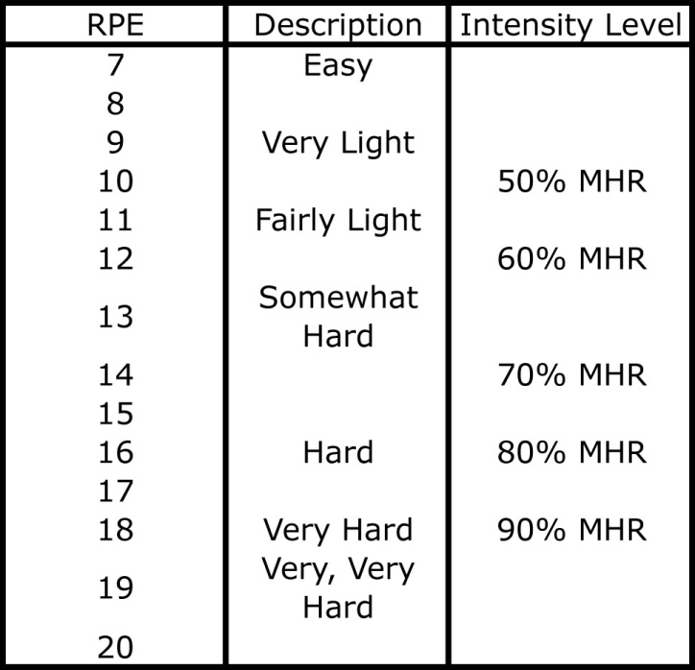

Treadmill

The treadmill speed has not been specified as this will vary per person depending on there fitness level and running ability. As previously stated adjust this in accordance to your RPE. Don’t be afraid to add extra intervals or increase treadmill speeds if you are feeling strong in a particular session or conversly reduce the number/ speed if you are struggling.
Treadmills are a very useful tool however free running outside is the best form of exercise to improve aerobic endurance. Run on grass or trails where possible to avoid stress on the muscles and joints and invest in a decent pair of running trainers.

Session 1
5 minute warm up | SPEED
30 seconds jog at (RPE 15) – 75% effort
1 minute walk at (RPE 10) – 50% effort X 5 (7.30s total)
5 minutes at (RPE 13)- 65%
5 minute cool down
Stretch

Session 2

5 minute warm up | SPEED
1 minute walk (RPE 8) - 40% effort
1 minute jog (RPE 12) - 60% effort
1 minute run (RPE 16) – 80% effort X 5 (15 mins total)
5 minute cool down
Stretch

Session 3

5 minute warm up | SPEED
5 minutes (RPE 12-14) 60-70% effort
5 minutes at 3° incline (RPE 14-16) 70-80% effort
5 minutes (RPE 12-14) 60-70% effort
5 minute cool down
Stretch

Rowing Machine

Concentrate on driving with the legs whist the upper body is leaning back slightly. Pull the arms back with the handle hitting slighty below your sternum. Keep wrists and grip relaxed. Once you feel you have mastered the technique aim to produce long powerful strokes as opposed to quicker shorter ones, this is a more efficient style of rowing.
The rest period between intervals in complete rest therefore you don’t have to row just use it to recover and rehydrate (small sips during exercise). Try to be as strict as possible with your timings.

Session 1

3 minute warm up | DISTANCE
2 minute (RPE 14) 70% effort
1 minute complete rest X 3 (9 mins total)
1 minute (RPE 15) 75% effort
30 seconds rest X 5 (7.30s total)
5 minute cool down
Stretch

Session 2
3 minute warm up | TIME
100m row (16RPE) 80% effort
45 seconds rest X 8
500M row (RPE 12-16) 60-80% effort
5 minute cool down
Stretch

Bike

As previously stated the level of resistance is only a guide as this will vary dependant on the make and model of the bike. The intervals can be completed seated or standing.
The bike seat should be at the same height as your hip bone. When the pedal is at the bottom there should be a slight bend in the knee.

Session 1
5 minute warm up | LEVEL | TOTAL DISTANCE
1 minute at Level 5+ (RPE 15) 75% effort
1 minute at Level 1 (RPE 6) 30% effort X 5 (10 mins total)
5 minutes at Level 3+ (RPE 12) 60% effort
5 minute cool down
Stretch

Session 2

5 minute warm up | LEVEL | TOTAL DISTANCE
1 minute Level 1 (RPE 6) 30% effort
1 minute Level 4+ (RPE 12) 60% effort
1 minute Level 7+ (RPE 16) 80% effort X 5 (15 mins total)
5 minute cool down
Stretch

CARDIOVASCULAR FITNESS: INTERMEDIATE

- The intermediate CV sessions are aimed at those that already have a basic level of
Fitness.
- All workout are flexible therefore the level/ speed/ incline used on each machine is a
guide and can be altered accordingly. The rate of percieved exhuastion (RPE, see
table below) is the main focus.
- The RPE in brackets next to each time is how hard you should find that interval e.g.
(RPE 14).
- An effort percentage has also being included to to make this clearer with 100% being
maximal effort.
- Record the speed/ level/ distance/ time used each interval in the space provided with
an aim of improving each time you train, don’t be affriad to challenge yourself!
- Always perform a warm up before the session that includes active streches of the
muscles that are going to be used.
- Always perform a cool down and static stretches after a workout. This will reduce
muscular soreness and improve flexibilty. Hold each stretch for 30+ seconds for maximum benefit.

Bike

As previously stated the level of resistance is only a guide as this will vary dependant on the make and model of the bike. The intervals can be completed seated or standing.
The bike seat should be at the same height as your hip bone. Once the pedal is at the bottom there should be a slight bend in the knee.

Session 1

5 minute warm up | LEVEL
1 minute level 1 (RPE 6) 30% effort
1 minute Level 7+ (RPE 14) 70% effort
1 minute Level 12+ (RPE 16-18) 80-90% effort X 7 (21 mins total)
5 minute cool down
Stretch

Session 2

5 minute warm up | LEVEL | DISTANCE
25 minutes Level 5+ (RPE 12-16) 60-80% effort
5 minute cool down
Stretch

Session 3 (anaerobic sprints)

5 minute warm up | LEVEL
15 seconds Level 15+ max (RPE 18-20) 90-100% effort
45 seconds Level 1 active recovery (RPE 6) 30% effort X 10 (10 mins total)
10 minutes Level 5+ (RPE 12-16) 60-80% effort
Stretch
*Aim to give 100% effort in all sprints during this session to get maximum benefit! Have the resistance as high as you can manage. Active recovery means that you legs are still pedalling but at a very low resistance use this time to recover and rehydrate (small sips when exercising).

Treadmill

The treadmill speed has not been specified as this will vary per person depending on there fitness level and running ability. As previously stated adjust this in accordance to your RPE.
Treadmills are a very useful tool however free running outside is the best form of exercise to improve aerobic endurance. Run on grass or trails where possible to avoid stress on the muscles and joints and invest in a decent pair of running trainers.

Session 1

5 minute warm | SPEED
1 minute (RPE 8) 40% effort
1 minute (RPE 12-14) 60-70% effort
1 minute (RPE 16-18) 80-90% effort X 10 (30 mins total)
5 minute cool down
Stretch
Session 2

5 minute warm up | SPEED
2 minutes run (RPE 16) 80% effort
1 minute walk (RPE 8) 40% effort X 7 (21 mins total)
10 minute (RPE 14)- 70%
5 minute cool down
Stretch

Session 3
5 minute warm up | SPEED | DISTANCE
30 minutes (RPE 12-16) 60-80% effort
5 minute cool down
Stretch

Rowing Machine

Concentrate on driving with the legs whist the upper body is leaning back slightly. Pull the arms back with the handle hitting slighty below your sternum. Keep wrists and grip relaxed. Once you feel you have mastered the technique aim to produce long powerful strokes as opposed to quicker shorter ones, this is a more efficient style of rowing.
The rest period between intervals in complete rest therefore you don’t have to row just use it to recover and rehydrate (small sips during exercise). Try to be as strict as possible with your timings.

Session 1

3 minute warm up | TIME
200m row (16-18RPE) 80-90% effort
1 minute rest X 8
2000M row (RPE 12-16) 60-80% effort
5 minute cool down
Stretch
Session 2

3 minute warm up | DISTANCE
2 minute (RPE 14) 70% effort
1 minute complete rest X 5 (15 mins total)
1 minute (RPE 16) 80% effort
30 seconds rest X 5 (7.30s total)
5 minute cool down
Stretch
Session 3
3 minute warm up | TIME
2000m row (RPE 12-16) 60-80% effort
2 minute rest
1000m row (RPE 14-18) 70-90% effort
90 second rest
500m row (RPE 16-20) 80-100% effort
1 minute rest
250m row (RPE 18-20) 90-100% effort
5 minute cool down
Stretch
Triathlon

5 minute warm up | TIME | TOTAL TIME
3km Bike
2km Row
1km Run
5 minute cool down
Stretch
5 minute warm up | TIME | TOTAL TIME
3km Bike
2km Row
1km Run
5 minute cool down
Stretch
*Record the time it takes to complete each section and the total time and try to beat it next time around!

CARDIOVASCULAR FITNESS: ADVANCED

- The advanced fitness sessions are designed for those that already have a high
standard of fitness.
- All workout are flexible therefore the level/ speed/ incline used on each machine is a
guide and can be altered accordingly. The rate of percieved exhuastion (RPE, see table below) is the main focus.
- The RPE is in brackets next to each time is how hard you should find that interval
e.g. (RPE 14)
- An effort percentage has also being included to to make this clearer with 100% being
maximal effort.
- Record the speed/ level/ distance/ time used each interval in the space proved with
an aim of improving each time you train.
- Always perform a warm up before the session that includes active stretches of the
muscles that are going to be used.
- Always perform a cool down and static stretches after a workout. This will reduce
muscular soreness and improve flexibilty. Hold each strech for 30+ seconds for maximum benefit.

Bike

As previously stated the level of resistance is only a guide as this will vary dependant on the make and model of the bike. The intervals can be completed seated or standing.
The bike seat should be at the same height as your hip bone. Once the pedal is at the bottom there should be a slight bend in the knee.

Session 1

5 minute warm up | LEVEL
1 minute Level 7+ (RPE 14) 70% effort
1 minute Level 12+ (RPE 16-18) 80-90% effort X 10 (20 mins total)
30 seconds Level 5+ (RPE 12) 60% effort
30 seconds Level 12+ (RPE 17-19) 85-95% effort X 10 (10 mins total)
10 minutes Level 7+ (RPE 14) 70% effort
5 minute cool down
Stretch
Session 2

5 minute warm up | LEVEL
1 minute Level 3+ (RPE 10) 50% effort
2 minutes Level 8+ (RPE 15) 75% effort
2 minutes Level 12+ (RPE 17) 85% effort X 5 (25 mins total)
30 seconds level 1 (RPE 6) 30% effort
30 seconds Level10+ (RPE 16) 80% effort
30 seconds Level 15+ (RPE 18-20) 90-100% effort X 10 (15 mins total)
5 minute cool down
Stretch

Session 3 (anaerobic sprints)
5 minute warm up | LEVEL
20 seconds Level 15+ (RPE 18-20) 90-100% effort
40 seconds Level 1 active recovery (RPE 6) 30% effort X 10 (10 mins total)
15 minutes Level 8+ (RPE 15 ) 75% effort
Stretch

Treadmill

The treadmill speed has not been specified as this will vary per person depending on there fitness level and running ability. As previously stated adjust this in accordance to your RPE.
Treadmills are a very useful tool however free running outside is the best form of exercise to improve aerobic endurance. Run on grass or trails where possible to avoid stress on the muscles and joints and invest in a decent pair of running trainers.

Session 1

5 minute warm up | SPEED
1 minute (RPE 12-14) 60-70% effort
1 minute (RPE 16-18) 80-90% effort X 10 (20 mins total)
10 minutes (RPE 15) 75% effort
5 minute cool down
Stretch
Session 2

5 minute warm up | SPEED
3 minute (RPE 16) 80% effort
1 minute (RPE 10) 50% effort X 5 (20 mins total)
2 minutes (RPE 17) 85% effort
45 seconds (RPE 10) 50% effort X 5 (13.45s total)
1 minute (RPE 18) 90% effort
30 seconds (RPE 10) 50% effort X 5 (7.30s total)
5 minute cool down
Stretch

Rowing Machine

The rest period between intervals is complete rest therefore you don’t have to row just use it to recover and rehydrate (small sips during exercise). Try to be as strict as possible with your rest timings. Record the times of each interval in the section provided and aim to beat it next time.

Session 1
3 minute warm up | TIME
500m row (16-18RPE) 80-90% effort
1 minute rest X 8
5 minute row (RPE 12-16) 60-80% effort
5 minute cool down
Stretch

Session 2
5 minute warm up | TIME
3000m row (RPE 12-16) 60-80% effort
2 minute rest
2000m row (RPE 14-18) 70-90% effort
90 second rest
1000m row (RPE 16-20) 80-100% effort
1 minute rest
500m row (RPE 18-20) 90-100% effort
5 minute cool down
Stretch

Complete both these workouts in the quickest time possible and rest whenever required. Record the time taken for each section and the total time aiming to improve next time.

Triathlon

5 minute warm up | TIME | TOTAL TIME
5km Bike
3km Run
2km Row
5 minute cool down
Stretch
Triathlon 2

5 minute warm up | TIME | TOTAL TIME
200m Row
10 Burpees X 5
200m Run
15 Press Ups X 5
1km Bike
30 sit ups X 3
5 minute cool down
Stretch

HEALTHY EATING AND NUTRITION

The primary focus of this nutritional program is optimal health and to provide the fuel required whilst training to become a firefighter. Some principles may vary from person to person depending on goals, activity levels, tolerance to certain food groups and training regime. For example someone looking to reduce body fat will have different dietary requirements to someone looking to gain muscle. However, the fundamental principles will remain the same.

The benefits of a healthy diet cannot be underestimated! As the cliché says “you are what you eat” and even making some slight adjustments to your diet can have a very positive effect. Eating a healthy diet leads to

- Stronger immune system
- Healthier skin, teeth, nails and hair
- It will improve your concentration levels
- Improve your mood/ happiness
- Help you reduce body fat or gain muscle
- It will reduce the risk of heart attacks, diabetes and many other diseases
- Responsible for your energy levels providing fuel for your muscles and brain

The key to maintaining healthy eating:

- Aim to follow the 80/20 rule. Eat well 80% of the time and try limit treats or
unhealthier options to only 20% of your diet or less.

- Never starve yourself or go hungry. Eating nutrient rich foods and not missing
meals should have you feeling full & energised.

- Don’t think of yourself as “on a diet” this is just the way you eat. If you tell
yourself you are not allowed something you are more likely to crave it. Including the occasional treat in a balanced diet is the best approach.

- Preparation is essential. Sometimes you may have to plan your meals in advance
in order to have a healthier option. Try cooking double the amount when you prepare
food and save portions for future meals.

- Experiment with your cooking. Some healthy foods may not be the most exciting
however if you look up healthy recipes and use different herbs and spices there is no reason healthy food cant taste amazing.

- Share the responsibility. It is a lot harder to succeed on your own. If your partner/
family at home or your watch at the station also aims to eat healthy then you are far
more likely to succeed. Cooking healthy group meals at work or home will again
make healthy eating easier.

- Make small changes gradually For the majority of people making drastic changes
to your entire diet is not wise as you are less likely to maintain to your new eating
habit. How many new diets have you tried and failed? However, if you implement 1 or
2 changes per week and focus on making those second nature before implementing another then they are more likely to be long term. For example, in week 1 you commit to eating breakfast everyday and swapping chips for sweet potatoes or rice.

Key Nutritional Principles

- Always eat breakfast
- Aim to eat mostly natural food e.g. meat, fish, vegetables, fruit & nuts
- Eat as many leafy greens or fibrous vegetables as possible
- Replace or Reduce large portions of chips/ pasta/ bread for healthier alternatives
- Swap all sugary drinks for water/ squash
- Base all meals around a quality source of protein and veg. Vary carbohydrates
accordingly.

Eliminate all processed food

Processed food is bad news! It lacks nutrition and contains chemicals, dyes and added preservatives. All these chemicals must be metabolised and removed from the body and this can overload the body’s natural systems.

Aim to consume the bulk of your diet from natural sources. This includes meats, fish, vegetables, fruit, nuts, herbs and spices. As a general rule all food should rot, food that is manmade and designed to sit on a supermarket shelf for weeks cannot be classed as natural. Try to stick to single ingredient foods. For example, a homemade chilli that contains lean mince, onion, peppers, tomatoes, kidney beans, chilli, herb and spices is only made from single natural ingredients. A chilli bought from a super market may contain artificial preservatives and a lot of the nutrients are lost during the manufacturing process.

Examples of processed food

Most Cereal, White Pasta, Ready Meals, Sweets, Biscuits, Most Cooking Sauces, Chips, Crisps, Breakfast Bars, Fast Food, Chocolate, Pastries, White Bread, Pizza

There are many foods that can be classed as processed and it is impossible to eliminate them all however if 80/90% of your diet is real food that will have a positive impact on your health.

Protein

Protein is essential for recovery from the day to day exertions of firefighting or for repairing the muscle damage caused during exercise. Protein is also required for immune function and making essential hormones and enzymes.

Your diet should consist of 20-40% protein depending on your activity level and training regime. Always consume protein after a workout or for very phyically demanding job as this will instantly begin the process of recovery.

Good sources of protein (eat every meal) 20-40% of diet

Chicken breast, Turkey, Lean Mince, Lean Red Meat, Wild Meats, Salmon, Tuna, Any White Fish, Free Range Eggs, Cottage Cheese, Nuts, Beans

For optimum body composition (low percentage body fat) you should eat a diet that contains a quality protein source at every meal. Eating protein and/or slow release carbohydrates for breakfast will reduce cravings later in the day as it doesn’t drastically increase your blood sugar level like the majority of cereals.

Avoid processed meats! These are injected with salt, water and chemicals to preserve the meat and retain its colour. Choose organic grass fed meats and free range eggs when possible, opt for the local butchers instead of supermarket meat.

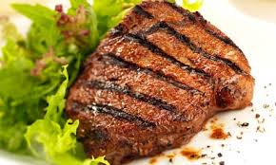

Carbohydrates

Carbohydrates are the bodies primary source of fuel as they can easily be used by the body for energy, therefore are an essential part of a firefighters diet. They can be stored in the muscles and liver and used later for energy. Carbohydrates can be catagorised as refined or unrefined.

Refined Carbohydrates These are the carbohydrates that we are looking to avoid. They have been manufactured and lack any nutritional value, although they may taste good they will cause more harm to your body than good. Research shows that refined carbohydrates are the leading cause in diseases such as obesity, diabetes, heart disease and cardiovascular disease.

The majority of refined carbohydrates contain added sugar which will spike your blood sugar and as a result these products are highly addictive therefore try and avoid at all costs.

Examples of refined carbohydrates (avoid/ reduce)

White Bread, White Pasta, Packaged Cereal, White Flour, Cakes, Biscuits, Sweets, Fruit Juice, Fizzy Pop, Crisps. Dough (all types), Tortillas, Sources (ketchup, bbq, etc), White Rice. Milk substitutes,

Unrefined Carbohydrates All the carbohydrates you eat should be unfined as they are still in there natural form. They contain fibre, vitamins and minerals which are essential for maintaining a healthy body.

Examples of unrefined carbohydrates 40-60% of diet

Sweet Potatoes, Potatoes, Oats, Quinoa, Beans, Lentils, Buckwheat, Fruit, Vegetables, Nuts, Whole grain Bread & Pasta, Brown Rice

It is important to understand that even though whole grains such as cereal and wholegrain bread do provide slightly more nutritional benefits than processed grains such as white bread. They still contain minimal fibre and high amount of fast release carbohydrates that will rapidly increase your blood sugar. Therefore, if you are going to eat grains it is better to eat whole grains than processed but eat in moderation and only when activity levels are high.

Gluten is a protein found in wheat, barley and rye and is a sustance that courses problems such as digestive disorders for many people. Therefore lots of people have benifitted from removing gluten from there diet.

Carbohydrates will make up the bulk of your diet, aim to consume 40-60% of total calories from carbs. Again this will very depending on activity rates for that day and your body composition goals. Always eat carbohydrates after a intense workouts or periods of vigorous activity as they will go straight to your muscles to replenish the stores used.
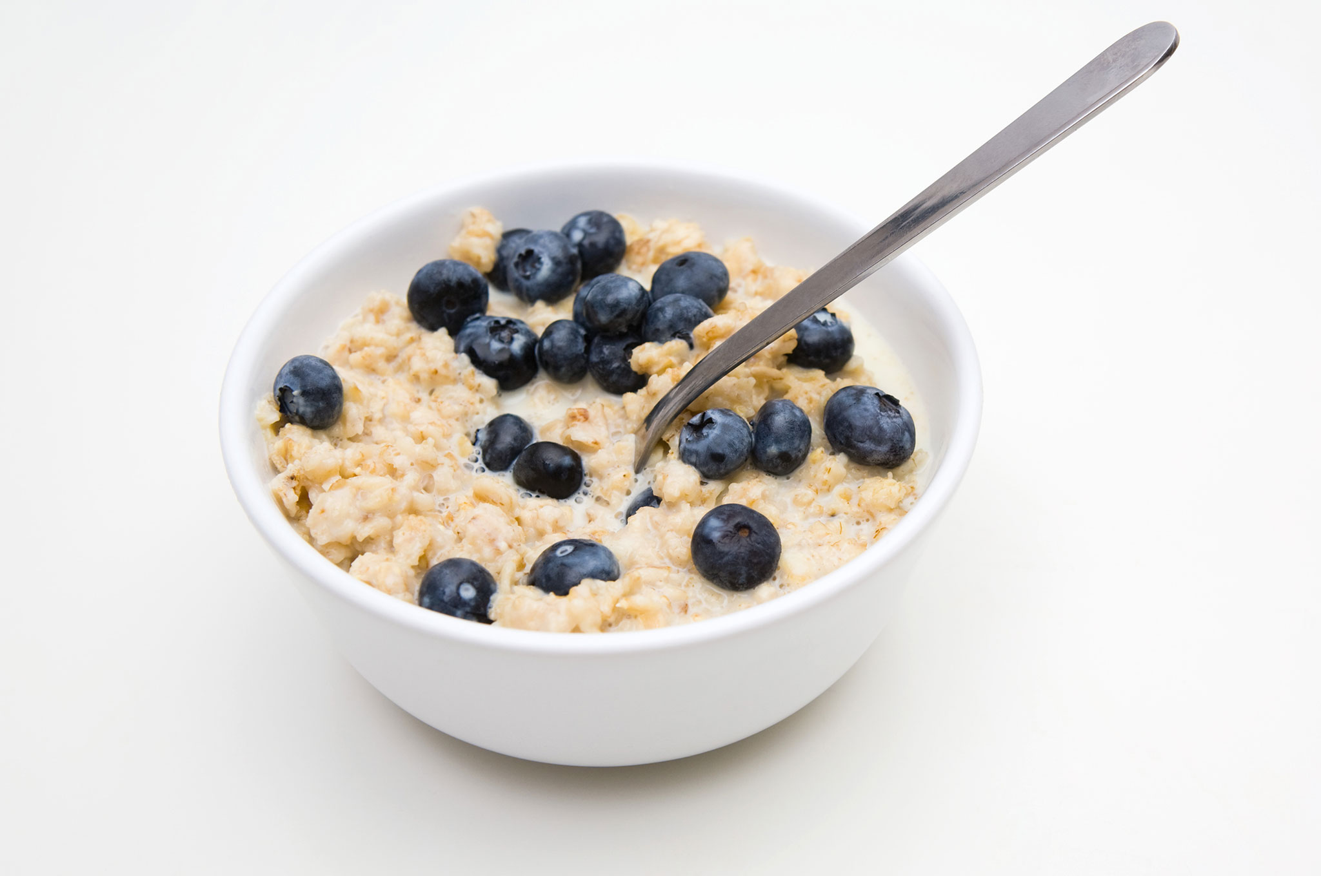

Fat

Fat can also be used as energy by the body. It is essential for normal growth and development and required to absorb certain vitamins. It also provides protection for vital organs.

Fat is often misunderstood in nutrition and perceived as “the enemy” by many people trying to eat a healthy diet or lose body fat. Research shows that eating a diet including certain fats is associated with leaner body composition.

However the key is to eat the right types of fat. Trans or hydrogenated fats should be completely eliminated from the diet. These fats are commonly found in processed food. Omega-3 fats are the healthiest for you to eat, they have been shown to reduce the risk of cardiovascular disease, cancer, strokes and have many other health benefits. These are found in fish oils, wild meat and grass fed beef. A list of healthy fats is shown below. For those that don’t eat fish an omega 3 a supplement can be beneficial.

Bad Sources of Fats (avoid)

Vegetable Oils, Fried Foods, Margarine, Processed Food, Baked Goods e.g. Cookies, Junk Food.

Good Sources of Fats (eat in moderation) 20-30% of diet
Butter, Free Range Eggs, Olive Oil (un-heated), Avocado, Coconut Oil, Nuts, Oily Fish- Salmon, Sardines, Trout, Mackerel, Chia Seeds, Flax Seeds, Grass Fed Meat.

Coconut oil is perfect to cook in as it is immediately used as energy and not stored as fat. It has many other health benefits such as a positive effect on cholesterol, boosts your immune system and increased metabolism.

Vitamins & Minerals

It is vital to know that the recommended daily allowance (RDA) for vitamins and minerals is the minimum the body needs for healthy daily function. Consequently you should be far exceeding these recommendations for optimum health. 5 portions of fruit and vegetables a day is an absolute minimum and in many countries they recommend more. You should aim to eat vegetables with every meal and fruit in moderation. If you eat a balanced diet including fruit and vegetables, supplements are generally not required as all your vitamins and minerals needs will be met.

Vegetables especially leafy green are high in nutrients and contain fibre. Vegetables such as broccoli, kale and cauliflower help the body detoxify which is why they are said to have “cancer fighting properties”. This is why it is suggested you can eat as much as you like and many refer to them as super foods.

Although fruit contains sugar nobody ever got fat from eating too many apples. No studies have ever shown eating high amounts of fruit leads to weight gain. The key is variety and moderation with your fruit intake. Berries are especially good for you with the darker the skin the better. Blueberries and blackberries are ideal snacks as they contain antioxidants which provide many health benefits. Avoid fruit juice and smoothies as they are very high in sugar and a lot of the nutrients are lost. Homemade smoothies are fine as you are in control of exactly what goes into them.

Good Sources of Vegetables (eat as much as possible)

Broccoli, Kale, Peppers, Spinach, Cabbage, Spring Greens, Lettuce, Cucumber, Green Beans, Asparagus, Mange tout, Snap Peas, Peas, Tomatoes, Peppers, Onions, Butternut Squash, Carrots, Sweet Corn.

Good Sources of Fruit (eat in Moderation)

Fresh Berries – Blueberries, Raspberries, Blackberries, Strawberries Apples, Orange, Grapefruit, Lemon, Limes, Pears, Kiwi, Melon, Banana, Pomegranate.

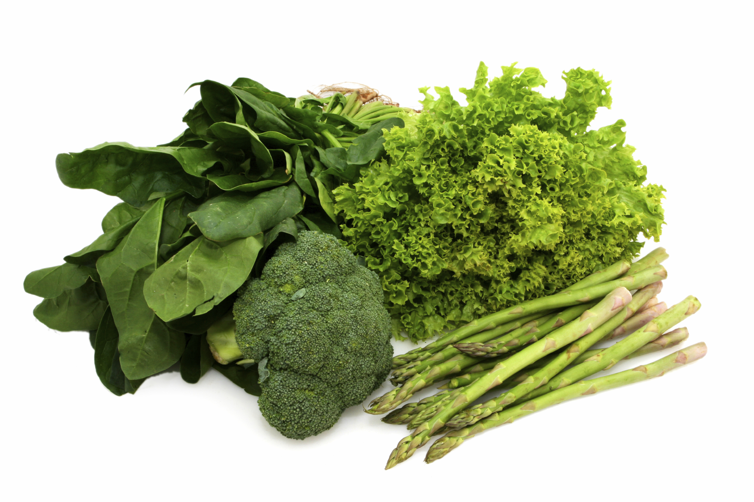

Hydration

Aim to drink a minimum of 3 litres of water per day and more will be required on training days. One of the easiest changes to promote fat loss is to drink more water. All fizzy drinks, sports drinks, fruit juice and alcohol should be avoided if your goal is to reduce body fat.

Alcohol will slow down your metabolism, halt recovery from training and provides excess calories. Therefore for the best results should be avoided. However if you to drink keep it within moderation and try not to follow it with a day of junk food to ease the hangover.

Green tea and coffee have been shown to provide a slight boost in resting metabolic rate. They are rich in antioxidants and green tea supports detoxification. Drink only organic green tea and coffee for best results. However don’t add sugar to these drinks and be careful when buying coffees as many are high in calories.

Caffeine has many benefits in both training and everyday life it is shown to increase concentration and reaction time. It increases fat burning when exercising, boosts endurance and reduces muscular soreness post training therefore is a good pre-workout drink. However the key is moderation the recommended daily allowance of caffeine is 200mg per day however it is agreed that for certain people 3-400mg has no adverse effects. 1 cup of instant coffee provides roughly 100mg of caffeine. Try not to form a reliance on caffeine and avoid taking 6 hours before you go to bed.
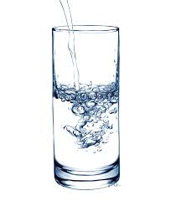

Diet Plan Example

Meal 1
Template | Example 1 | Example 2 | Example 3 | Example 4 | Example 5
Protein  Healthy Fats  Carbs -optional  Vegetables | Four Egg Omelette, Feta Cheese, Spinach, Peppers, Onions | Mackerel/ Salmon, Tomatoes, Kale | Bacon Medallions, Mushrooms, Tomatoes, Poached Eggs, Spinach,  Whole Grain Toast | Porridge & Mixed Berries | Natural Greek Yogurt, Berries, Nuts and Seeds

Meal 2
Template | Example 1 | Example 2 | Example 3 | Example 4 | Example 5
Protein  Healthy Fats  Carbohydrates  Vegetables | Tuna, Baked Potato, Green Beans | Fajitas Spice Chicken, Onion, Peppers, Mushrooms, Rice | Chicken Salad - Chicken Breast, Kale, Spinach, Pepper, Onion, Sweet Corn,  Beet Root, Cottage Cheese | Steak,  Sweet Potato Wedges,  Asparagus | Turkey Steak, Mashed Sweet Potato, Butter, Peas, Sweetcorn

Meal 3
Template | Example 1 | Example 2 | Example 3 | Example 4 | Example 5
Protein  Healthy Fats  Carbohydrates  Vegetables | Haddock, Lemon, Parsley, Potato Chips (homemade), Mushy Peas | Chilli - Lean Mince, Tomatoes, Onion, Peppers, chilli, mushrooms, rice | Lamb Steak, Mint Sauce, Mashed Potato, Butter, Kale, Sugar Snap Peas | Chicken Dinner - Roast Chicken, New Potatoes, Cabbage, Broccoli, Carrots, Butternut Squash, Peas | Salmon – Honey & Soy Sauce, Baked Sweet Potato, Mange tout, Spring Greens

Snacks
Fruit, Nuts, Cottage Cheese, Cooked Meats, Greek Yogurt, Boiled Eggs, Main Meal Left Over’s,

- These are just guidelines to give you an idea of the type of food combinations you should be eating. They are very flexible so you can adjust to suit your tastes and hunger that day.

- 3 meals a day suits most people and some days you may have more meals depending on training & activity levels.

- Most people don’t need to worry about counting calories. Eat when hungry and till you are full, it is very difficult to overeat on these good quality nutritious foods.

- You shouldn’t be hungry or feel like you are on a horrible diet (apart from resisting the obvious treats).

Nutrition & Training

- Avoid refined carbohydrates prior to training if your goal is to burn body fat .Protein, healthy fats and green vegetables would be the perfect pre-training meal.

- If you are training for performance, to improve fitness, increase strength, taking part in an endurance event or playing sport have carbohydrates beforehand.

- Eat carbohydrates after intense exercise to replenish the glycogen stores used during the session.

- Consume protein after intense resistance training to aid recovery.

- Green vegetables and dark skin berries will accelerate recovery as they contain antioxidants.

