Equality, Diversity & Inclusion
Annual Report
2022

Equality, Diversity & Inclusion (EDI) Annual Report

Contents

Section | Title | Page No
1 | Background | 2
2 | Purpose | 2
3 | Why Equality, Diversity & Inclusion | 2
4 | Our Performance | 3
5 | Training & Education | 6
6 | Memberships | 7
7 | Our Policies | 8
8 | Wellbeing | 8
9 | Our Story | 8
10 | EDI Activity | 8
11 | In Summary | 17

Equality, Diversity & Inclusion Annual Report

BACKGROUND

2022 saw the introduction of our Interim Equality, Diversity & Inclusion (EDI) Strategy which enables us to share the priorities which both underpin our ambition to create an inclusive workplace, and contribute to our strategic aspiration of making our service a great place to work. This Strategy explains how we will meet the requirements in the Equality Act 2010 and the Public Sector Equality Duty, as well as the ways in which we will effectively promote EDI within all areas of service delivery and our employment practices. The supporting EDI Action plan demonstrates how we plan to continue to embed EDI into everything we do, for the staff working for us and for the communities we serve across South Yorkshire.

PURPOSE

This Equality, Diversity & Inclusion Annual Report offers a unique opportunity to capture and celebrate the fantastic work carried out across the organisation and supports the other documents that we produce, our Annual Pay Gap Report and Workforce Profile.

We want our commitment to EDI to be led from the top. To support this work members of our Senior Leadership Team play a key role as strategic influencers to help give direction and focus to this key work, including driving the commitments within our EDI Action Plan.

WHY EQUALITY, DIVERSITY & INCLUSION?

Equality, Diversity and Inclusion are at the heart of our service, in how we engage our communities, provide effective services that meet local needs, and help make our workforce truly representative of the communities we serve.

We want the talents of individual staff members to be genuinely recognised and for everyone to be in a position to help us become the best organisation we can be.

Because we understand that the principles of EDI are integral to keeping our communities safer and stronger, we have grouped our EDI priorities under the following areas:-

- Improving diversity
- Inclusive culture
- Fair treatment
- Inclusive services
- Engaging communities

OUR PERFORMANCE

As part of our progress towards a more diverse and inclusive workplace, we are monitoring a series of statistics. The three Local Performance Indicators (LPIs) allow us to analyse our advancement numerically and have year-on-year comparisons in the years to come.

LPI 3.41 - The Percentage of Applications for Vacancies from Underrepresented Groups

This data is a representation of the period from 15/10/2021 to 31/03/2022 for corporate recruitment only. Further analysis of wholetime recruitment is below with further work required to provide on-call recruitment data. As this is a new LPI no previous comparison is currently available.

The data shows we are attracting a diverse range of people to apply to our corporate roles. Whilst the values are high for females, we need to do more positive action work to attract more applicants from the other underrepresented groups.

LPI 3.42 - The Percentage of Leavers from Underrepresented Groups

This data is a representation of the period from 01/04/2021 to 31/03/2022.With comparisons from the period 01/04/2020 to 31/03/2021.

As you can see there has been a decrease in the percentage of leavers from underrepresented groups, in comparison to the 2020/21 period. This shows a positive move towards a more inclusive workplace, which welcomes and retains its diverse staff. It is important to note that some leavers are part of multiple underrepresented groups and we should take an intersectional approach to EDI.

LPI 3.40 - The Percentage Completion of Equality, Diversity and Inclusion (EDI) Training

We currently have two main forms of EDI Training, a one-day course training course (currently provided by Ioda) and our own online LearnPro.

IODA EDI Course Completion Rates

There has been a particular focus this year to increase the number of corporate staff completing the external EDI course, which has seen the percentage completion rate reach 85%. For the remainder of 2022, additional resources and investment are now focussed on increasing the percentage completion for operational staff.

LearnPro EDI Course Completion Rates

There are two EDI online courses (LearnPro), one for all staff “Equality and Diversity Essentials” and “Managing Diversity” for anyone grade 7 and above (or equivalent). The Equality and Diversity Essentials course, which is mandatory for all employees has a current completion rate of 80.16%. The percentage completion rate for “Managing Diversity” is just 53%. These statistics will help target campaigns to increase completion rates for the 2022/23 period.

Positive Action and Wholetime Recruitment

In addition, to our LPIs, we monitor attendance at our Positive Action events and the impact this is having on the diversity of our wholetime recruit cohorts.

During this period we were in contact via email with over 1800 underrepresented individuals who registered their interest in becoming a wholetime firefighter. The impact of COVID-19 meant that our planned ‘Have a Go Days’ could not take place ahead of wholetime recruitment in 2021. Therefore, in early 2021 we moved to online ‘Have a Chat Sessions’. These twice-weekly sessions provided an introduction, to the role of a firefighter, firefighter fitness, the recruitment process and practical testing requirements, as well as, providing an opportunity for potential applicants to ask questions. 72 different attendees took part in these sessions.

We also introduced online female fitness information sessions, targeted at improving the practical testing pass rate for females and we monitor how many of our successful candidates accessed our positive action interventions.

This Positive Action work, although delivered remotely, has increased the number of recruits from an underrepresented group, in comparison to the 2020 intake.
 | 2020  (24 Recruits) |  | 2021  (35 Recruits)
 | No. | % | No. | %
Female | 2 | 8% | 5 | 14%
Minority Ethnic Group | 0 | 0% | 1 | 3%
Lesbian, Gay, Bisexual and Transgender (LGBT)+ | 1 | 4% | 5 | 14%

Whilst the practical testing pass rate, is still lower for those from underrepresented groups as shown in the table below, it is anticipated that our continued Positive Action work will continue to increase these figures, this data will be captured in the next Annual Report.

Practical Testing Pass Rate
Sept 2021 | No. | %
Overall | 121 of 135 | 90%
Female | 9 of 11 | 82%
Minority Ethnic Groups | 6 of 7 | 86%
LGBT+ | 8 of 10 | 80%

TRAINING & EDUCATION

Educating our staff is vital to developing and improving organisational learning around EDI.

This starts with the induction packages that we offer for new starters (or as a refresher) targeted to a range of workgroups. This training begins by explaining the difference between Equality, Diversity and Inclusion, provides brief information on equality legislation, summarises what EDI means to individuals and finishes by detailing an individual’s responsibilities as an employee of South Yorkshire Fire and Rescue (SYFR).

All our staff are required to carry out a mandatory online learning module on EDI as well as a one day training session delivered by external provider, IODA. This training aims to provide delegates with the information and knowledge needed to understand and promote Equality, Diversity and Inclusion within SYFR. The completion rates for this training is regularly monitored and is listed above.

Our Language, Stereotypes & Assumptions package explains the use of diverse language and the context behind it, what stereotypes are and how they can impact on individuals and groups and how to challenge assumptions based on stereotypes.

Operational crews receive additional EDI input as part of the modular training sessions that we deliver. This training covers basics around engaging with our various communities and the support available to crews to develop skills in this area and covers areas such as Hate Crime and Dementia Awareness.

One other key area of training is the quarterly sessions offered on completing Equality Assessments (EqIA).

Our EDI Conversations package, new for 2022 supports us to build on everyone’s knowledge and understanding of the EDI learnPro to support open conversations around EDI to help upskill the organisation, normalise EDI discussions and improve the service as a whole.

We also provide a range of other education and developmental opportunities as detailed in our online Equality, Diversity & Inclusion Calendar. Much of this work is in partnership with organisations such as Women in the Fire Service (WFS), the Asian Fire Service Association (AFSA) and the National Fire Chief’s Council (NFCC) and focuses on key EDI related topics.

MEMBERSHIPS

Memberships of the right organisations and groups are vital in helping us achieve our EDI goals. We are a Disability Confident employer and work closely with a range of groups including the AFSA, WFS and the NFCC.

Our internal staff groups, supported by a senior manager, work with us to find creative and innovative ways for us to address particular issues across the organisation. An increase in active membership of many of our staff groups is resulting in positive and constructive conversations which are leading to improved ways of working and a better working environment for all staff.

OUR POLICIES

We are looking for our refreshed policies to use gender neutral language and for any new or updated policies to include the views and input of our staff groups (in addition to our existing consultation with representative bodies) to ensure they are as inclusive as possible.

WELLBEING

The last 18 months have been difficult, particularly in the light of the COVID-19 pandemic, despite this we have made some fantastic achievements within our EDI work and we have put a range of measures in place to help and support our staff during these times.

OUR STORY
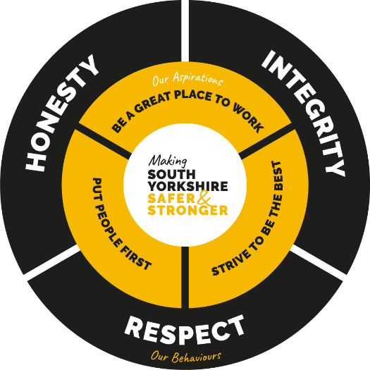
In 2018, we published a strategic narrative- called Our Story - which established our vision to become one of the UK’s leading fire and rescue services.

Our Story clearly sets out our purpose which is ‘making South Yorkshire safer and stronger’. It also explains the behaviours we expect our staff to display, regardless of rank or role, and describes our aspirations for the future. Together, this all forms an essential part of everything we do.

EDI ACTIVITY

Listed below is a range of the activities carried out in support of our EDI agenda between 1 April 2021 and 31 March 2022. Understandably, our ability to get out in the community continues to be impacted upon by the COVID-19 pandemic, although this has helped us develop more engaging activities on line which can make them more accessible.

April 2021

Our new EDI Advisor joined the team just as we celebrated Eid and Vaisakhi. As in previous years, we have issued targeted messages around cooking and celebrating safely to our communities.

Stephen Lawrence Day was on the 22 April, we joined the Race Action Programme conversation with Stuart Lawrence, Stephen’s brother, and youth advocate.

We also attended the first AFSA North Meeting where we discussed how we could work as a region to share ideas around supporting our colleagues and communities.

Equality Analysis (EA) training was rolled out at the end of the month, both internally and by the NFCC. Equality Analysis documents will be refreshed and updated as policies are reviewed.

Our Community Safety Watch Manager and Neighbourhood Fire Community Support Officer (NFCSO) worked with schools, youth services and partners to educate young people on the dangers associated with entering any open water; sending out water safety video links to all Primary and Secondary schools with a letter for parents / guardians and a short survey to capture feedback to ensure our education tools are relevant and have the desired effect.
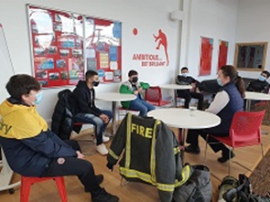
We visited Rotherham United to speak to refugees around Fire Safety and careers in the Fire Service and sent out the Equinox presentation to all Rotherham secondary schools and delivered this to Dinnington Academy live via TEAMS.

May 2021
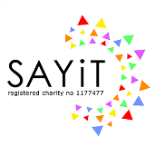
17 May was International Day against Homophobia and Transphobia, we celebrated by presenting our response to homophobia on our social media posts at Sheffield LGBT+ charity SAYiT’s online event. We also reminded the group that our wholetime firefighter recruitment process was opening soon.

Throughout May we shared information around key dates including support for Hoarding Awareness Week, Deaf Awareness Week, Mental Health Awareness Week and Dementia Action Week, all of which are important areas for fire safety. We completed a draft training package around Language, Stereotypes and Assumptions and delivered this to new recruits in Control. As well as also producing Hate Crime Awareness slides that can be offered as a training session or eLearning.

The presentation for refugees staying at the Holiday Inn Express was updated and then delivered by the Sheffield NFCSO. We also joined the Sheffield BAMER Reference Group meeting who share best practice and information.

We also took part in a number of assemblies at Maltby Comprehensive following a rise in fires and ASB. We have also supported Operation Keepsafe joining patrols with South Yorkshire Police (SYP) in Maltby.

June 2021
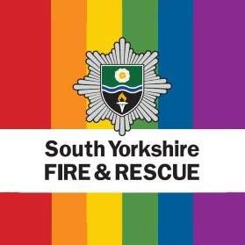
As in previous years, SYFR showed its full support for Pride Month. As well as flying the Progress Pride Flag at stations, we also issued rainbow epaulettes and lanyards. We held a month of education through bulletins and re-shared our interactive exercises on terminology.

Other events we supported and publicised in June included Carers Week, Learning Disability Week, Refugee Week and Windrush Day.

Work began on a pictorial fire safety leaflet for non-English residents who we do not yet have translated home safety advice. This could also be used for people with neurodiverse conditions or learning difficulties.

EDI Advisors and staff groups were consulted on the new community building at Barnsley Fire Station and various recommendations were made.
We also visited the site to give our feedback on the new fire station itself. The station design got through to the final stages of the National Diversity Award.

We attended the Intersectionality Conference 2021 for Fire and Police on the 18 June. This included speakers from a diverse range of backgrounds, providing a host of learning opportunities and workshop discussions.

We also attended a number of multi-agency meetings around Water Safety as part of Operation Keep Safe patrols with SYP and local councils across five open water sites. We also attended Swinton Lock to talk to young people and also carried out a water safety talk to Brookfield Academy at Swinton with Councillor Sansome.

July 2021

During July 2021 work took place with our Community Safety and Business Fire Safety teams (BFS) on the Afghan Immigration Programme. A number of hotels across our districts were being used to house refugees from Afghanistan. Translated Fire safety advice was provided and Fire Safety Audits were carried out with advice provided to Managers and Staff of the Hotels to assist them in the temporary housing of the refugees.

BFS also worked with Sheffield City Council to conduct fire safety audits of all the premises being used to house homeless persons. These range from large hotels, to small guesthouses and also include several Houses in Multiple Occupation.

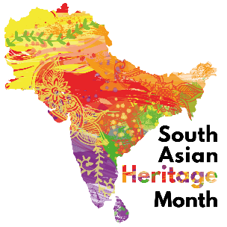
South Asian Heritage Month began in July and we held a month of education and celebration through the Staff Bulletin. We also used the month to restart Community Engagement and Positive Action with Parkway White Watch attending Darnall Football Academy. This youth group was founded by Sheffield humanitarian, and spoken word artist, Aasim Khan who is of Pakistani heritage and has won a Yorkshire Asian Young Achiever of the Year Award.

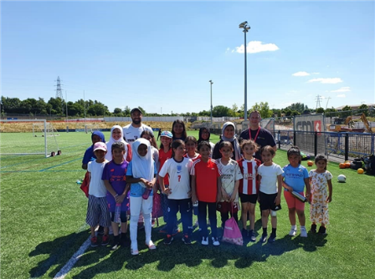
The first face-to-face meeting of the AFSA North Group was held at Cheshire Fire and Rescue Service (FRS) where we shared our EDI work.

We also joined the South Yorkshire LGBT+ Network Inclusion Meeting with SAYiT and set up a group for sharing resources. The Fire Cadets attended a talk from the Refugee Council and there will be some ongoing engagement in this area.

August 2021
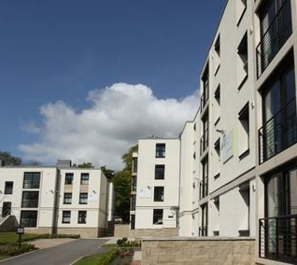
This month saw the launch of our online EDI Calendar which includes a range of events and celebrations, including International Day for the Remembrance of the Slave Trade and its Abolition with an educational piece in the Bulletin including reference to South Yorkshire.

We also visited accommodation at the University of Sheffield used to temporarily house Asylum Seekers. We provided safety guides in Arabic and Farsi. This was also an opportunity to discuss positive action and volunteering opportunities.

The Diversity in the Community Handbook was updated with the latest SYFR branding applied and an additional section on Armed Forces to support our commitment to the Armed Forces Covenant.

We delivered EDI induction training to new Firefighter Transfers at the Training and Development Centre (TDC), started to attend BFS management meetings and joined Sheffield City Council’s Black History Month planning meeting

September 2021
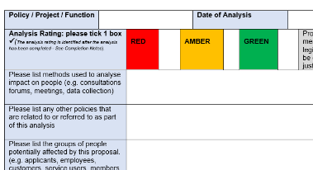
The NFCC EqIA Template was distributed in Community Safety (CS) to support the updates to the policy.

The Jewish festivals of Rosh Hashanah and Yom Kippur were highlighted in the Bulletin and a feature on World Afro Day was also published, highlighting the hair discrimination often encountered by Black people.
We worked with our Race Staff Network to look at the proposal for us to sign up to the Halo Code to show that we champion the right of staff to embrace all Afro-hairstyles.

Engagement with Zest Community in Sheffield continued with a session covering Community Fire Safety as well as an overview all the different career opportunities with FRS.

October 2021

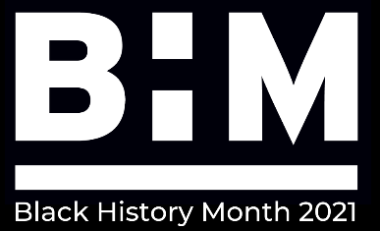
October is Black History Month (BHM) and we held a month of education and celebration. Profiles of ground-breaking black firefighters were shared in the Bulletin, alongside some local history and event promotion. In collaboration with Cheshire FRS we compiled a list of webinars related to the month and encouraged all staff to spend at least one hour on BHM related activity.

We worked with other departments to support Prevention and Protection initiatives at Skyline Flats in Barnsley. This included providing translated fire safety resources, engagement with a local Romanian church and signing up stakeholders to make Safe & Well referrals. We also attended a session held by Migration Yorkshire focussing on the migrant situation in Barnsley.

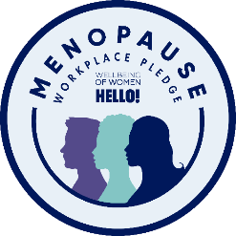
A menopause awareness day was held at Lifewise where we provided information packs and shared guidance with SYP. As part of the awareness day we signed up to the Wellbeing of Women Workplace Pledge and are now listed as an organisation that recognises and supports issues around menopause.

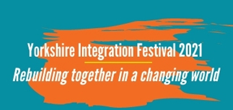
November 2021
Migration Yorkshire held a day of celebrating the inclusion, diversity and contribution of people who have come to our region from across the world. The Integration Festival was about bringing people together, experiencing, learning, sharing; and further improving and planning integration in our region and beyond. Subjects discussed included reflections on settling in Yorkshire, responding to the Afghan crisis and the future of refugee integration in our region.

We supported our continuing engagement with Mears, and our Doncaster Watch Manager (WM) attended Doncaster International Hotel which is now being used to accommodate asylum seekers.

The AFSA Winter Conference was held in Liverpool, hosted by Merseyside FRS. This two day conference was packed with speakers, workshops and networking opportunities. Topics included EDI practices, structural racism, health inequalities, neurodiversity and anti-racism, with a more community-based focus on day two.

December 2021

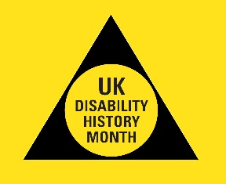
Information about Disability History Month was shared within the organisation along with education around the 2021 themes.

We collaborated with East Sussex FRS to review guidance on fire safety advice for autistic children and adults.

We attended an online Disability Summit hosted by AFSA covering workplace disability and inclusive employment, with particular emphasis on hidden impairments.

EDI training was delivered to both Volunteers and new BFS Officers at TDC and we continued with our delivery at Zest Community in Sheffield on their Zest4Life programme.

January 2022

Our new EDI Support Officer joined us in January 2022, providing much needed resources and skills to the team.

Worked continued to increase the attendance at all staff groups, with a refresh of the groups. Many of the groups now have increased engagement and impact on the whole organisation.

EDI induction training was delivered to our 68th firefighter recruits at TDC and work started on a new EDI Handbook to supplement all induction training.

Our pictorial Home Fire Safety Guide was delivered and distributed and our refreshed Diversity in the Community Handbooks were condensed into a one-page infographic outlining information about specific communities and risks.
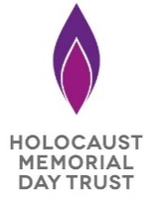
SYFR featured in the UK Holocaust Memorial Day ceremony with firefighters filmed in conversation with a survivor of the Rwandan genocide.

We took part in NFCC consultations on Gender Diversity and Neurodiversity and attended Cheshire FRS’s ‘Proud to Provide’ conference.

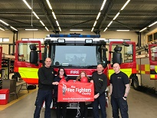
Despite the impact of COVID-19 on our cadet sessions, 22 Cadets from across our 7 branches were awarded a B Tech level 2 qualification, this was celebrated with a presentation day at TDC. Also in Jan 22 Two Cadets were nominated to attend the South Yorkshire Legal Service at Sheffield Cathedral, held on 20 March in their new uniform.

February 2022

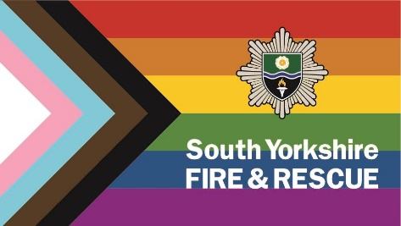
February marked LGBT+ History Month, we flew the Progress Pride flag on SYFR buildings to show support and promote inclusive recruitment. We published a series of articles internally via the Bulletin to help educate and upskill our staff, covering national and local LGBT+ history, including a piece on the Rainbow Flag written by a member of Operational staff.

Our EDI team worked with our Corporate Communications team to create a series of four LGBT+ History Month TikToks. These were hugely successful and collectively gathered a total of 840,000 views, 141,000 likes and 3,700 comments; “As someone living in South Yorkshire and LGBT+, thank you”, “As a future firefighter, this is the kind of thing I love to see” and “I passed a fire station and saw that (progress pride) flag flying – it brightened my day”. This campaign successfully engaged with the community, showing that the fire service is a place for all and that everyone is included and welcomed when accessing its services.

Planning started for ‘Likkle Jamaica’ – a celebration involving partners from our African and West Indian communities.

Our Fire Cadet Enrolment forms were updated with more inclusive language and the option for Cadets to provide more information about themselves. An EA was also completed for the Cadets as well as for the Prevention Strategy, Hearing Impairment Policy, and the Barnsley Community Building.
We represented SYFR at the Barnsley Homeless Alliance conference, as well as attending workshops on older isolated Minority Ethnic people in Sheffield with Sheffield Churches Council for Community Care (SCCCC), and Trauma Informed Working with the South Yorkshire Violence Reduction Unit.

March 2022

The month began with Shrove Tuesday and the start of Lent, which was an opportunity for safety messages around cooking as well as education about these festivals in the Bulletin.
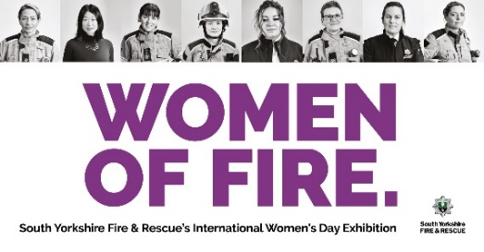
We celebrated International Women’s Day, which included a new exhibition featuring portraits of women currently working within the service. We attended the ‘Making a Cultural Difference’ event hosted by AFSA and Staffordshire FRS.

Working in partnership with the NFCC we created a new EqIA initial screening tool, which will be incorporated into the full EA guidance. Other NFCC projects include the new FRS Core Code of Conduct.

Education was published around the International Day for the Elimination of Racial Discrimination, and webinars for Neurodiversity Celebration Week were promoted.

Some joint work with the council in the Roma Slovak communities in Page Hall began, and some positive action took place at the Sheffield College Fir Vale Campus, which specialises in English for Speakers of Other Languages (ESOL).

The HSC feedback survey was made more accessible and was updated to reflect current terminology.

We attended the Doncaster Chambers Careers event, alongside a crew and appliance. We had a stall in both the Primary and Secondary School sections. Hundreds of Primary and Secondary school students attended throughout the day, learning more about their future careers in the fire service.

EDI, Human Resources (HR) and staff groups worked together to update language and terminology used in our new starter form. This is to ensure we are inclusive of all and the first experience of new starters with our organisation is a positive one.

IN SUMMARY

We hope this EDI Annual Report has shown you we are continuously working hard across the organisation to create a welcoming and inclusive environment for everyone. In addition to complying with our statutory obligations, the evidence listed above highlights how we have invested time and dedication to several initiatives and activities to increase diversity, inclusion and belonging in the organisation.

This work will continue to progress, reviewing our progress and our achievements will be shared annually in this report.

If you have any question or queries regarding this report, or feel anything should be added in the years to come please get in touch with the EDI Team.

