Equality Diversity & Inclusion Strategy – Interim arrangements for the remainder of 2022

Introduction
Our EDI Strategy for 2019-2022 set out our plans to embed EDI into everything we do for the staff working for us and for the communities we serve across South Yorkshire; stating our understanding that the principles of EDI are integral to keeping our communities safer and stronger.
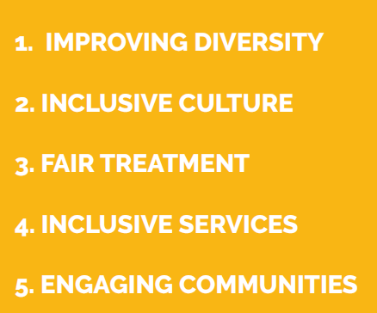
This strategy has been supported by an action plan against our 5 objectives, and is regularly updated and monitored.

This interim strategy for 2022 allows us to reaffirm our focus on EDI whilst affording us the opportunity to carry out meaningful consultation across the organisation, plan our EDI work for the coming years; as well as aligning our new strategy to documents such as our Annual Plan, People Strategy, CRMP, Fit for the Future, the Core Code of Ethics, the pending White Paper and the refreshed ‘Our Story’. Consideration will also be given to how we can incorporate recommendations from wider sectors such as the recommendations from the Commission on Race and Ethnic Disparities (CRED) Report around advancing fairness in the workplace.
This consultation will include a review of our objectives and our action plan to ensure we are putting our efforts into the right areas, together with a self-assessment using the NFCC’s maturity model, which will enable us to understand our current level of maturity in relation to EDI. Considerations will also be given on how we consult with the South Yorkshire community.

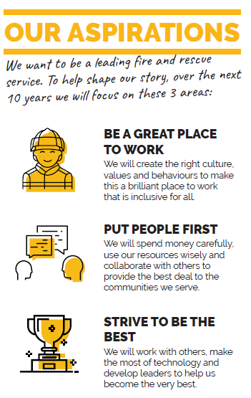
Our Aspirations
Our aspirations are shown in the diagram here, to help us achieve our aspirations, we are working on a communications plan to support understanding of EDI across the organisation, an EDI toolkit, guidance on having EDI conversations and incorporating EDI objectives into our Personal Review process.

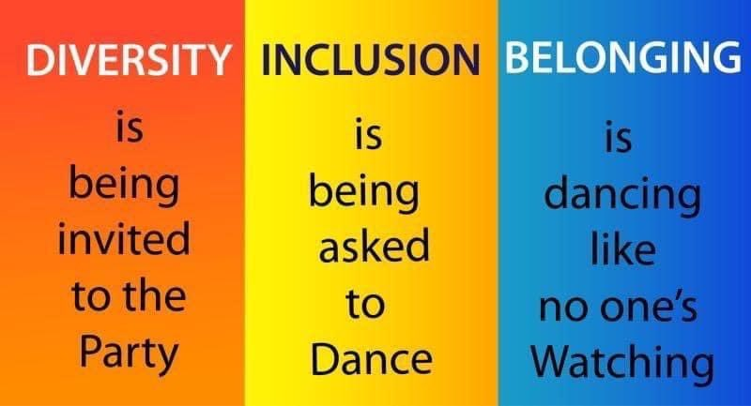
Interdependencies
There are a number of interdependencies currently that offer us the opportunity to ensure EDI is at the heart of everything we do; this includes a number of projects have either begun or are being established which cover the areas of:-
- leadership and development
- progression
- attraction and recruitment
- community safety

Our EDI Governance Structure
We have recently reviewed and updated our meeting and decision making structures, to make it clearer to staff how and where decisions are made.
Our Equality, Diversity & Inclusion Committee is chaired by the Head of Human Resources and reports directly to the People Board, chaired by the Deputy Chief Fire Officer. The role of the committee is to report progress against the service’s EDI action plan, recruitment and retention of staff and matters arising from staff group meetings.
EDI themes are also prioritised at all of the other committees and boards which form part of our decision making structures. This reflects our position to fully embed EDI throughout our culture; it should be considered across service areas - not simply treated as a standalone topic or function area responsibility.

APPENDIX 1 - ANNUAL EDI OBJECTIVES 2022
The table below details the our goals and objectives for the remainder of 2022.This work will be supported by the action plan below;
OBJECTIVE | DESCRIPTION | EDI GOALS
IMPROVING DIVERSITY | Recruit, develop, support and retain a workforce which reflects the diversity of the communities we serve. | - Develop a diverse and representative workforce  - Retain and value a diverse workforce  - Be viewed as an employer of choice
INCLUSIVE CULTURE | Build an organisational culture that recognises, champions and celebrates EDI in everything it does. Create an inclusive working environment which allows people to be themselves at work. | - Create a culture where EDI is at the heart of everything we do  - Provide education to explain what equality, diversity & inclusion mean  - Recognise and share the benefits of a diverse and inclusive workforce
FAIR TREATMENT | Commit to preventing discrimination and promoting equality of opportunity and fair treatment in our employment practices and the way we delivery our services. | - Review all our HR policies to ensure they are accessible  - Provide education around the types of protection provided by the Equality Act 2010
INCLUSIVE SERVICES | Provide inclusive and culturally appropriate services.  Aim to ensure we understand the needs of our communities and the barriers they may face in accessing our services.  Ensure our services are accessible and delivered without discrimination or exclusion. | - Utilise the NFCC’s maturity model self-assessment tool to understand our current offer and measure our ambitions  - Provide services that are accessible and cater for everyone  - Identify gaps in community partnerships
ENGAGING COMMUNITIES | Continue to develop awareness of how to effectively engage with and understand our communities’ needs, to ensure our services reach all communities. | - Provide education around how we can engage appropriately with all our communities  - Actively engage with communities in a variety of ways and share good practice across the service

OBJECTIVE | EDI GOAL | EDI ACTION – 2022 - 2023 | LEAD | WHEN
IMPROVING DIVERSITY | Develop a diverse and representative workforce. | Monitor and improve the representation across the workforce. | HR – EDI & DATA TEAM | Annually
 | Retain and value a diverse workforce. | Monitor and improve retention from underrepresented groups across the workforce. | HR – EDI & DATA TEAM | Annually
 | Be viewed as an employer of choice. | Review how attractive we are to applicants from underrepresented groups and identify relevant actions to improve. | HR | June 2023
INCLUSIVE CULTURE | Create a culture where EDI is at the heart of everything we do. | Review our Personal Review system to incorporate an EDI discussion and at least one objective for all employees. | HR - OD | August 2022
 | Provide education to explain what equality, diversity & inclusion mean. | Update the terminology used across all HR platforms.  Work with Corporate Communications to begin conversations around “What EDI means to me”. | HR - ER  HR – EDI & CC | December 2022  July 2022
FAIR T  REATMENT | Review all our HR policies to ensure they are accessible. | Ensure our policies are reviewed and appropriate consultation is carried out. | HR – EDI | Annually
 | Provide education around the types of protection provided by the Equality Act 2010. | Work with staff groups to agree the areas of education to focus on.  Review our initial training package to determine future areas of training required.  Monitor the completion rates for EDI LearnPro & one day external course | HR & STAFF GROUPS  HR | September 2022  September  2022  Quarterly
INCLUSIE SERVICES | Provide services that are accessible and cater for everyone. | Utilise the NFCC’s maturity model self-assessment tool. | HR – EDI | July 2022
 |  | Utilise data to target the most in need of our services. | Community Safety | September 2022
 |  | Support the awareness and understanding of our family friendly policies across the organisation. | HR - ER | Quarterly
ENGAGING COMMUNITIES | Provide education around how we can engage appropriately with all our communities. | Update Community Handbook and communicate across the organisation. | Community Safety | September 2022

