Role Profile | Lifewise Support Volunteer | 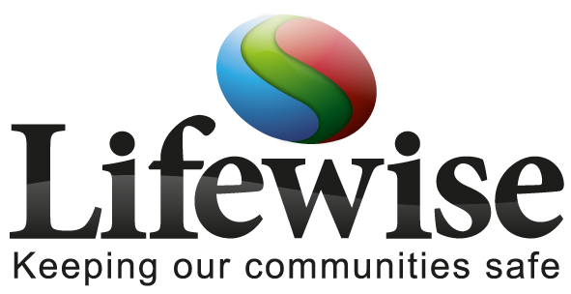
Have you got the time and energy for this active and rewarding role ? We are looking for volunteers to meet, greet and look after visitors to the Lifewise Centre. Those of you that have the confidence will be given the opportunity to undertake some role play activities during some of the scenarios, however this is not mandatory and only for those that wish to expand their skills.

The Lifewise Centre is a multiagency approach to delivering education, prevention, intervention and in some cases rehabilitation to communities across South Yorkshire and beyond. The partnership of South Yorkshire Police, South Yorkshire Fire & Rescue, the NHS as well as many other organizations are working to develop and deliver key messages in relation to safety, crime prevention and wellbeing.

The role
As a volunteer you will engage with various agencies, together with school groups and other groups to enable the smooth running of events at the Centre. You will provide general assistance relating to the arrival of school groups, and other visitors, hospitality provision and act as a general point of contact whilst the events are taking place. You may be required to help get the sets ready for the arrival of our audiences and to clear away afterwards. You may also be asked to chaperone groups as they move around the centre. This is a new and exciting volunteer role which we hope will develop further in time.

Skills and experience required for the role
- Good Communication Skills
- Good interpersonal skills
- Enthusiastic
- Ability to work in a small team and individually
- Health and safety awareness

Times you can volunteer
Monday - Saturday
Between the hours of 8:00am and 9pm

Interested?

If you would like more information and an application form please email SYPVolunteers@southyorks.pnn.police.uk telephone 01709 832353 asking for the Police Support Volunteer Project Officer

Please note that all successful candidates will be subject to the SYP vetting process.

