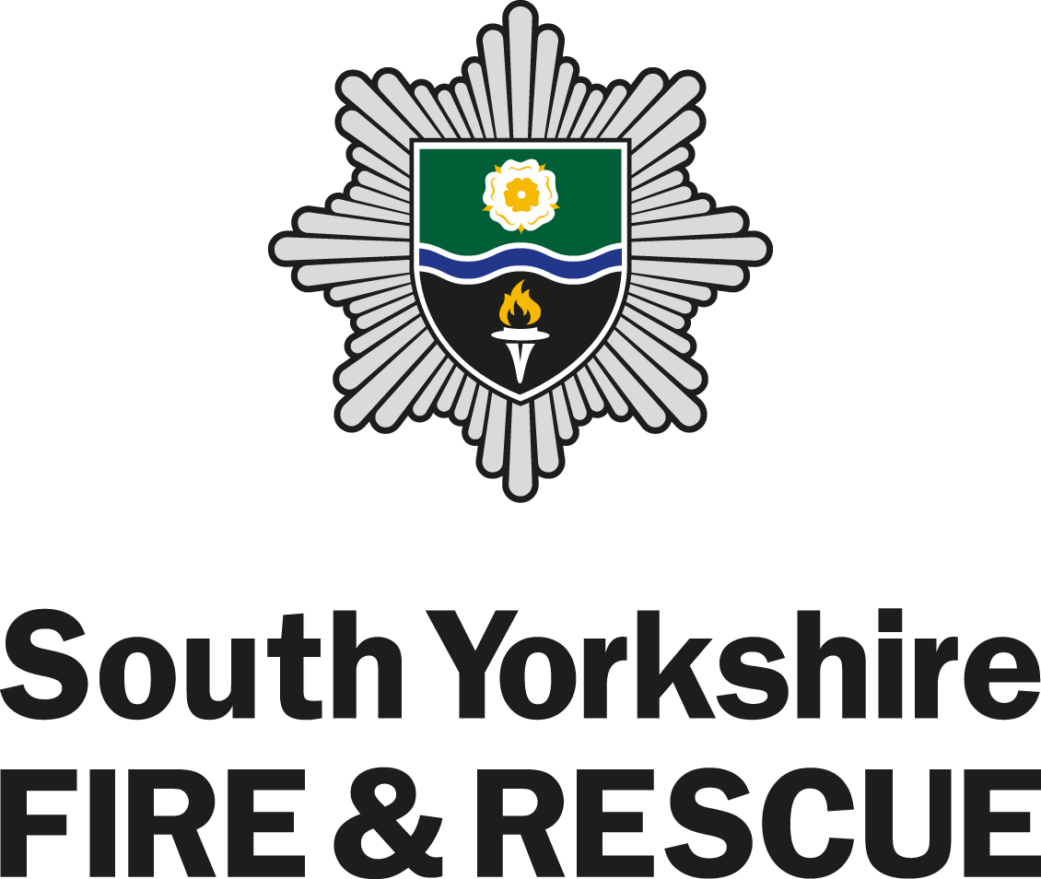

On-Call Firefighter
Information Pack
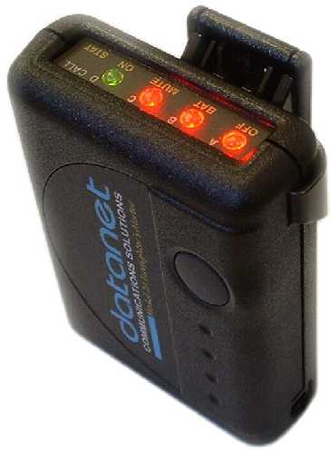

CONTENTS

INTRODUCTION 1
What is an On-Call Firefighter? 1
How does it work? 1
Could I be an On-Call Firefighter? 1
How do I know if I can apply to become an On-Call Firefighter? 1
What will be expected from me as an On-Call Firefighter? 2
What is the response time? 2
What does ‘availability’ mean? 2
What you can expect from us: 3
What payments will I receive? 3
RECRUITMENT STAGES 4
Stage 1 – Pre-Checklist 4
Stage 2 – Psychometric Test 4
Stage 3 – Declaration of Criminal Convictions & Fitness Declaration and Consent 5
Stage 4 – Practical Selection Tests 5
Stage 5 – Interview 6
Stage 6 – Swimming Test 6
Stage 7 – Medical, References, Employment Checks, Basic Disclosure & Kit Measurements 6
Stage 8 – Kitting out and Bleep Test 7
TRAINING COURSE 8
TIMELINE 8
ADDITIONAL INFORMATION 8
Employer Notification 8
Driving and the EC Drivers Hours and Tachograph Rules for Goods Vehicles 9

INTRODUCTION

What is an On-Call Firefighter?

An ‘On-Call’ Firefighter with South Yorkshire Fire & Rescue (SYFR) responds to the same fire and emergency calls using the same fire engines and equipment as a full-time Firefighter. The only difference is that On-Call Firefighters are on-call at home or at work rather than permanently based at a fire station.

Also known as a Retained Firefighter or RDS Firefighter (Retained Duty System), the role offers flexible working hours and may suit people with childcare commitments and other responsibilities.

As an On-Call Firefighter you would be paid a retaining fee along with an additional payment for every incident you attend. You would also be required to attend for training each week for which a payment is also made.

How does it work?

When an emergency call comes into Control, a message is sent to you via an alerter. Once your alerter is activated you have to reach the Retained Duty System (RDS) station within five minutes. You can travel by foot, car or bike but you must travel safely and at normal road speeds.

Being an On-Call Firefighter is like having a part-time job; you commit to certain hours and you get paid for them.

Could I be an On-Call Firefighter?

As an Equal Opportunities employer; we actively encourage interest from all sections of the community and positively welcome applications from women, people with disabilities and members of black and ethnic minority groups who are currently under-represented in our workforce.

SYFR currently has On-Call Firefighters from a wide range of backgrounds and employment situations, including self-employed people, people with jobs at local businesses and people who are on-call during daytime hours while their children are at school.

SYFR has On-Call Firefighters at the following stations:

- Askern
- Birley
- Cudworth
- Dearne
- Penistone
- Rossington
- Stocksbridge

You should refer to our website http://www.syfire.gov.uk/jobs/ for details about our current vacancies and availability requirements.

How do I know if I can apply to become an On-Call Firefighter?

To be considered for an On-Call Firefighter position, you must:
- be able to reach the RDS fire station within a five minute response time travelling at normal road speeds (see ‘what is the response time’)
- be 18 years of age by the time your training course starts
- be fit enough to pass the physical selection tests and medical examination which includes substance misuse testing
- demonstrate reading, writing and arithmetic at Key / Functional Skills Level III
- be eligible to work in the United Kingdom, proof of this will be taken at the medical stage of the selection process

What will be expected from me as an On-Call Firefighter?

- to provide an agreed level of availability (see ‘what does availability mean’)
- to respond to all emergency calls whilst on call within five minutes (see ‘what is the response time’)
- to attend the fire station for weekly drill nights
- to carry out maintenance of equipment and appliances
- to maintain an appropriate level of physical fitness
- to maintain competency through attending training sessions
- to undertake a development programme to demonstrate competence in the role of a Firefighter

What is the response time?

When you are on-call (available to respond to emergency calls) you must be able to reach the RDS fire station and be in a position to turn out on the appliance, in full fire kit, within five minutes of your alerter sounding. The five minute response time is applicable for responding from home, work or from any other location during the period that you are on-call for.

What does ‘availability’ mean?

You will be required to state the times around your current commitments that you would be ‘available’ to respond to emergency calls. When determining your hours of availability you need to think carefully about your individual situation and the hours that you are able to commit. This can include periods of time that you are at rest or times when you are out and about (within five minutes of the RDS fire station) not just when you are sat at home.

Your availability needs to be realistically based around your own commitments and you must ensure that you get sufficient rest periods under current legislation (Working Time Directive).

An example of how this might work is shown below:

You drop your children off at school and at 08:45 and pick them up again at 15:00 Monday to Friday, therefore your availability might be:

 | 00 01 | 01 02 | 02 03 | 03 04 | 04 05 | 05 06 | 06 07 | 07 08 | 08 09 | 09 10 | 10 11 | 11 12 | 12 13 | 13 14 | 14 15 | 15 16 | 16 17 | 17 18 | 18 19 | 19 20 | 20 21 | 21 22 | 22 23 | 23 24 | Total
M |  |  |  |  |  |  |  |  |  | 1 | 1 | 1 | 1 | 1 |  |  |  |  | 1 | 1 | 1 | 1 | 1 | 1 | 11
T |  |  |  |  |  |  |  |  |  | 1 | 1 | 1 | 1 | 1 |  |  |  |  | 1 | 1 | 1 | 1 | 1 | 1 | 11
W |  |  |  |  |  |  |  |  |  | 1 | 1 | 1 | 1 | 1 |  |  |  |  | 1 | 1 | 1 | 1 | 1 | 1 | 11
T |  |  |  |  |  |  |  |  |  | 1 | 1 | 1 | 1 | 1 |  |  |  |  | 1 | 1 | 1 | 1 | 1 | 1 | 11
F |  |  |  |  |  |  |  |  |  | 1 | 1 | 1 | 1 | 1 |  |  |  |  | 1 | 1 | 1 | 1 | 1 | 1 | 11
S |  |  |  |  |  | 1 | 1 | 1 | 1 | 1 | 1 | 1 | 1 | 1 | 1 | 1 | 1 | 1 | 1 | 1 | 1 | 1 | 1 | 1 | 19
S |  |  |  |  |  | 1 | 1 | 1 | 1 | 1 | 1 | 1 | 1 | 1 | 1 | 1 | 1 | 1 | 1 | 1 | 1 | 1 | 1 | 1 | 19
 |  |  |  |  |  |  |  |  |  |  |  |  |  |  |  |  |  |  |  |  |  |  |  |  | 93

What you can expect from us:

- a wide range of specialist and general training opportunities
- personal development including attending training and taking role specific qualifications
- payment for the hours of availability you give, for call outs and for other duties carried out on station
- the opportunity to join a final salary pension scheme

Career Opportunities
SYFR is committed to the continued development of all staff; career progression is dependent upon you demonstrating your competence with our development programme. In addition to the development opportunities on offer, prior learning and previous qualifications are acknowledged, therefore, existing skills and experience will be evaluated and taken into consideration as part of your future career development.

Pension
On appointment to the Fire Service you will be automatically enrolled into the Firefighters Pension Scheme 2015.

Annual Leave
You will get four weeks annual leave, rising to five weeks after five complete years of service.

What payments will I receive?

Retainer Fee
An On-Call Firefighter receives an annual retainer fee. The amount depends on the availability provided. Currently if you provide cover for 120 hours or more per week you will receive 100% of the retainer fee, and if you provide cover for 119 hours or less per week you will receive 75%.

Disturbance Fee
You are entitled to an attendance fee if you attend the fire station in response to your alerter but are not required to ride as a crew member.

Work activity
When you form part of the crew attending an emergency incident you will be paid in accordance with the relevant hourly rate. You will also receive payment at the appropriate hourly rate for:

- attending our trainee course
- when you attend for training
- when carrying out standard tests
- maintenance of equipment and station
- attending fetes and galas

The current levels of payment are shown below (correct as at December 2015):

 | £ per annum  for 100% availability | £ per annum  for 75% availability | £ hourly rate | £ Disturbance fee
Trainee | Trainee | 2,202 | 1,101 | 10.05
Development | Development | 2,293 | 1,147 | 10.47
Competent | Competent | 2,935 | 1,467 | 13.40

You will be paid at trainee rate when attending the trainee course, once you have completed the required training you will be paid at development rate. On completion of your development programme (when you have been deemed competent in role) you will be paid at the competent rate of pay.

RECRUITMENT STAGES

To become an On-Call Firefighter you are required to undertake a series of tests designed to assess your suitability for the role.

The first step is to register your interest via our website at http://www.syfire.gov.uk/jobs/.

When the next recruitment process begins we will then contact you and ask you to complete a basic application form to provide details of your availability so we can determine your fit against our current vacancies. The form will also ask you provide basic personal information, details of your work history, education and qualifications and references.

If we have vacancies that could suit your availability, you will be invited to progress to the selection tests to assess your suitability for the Firefighter role. The first two stages are designed to make an initial assessment of your potential to work as a Firefighter using a range of specifically designed questions which examine the qualities and basic knowledge you need for the role.

Stage 1 – Pre-Checklist

Being a firefighter is challenging and can involve a number of situations not commonly found in other jobs. This checklist will help you decide whether you are likely to enjoy working as a firefighter and whether you are eligible to apply.

Stage 2 – Psychometric Test

The purpose of this stage is to examine key qualities you need to work in the role of a firefighter. These assessments are designed to give all candidates a fair chance to show that they have the skills, abilities and personal qualities important for success as a firefighter.

The psychometric tests include multiple choice ability tests. These tests relate to the role of a Firefighter and assess your ability to work with numbers, solve problems as well as verbal and risk assessments.

Situational Judgment Test | In this test you will be presented with the type of situations you could face in the role of a Firefighter and will be asked how you think you should react to each situation. This is not a timed test but should take between 20 and 30 minutes.
Verbal Assessment | This test is designed to measure your ability to interpret and make sense of written information. This is a timed test and you will have 12 minutes to complete the questions.
Numerical Reasoning | Firefighters need to be able to make basic mathematical calculations. You will be presented with a number of scenarios that will show numerical information in a variety of formats from tables to graphs. This is a timed test and you will have 15 minutes to complete the questions.
Risk Assessment | This test is designed to assess how you judge a situation and whether you can recognize the degree of risk associated with the various response options. This is not a timed test but should take up to 15 minutes to complete.

Before undertaking the psychometric tests you will be asked if you require reasonable adjustments to complete the timed tests, for example if you are dyslexic. If the answer to this question is yes you will be prompted to contact us with information of the adjustments you require and if applicable, a copy of your dyslexia report.

Stage 3 – Declaration of Criminal Convictions & Fitness Declaration and Consent

Once you have successfully passed the initial sift you will be required to complete:

- A declaration of any unspent criminal convictions and a medical questionnaire.

Under the Rehabilitation of Offenders Act 1974 you are obliged to declare any unspent convictions or criminal proceedings pending as these may bar you from working as a Firefighter. This will be checked before an offer of employment is made. Failure to declare any unspent conviction(s) will result in your application being withdrawn.

- A Fitness Declaration and Consent Form. This will be kept confidential and reviewed by our Occupational Health team who will contact you, if required, to discuss any issues or concerns ahead of the Practical Testing.

Stage 4 – Practical Selection Tests

These job-related assessments consist of seven different tests which will assess your fitness and practical ability to handle fire service equipment. The tests are designed to simulate the tasks carried out in the training course and then in the role of Firefighter.

Bleep Test | You must achieve a minimum level of 8.7 to demonstrate your physical fitness.
Ladder Climb | This is a physical test of confidence and the ability to follow instructions. You will ascend a 13.5 metre (45 foot) fire service ladder to a point two thirds of the full working height, take a leg lock and remove your hands from the ladder and look down to the assessor to identify a symbol placed flat on the ground at the foot of the ladder. You will be assisted if necessary by the safety officer.
Casualty Evacuation | This is a physical test of upper and lower body strength and co-ordination. Guided by a safety officer, you will drag backwards a 55kg (approx. 8½ stone) dummy along a distance of 30 metres (100 foot) around four cones within a set amount of time
Ladder Lift | This is a test of upper and lower body strength and co-ordination. You will raise the bar of a ladder lift simulator to a height of 190cm (6 foot) with 15 kg of weight placed on the simulator cradle, giving a total lift load of 24 kg (approx. 3½ stone). You will be assisted if necessary by the safety officer.
Enclosed Space | This is a test of confidence, agility and identification of claustrophobic tendencies. Wearing a breathing apparatus facemask, you will negotiate a crawl and walkway with clear vision. You will then retrace your steps wearing a mask that obscures your vision. This is a timed exercise. You will be assisted if necessary by the safety officer.
Equipment Assembly | This is a test of manual dexterity. You must assemble and then disassemble a piece of equipment following a demonstration by the safety officer.
Equipment Carry | This is a test of aerobic fitness, stamina, upper and lower body strength and co-ordination. You will need to carry items of equipment a distance of 25 metres (82 foot) around two cones within a given amount of time.

Full instruction is given on the day and you will be given protective clothing to wear.

Further information regarding general exercise, aerobic training and strength training is available on our website.

Stage 5 – Interview

This will be your opportunity to show to the interview panel how your skills and attributes contribute to your suitability for the role of a Firefighter. As part of this you will be asked to prepare and deliver a short presentation/briefing on a topic relevant to our fire service.

The Interview is the final stage of the competitive selection process. Candidates will be selected for employment subject to a satisfactory swimming test, medical, references, employment checks and basic disclosure.

GP medical questionnaires and references from previous employers will be requested at this point.

Stage 6 – Swimming Test

You will need to demonstrate the following at a local swimming pool:
- Jump/dive into deep water
- Swim 50 metres continuously on front and back in deep water
- Tread water for 30 seconds
- Surface dive to the floor of the pool (3 metre depth)
- Climb out unaided without ladder/steps and where the pool design permits

Stage 7 – Medical, References, Employment Checks, Basic Disclosure & Kit Measurements

Medical
The medical appointment at our headquarters will incorporate:

- A review of your medical questionnaire (obtained from your GP and if relevant other organizations e.g. the Armed Forces and Sports Clubs)
- An examination with our medical officer who will assess your fitness for the role This will include further medical testing should any medical problems be detected
- A series of screening tests with our occupational health nurse including:
  - Hearing test
  - Lung function
  - Blood pressure
  - Vision
  - Weight and height
  - Substance misuse and alcohol testing
- A comprehensive eyesight test carried out by a qualified optometrist

Further information on the medical specifics can be found in our Frequently Asked Questions on our website.

References
References will be sent for you, prior to your medical. You will need to supply details of your current and previous employer(s) for references to be obtained.

Employment Checks
- Proof of residence – to verify that you reside within our service boundary (South Yorkshire) you will be required to bring to your medical relevant documents, dated within the last 3 months, to confirm your address e.g. a utility bill or bank statement.

- Eligibility to work in UK – in line with section 8 of the Asylum and Immigration Act 1996 all employers in the UK have to make basic checks on everyone they employ. Therefore you will be required to bring to your medical relevant documents to confirm your eligibility to work in the UK, such as a passport.

Basic Disclosure
You will need to complete a basic disclosure online. A basic disclosure certificate will inform us of any unspent convictions. Please note, it is your responsibility to be sure of the status of any prior conviction(s). If your disclosure certificate highlights any conviction(s) that you have not declared to us your application will be withdrawn.

Please be aware that some of our Firefighters carry out activities for which an enhanced Disclosure and Barring Service (DBS) check (previously CRB) is required e.g. fire cadet instructing. You could therefore be required to complete an enhanced DBS check at a later stage in your employment.

Kit Measurements
You will need to provide your measurements to enable us to order your uniform and fire kit.

Subject to selected candidates satisfactorily completing all of the above, formal offers of employment will be made.

Stage 8 – Kitting out and Bleep Test

An appointment will be made you to collect your uniform and Fire Kit.

At this stage, you will also be required to undertake the bleep test again to demonstrate you have maintained the required fitness levels. Please note that failure to undertake the bleep test and/or meet the required level of fitness, level 8.7, will result in you being unable to continue to the training course and your offer of employment will be withdrawn/contract terminated.

TRAINING COURSE

Once a formal offer of employment has been offered and accepted, you will be invited to attend an induction followed by the first two weeks of the intensive Initial Training Course (ITC).

The first week of training will include work with pumps and ladders and the second week will be work with breathing apparatus - phase A. After the first two weeks of training you will be safe to ride an appliance but not wear breathing apparatus (BA). Within 6 months you will be required to undertake a further two weeks of training to complete breathing apparatus - phase B, after which you will be safe to wear BA.

The ITC is physically demanding and requires good levels of stamina and upper body strength. You must ensure you maintain the required fitness levels to safely participate in the ITC.

The ITC will be held at our Training and Development Centre (TDC) in Handsworth and due to the duration and intense nature of the training, the course is residential and on-site accommodation is provided.

You will be required to pass all elements of the training before joining your designated team on a fire station and working further to demonstrate your competence, eventually becoming a fully competent Firefighter.

Training will also be enhanced by regular drill nights and training sessions on station.

TIMELINE

Registrations of interest | TBC
Closing date for Applications | TBC
Pre-checklists and Psychometric Tests | TBC
Practical tests | TBC
Interviews | TBC
Swimming Assessment | TBC
Medical Examinations | TBC
Kitting Out | TBC
Fitness Confirmation (Bleep Test) | TBC
Induction | TBC
Initial Training Course (Part 1) | TBC
Initial Training Course (Part 2) | TBC

ADDITIONAL INFORMATION

Employer Notification

Applicants should inform their primary employer of their intention to join the Service. Employers should be informed of the positive elements to their organisation that an On-Call Firefighter can offer such as:

- increased knowledge of fire and safety matters
- specialist qualifications, e.g. first aid, LGV, BA, etc
- good publicity for the company
- a good standard of physical fitness
- the ability to work together well in team environments
- the ability to communicate fast and accurately
- the ability to take decisions under stress, to follow instructions and to be reliable

It is important, however, that the employer is also made aware of the following:

- The possibility of the On-call Firefighter being late for work due to being delayed on a call
- The time off required for the Initial Training Course

Driving and the EC Drivers Hours and Tachograph Rules for Goods Vehicles

The EC Drivers Hours & Tachograph Rules for Goods Vehicles came into effect in April 2007 and exist to ensure the health and safety of mobile workers and drivers of in scope vehicles.

The purpose of the rules is to limit driving time and ensure proper breaks and rest periods are taken so that road traffic collisions are prevented.

The rules apply to certain categories of mobile workers, the most common being drivers of Large Goods Vehicles (LGV) and Passenger Service Vehicles (PSV). These are called in scope vehicles.

The rules particularly apply to On-Call Firefighters as it will impact on the ability of candidates who drive an in scope vehicle during their primary employment to get appropriate rest periods, thus affecting their availability to provide On-Call Firefighter cover.

If you are unsure as to whether you drive an in scope vehicle, you should seek advice from the Vehicle and Operator Services Agency (VOSA).

