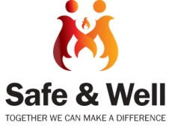
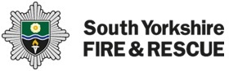
Professional Concern of Fire Safety Referral Form

Date of Referral:
Referrer Details
Safe & Well Code: |  |  | Organisation:
Name of referrer: |  |  |  |  | Job Title:
Telephone number: |  |  |  |  | Email:
Service User / Occupier Details
Name: |  |  |  |  |  |  |  | D.O.B
Address:
Post Code:
Contact Number(s):
Alternative Contact Number:
(e.g. Family member – please state name & relationship to tenant)
Number of people in household |  | Adults: |  |  |  |  | Children:
Risk Assessment |  |  |  |  |  |  |  |  |  | Yes |  | No
Is the household under threat of Arson or fire related crime?
Does the occupant have a cognitive or physical disability that may reduce their response to a smoke alarm and/or impede them exiting the property in the event of a fire?
Are there signs of hazardous smoking practices in the property such as burn marks on soft furnishings / clothes or overflowing ashtrays?
If the occupier is cooking for themselves, are there any safety concerns e.g. forgetfulness, use of hot oil, traditional chip pan, wok etc?
Is there evidence of substance misuse (drugs and/or alcohol)?
Does the occupant have a sensory impairment?
Does the occupier use or have access to medical oxygen or other flammables stored within the home?
Does the occupier exhibit hoarding behaviours or are there any safety concerns over housekeeping and/or blocked exits?
Has the occupier had a previous fire?
Are there working smoke alarms on each level of the property?
Are any occupants over 65?
Are there identifiable unsafe electrics in the property e.g. frayed wires, overloaded sockets, scorch marks etc?
If you have ticked ‘YES’ to any of the above, or you have further concerns relating to fire safety, please give further details on the next page.
Please tick to confirm that the Occupier has agreed to have details passed to SYFR:
All information recorded will be maintained in accordance with the Data Protection Act 1998
If you have ticked ‘YES’ to any of the above, or you have further concerns relating to fire safety, please give details below:

Please forward completed form to:
Email: cfsadmin@syfire.gov.uk
Fax: 0114 2532888
Post: Community Safety, South Yorkshire Fire & Rescue, 197 Eyre Street, Sheffield, S1 3FG
For contact by telephone please dial 0114 2532314.

DM# 404528

