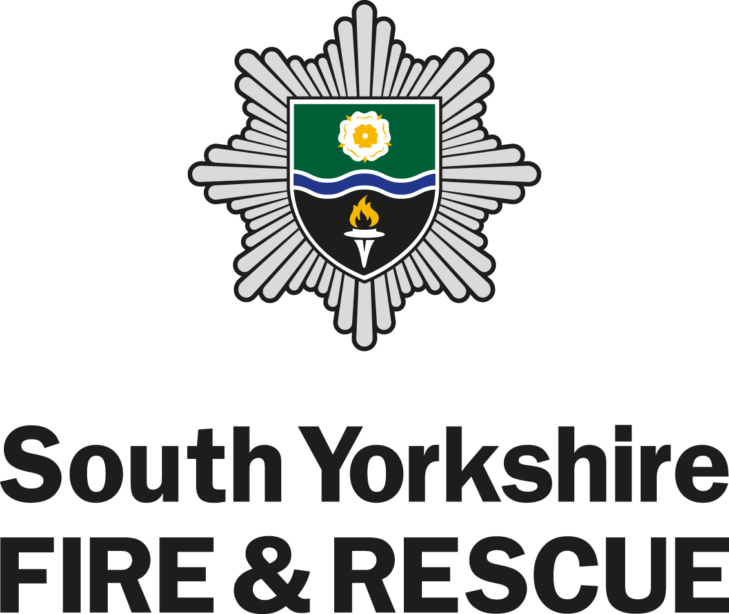

Wholetime Firefighter
Information Pack

CONTENTS
INTRODUCTION 1
The role of today’s Firefighter 1
What will be expected from me as a Firefighter? 1
What are the duties and responsibilities of a Firefighter? 1
Hours of Work 1
Could I be a Firefighter? 2
What you can expect from us 2
RECRUITMENT STAGES 3
Stage 1 – Pre-Checklist 3
Stage 2 – Psychometric Test 3
Stage 3 – Declaration of Criminal Convictions & Fitness Declaration and Consent 4
Stage 4 – Practical Selection Tests 4
Stage 5 – Interview 5
Stage 6 – Swimming Test 5
Stage 7 – Medical, References, Employment Checks, Basic Disclosure & Kit Measurements 6
Stage 8 – Kitting out and Bleep Test 7
TRAINING COURSE 7
TIMELINE 7

INTRODUCTION

The role of today’s Firefighter

What do you imagine when you think of a Firefighter?

The traditional image is perhaps of a Firefighter turning out in a fire engine with blue lights flashing and sirens wailing, heading to rescue people from a burning building.

Whilst this is still a small part of what we do, the demands of our fire service have changed considerably in recent times and the role and requirements of our Firefighters has changed too.

The types of emergencies we attend are more varied- road traffic collisions, people who are trapped, floods and storms, chemical spillages and the growing threat of terrorism are just some of what we are now trained to respond to. Thankfully, overall the number of incidents we attend is decreasing.

Our service is focusing more and more on prevention and protection work so that we can continue to reduce the number and impact of incidents in South Yorkshire. A major part of a Firefighter’s role is in contributing to this.

Our Firefighters spend a lot of their time out in the community delivering fire prevention advice and other safety messages. They visit people's homes and talk to people about how they can plan to avoid and survive a fire if it occurs. This involves conducting home fire safety checks and fitting smoke alarms.. They also deliver presentations and talks to school children, community groups and voluntary groups to educate and promote fire safety awareness.

South Yorkshire communities are diverse and we are working hard to meet their differing needs through the services we provide. Our Firefighters must be able to communicate effectively with varied individuals and groups- from older people, young adults and school children to religious groups and people from a variety of backgrounds and cultures. Treating people with dignity and respect is at the heart of what we do.

What will be expected from me as a Firefighter?

- to maintain an appropriate level of physical fitness
- to maintain the skills you need to do the job by attending training sessions
- to undertake a development programme to demonstrate competence in your role as a Firefighter

What are the duties and responsibilities of a Firefighter?

- Educate your community in how to stay safe
- Save and preserve lives in danger
- Take responsibility for effective performance
- Resolve emergency incidents as effectively as possible
- Protect the environment from the effects of hazardous materials
- Support the development of colleagues in the workplace
- Contribute to safety solutions to minimise risks to your community
- Drive, manoeuvre and redeploy fire service vehicles and equipment

Hours of Work

You will be required to work days, nights, evenings, weekends and public holidays. SYFR operate the following wholetime duty systems to meet the needs of our communities.

- 2-2-4 – employees working this system will work two day shifts (08:00-19:00) followed by 2 night shifts (19:00-08:00) followed by four days off (known as rota days).

- Close Proximity Crewing (CPC) – employees working this system participate in self-rostering and will work an eleven hour day shift (0800 – 1900 hours), being available on station or with the appliance for immediate mobilisation, followed by thirteen hours (1900 – 0800 hours) of close proximity “on-call” from the station (CPC night shift) during which time employees will be on ‘stand down’ from all duties except responding to operational incidents and operationally essential work. Employees must work a minimum of 13 shifts and a maximum of 17 shifts per month, equating to 182 shifts per year.

- Day Staffing (DS) – employees working this system work an average of 38.5 hours per week, typically working two day shifts (08:00-19:00) followed by two days off followed by three day shifts. The pattern is then reversed for the following week meaning employees only work alternate weekends.

You will be informed of your shift pattern upon appointment and will also be advised which station you will be initially based at following your training course.

Could I be a Firefighter?

As an Equal Opportunities employer; we actively encourage interest from all sections of the community and positively welcome applications from women, people with disabilities and members of black and minority ethnic groups who are currently under-represented in our workforce.

To be considered for a Wholetime Firefighter position in SYFR, you must:
- be eligible to work in the United Kingdom
- be 18 years of age by the time your training course starts
- live within our service boundary (South Yorkshire)
- have a basic swimming ability and water confidence which will enable you to operate safely in water rescue situations
- be physically fit to meet the requirements of the role and medical examination
- be able to demonstrate reading, writing and numerical skills to meet the requirements of the role
- You must also be committed to maintaining and developing new skills, and studying on top of your normal working days.

What you can expect from us

Being a Firefighter is an interesting, varied and fulfilling career. In addition to safety critical training we can offer a wide range of specialist and general training opportunities to contribute to your personal development and career aspirations.

Pay (as at December 2015)
Trainee £22,017 per annum
Development £22,933 per annum
Competent £29,345 per annum

You will be paid at trainee rate when attending the trainee course. Once you have completed the required training you will be paid at the development rate. When you’ve completed your development programme (when you have been deemed competent in role) you will be paid at the competent rate of pay.

Uniform
All new firefighters are issued with their uniform and kit before the initial training course starts.

Kit includes a 'working rig' uniform which is everyday dress and 'personal protective equipment' which is the full firefighting kit including helmet, boots and sports kit.

Leave
Annual leave comprises of 34 days per annum including public holidays and will be taken in accordance with whichever Duty System you are appointed to.

Career Progression
We are committed to the continued development of all staff. How you progress in your career is dependent on you showing your competence in the role as part of our development programme. As well as the development opportunities we offer, prior learning and previous qualifications and experience are also taken into account as part of your future career development.

Pension
On appointment to the Fire Service you will be automatically enrolled into the Firefighters Pension Scheme 2015.

RECRUITMENT STAGES

To become a Firefighter you will have to undertake a series of tests designed to assess your suitability for the role.

The first step is to register your interest via our website at http://www.syfire.gov.uk/jobs/.

When the next recruitment process begins we will then contact you and invite you to progress to the selection tests to assess your suitability for the Firefighter role. The first two stages are designed to make an initial assessment of your potential to work as a Firefighter using a range of specifically designed questions which examine the qualities and basic knowledge you need for the role. Firefighter recruitment is always a competitive process, with an extremely high number of applicants competing for a small number of roles, so we can only take the highest performing individuals at each part of the selection process on to the next stage.

Stage 1 – Pre-Checklist

Being a firefighter is challenging and can involve a number of situations not commonly found in other jobs. This checklist will help you decide whether you are likely to enjoy working as a firefighter and whether you are eligible to apply.

Stage 2 – Psychometric Test

The purpose of this stage is to examine key qualities you need to work in the role of a firefighter. These assessments are designed to give all candidates a fair chance to show that they have the skills, abilities and personal qualities important for success as a firefighter.

The psychometric tests include multiple choice ability tests. These tests relate to the role of a Firefighter and assess your ability to work with numbers, solve problems as well as verbal and risk assessments.

Situational Judgment Test | In this test you will be presented with the type of situations you could face in the role of a Firefighter and will be asked how you think you should react to each situation. This is not a timed test but should take between 20 and 30 minutes.
Verbal Assessment | This test is designed to measure your ability to interpret and make sense of written information. This is a timed test and you will have 12 minutes to complete the questions.
Numerical Reasoning | Firefighters need to be able to make basic mathematical calculations. You will be presented with a number of scenarios that will show numerical information in a variety of formats from tables to graphs. This is a timed test and you will have 15 minutes to complete the questions.
Risk Assessment | This test is designed to assess how you judge a situation and whether you can recognize the degree of risk associated with the various response options. This is not a timed test but should take up to 15 minutes to complete.

Before undertaking the psychometric tests you will be asked if you require reasonable adjustments to complete the timed tests, for example if you are dyslexic. If the answer to this question is yes you will be prompted to contact us with information of the adjustments you require and if applicable, a copy of your dyslexia report.

Stage 3 – Declaration of Criminal Convictions & Fitness Declaration and Consent

Once you have successfully passed the initial sift you will be required to complete:

- A declaration of any unspent criminal convictions and a medical questionnaire.

Under the Rehabilitation of Offenders Act 1974 you are obliged to declare any unspent convictions or criminal proceedings pending as these may bar you from working as a Firefighter. This will be checked before an offer of employment is made. Failure to declare any unspent conviction(s) will result in your application being withdrawn.

- A Fitness Declaration and Consent Form. This will be kept confidential and reviewed by our Occupational Health team who will contact you, if required, to discuss any issues or concerns ahead of the Practical Testing.

Stage 4 – Practical Selection Tests

These job-related assessments consist of seven different tests which will assess your fitness and practical ability to handle fire service equipment. The tests are designed to simulate the tasks carried out in the training course and then in the role of Firefighter.

Bleep Test | You must achieve a minimum level of 8.7 to demonstrate your physical fitness.
Ladder Climb | This is a physical test of confidence and the ability to follow instructions. You will ascend a 13.5 metre (45 foot) fire service ladder to a point two thirds of the full working height, take a leg lock and remove your hands from the ladder and look down to the assessor to identify a symbol placed flat on the ground at the foot of the ladder. You will be assisted if necessary by the safety officer.
Casualty Evacuation | This is a physical test of upper and lower body strength and co-ordination. Guided by a safety officer, you will drag backwards a 55kg (approx. 8½ stone) dummy along a distance of 30 metres (100 foot) around four cones within a set amount of time
Ladder Lift | This is a test of upper and lower body strength and co-ordination. You will raise the bar of a ladder lift simulator to a height of 190cm (6 foot) with 15 kg of weight placed on the simulator cradle, giving a total lift load of 24 kg (approx. 3½ stone). You will be assisted if necessary by the safety officer.
Enclosed Space | This is a test of confidence, agility and identification of claustrophobic tendencies. Wearing a breathing apparatus facemask, you will negotiate a crawl and walkway with clear vision. You will then retrace your steps wearing a mask that obscures your vision. This is a timed exercise. You will be assisted if necessary by the safety officer.
Equipment Assembly | This is a test of manual dexterity. You must assemble and then disassemble a piece of equipment following a demonstration by the safety officer.
Equipment Carry | This is a test of aerobic fitness, stamina, upper and lower body strength and co-ordination. You will need to carry items of equipment a distance of 25 metres (82 foot) around two cones within a given amount of time.

Full instruction is given on the day and you will be given protective clothing to wear.

Further information regarding general exercise, aerobic training and strength training is available on our website.

Stage 5 – Interview

This will be your opportunity to show to the interview panel how your skills and attributes contribute to your suitability for the role of a Firefighter. As part of this you will be asked to prepare and deliver a short presentation/briefing on a topic relevant to our fire service.

The Interview is the final stage of the competitive selection process. Candidates will be selected for employment subject to a satisfactory swimming test, medical, references, employment checks and basic disclosure.

GP medical questionnaires and references from previous employers will be requested at this point.

Stage 6 – Swimming Test

You will need to demonstrate the following at a local swimming pool:
- Jump/dive into deep water
- Swim 50 metres continuously on front and back in deep water
- Tread water for 30 seconds
- Surface dive to the floor of the pool (3 metre depth)
- Climb out unaided without ladder/steps and where the pool design permits

Stage 7 – Medical, References, Employment Checks, Basic Disclosure & Kit Measurements

Medical
The medical appointment at our headquarters will incorporate:

- A review of your medical questionnaire (obtained from your GP and if relevant other organizations e.g. the Armed Forces and Sports Clubs)
- An examination with our medical officer who will assess your fitness for the role This will include further medical testing should any medical problems be detected
- A series of screening tests with our occupational health nurse including:
  - Hearing test
  - Lung function
  - Blood pressure
  - Vision
  - Weight and height
  - Substance misuse and alcohol testing
- A comprehensive eyesight test carried out by a qualified optometrist

Further information on the medical specifics can be found in our Frequently Asked Questions on our website.

References
References will be sent for you, prior to your medical. You will need to supply details of your current and previous employer(s) for references to be obtained.

Employment Checks
- Proof of residence – to verify that you reside within our service boundary (South Yorkshire) you will be required to bring to your medical relevant documents, dated within the last 3 months, to confirm your address e.g. a utility bill or bank statement.

- Eligibility to work in UK – in line with section 8 of the Asylum and Immigration Act 1996 all employers in the UK have to make basic checks on everyone they employ. Therefore you will be required to bring to your medical relevant documents to confirm your eligibility to work in the UK, such as a passport.

Basic Disclosure
You will need to complete a basic disclosure online. A basic disclosure certificate will inform us of any unspent convictions. Please note, it is your responsibility to be sure of the status of any prior conviction(s). If your disclosure certificate highlights any conviction(s) that you have not declared to us your application will be withdrawn.

Please be aware that some of our Firefighters carry out activities for which an enhanced Disclosure and Barring Service (DBS) check (previously CRB) is required e.g. fire cadet instructing. You could therefore be required to complete an enhanced DBS check at a later stage in your employment.

Kit Measurements
You will need to provide your measurements to enable us to order your uniform and fire kit.

Subject to selected candidates satisfactorily completing all of the above, formal offers of employment will be made.

Stage 8 – Kitting out and Bleep Test

An appointment will be made you to collect your uniform and Fire Kit.

At this stage, you will also be required to undertake the bleep test again to demonstrate you have maintained the required fitness levels. Please note that failure to undertake the bleep test and/or meet the required level of fitness, level 8.7, will result in you being unable to continue to the training course and your offer of employment will be withdrawn/contract terminated.

TRAINING COURSE

Once a formal offer of employment has been offered and accepted, you will be invited to attend a 2-day Induction immediately followed by a 13-week Initial Training Course (ITC).

The ITC is physically demanding and requires good levels of stamina and upper body strength. You must ensure you maintain the required fitness levels to safely participate in the ITC.

The ITC will be held at our Training and Development Centre (TDC) in Handsworth and will cover the safety critical training needed to enable you to be safe to ride a fire appliance. Due to the duration and intense nature of the training, the course is residential and on-site accommodation is provided.

You will be required to pass all elements of the training before joining your designated team on a fire station and working further to demonstrate your competence, eventually becoming a fully competent Firefighter.

TIMELINE

Registrations of interest | TBC
Application and Psychometric Tests | TBC
Practical tests | TBC
Interviews | TBC
Swimming Assessment | TBC
Medical Examinations | TBC
Kitting Out | TBC
Fitness Confirmation (Bleep Test) | TBC
Induction | TBC
Initial Training Course | TBC

