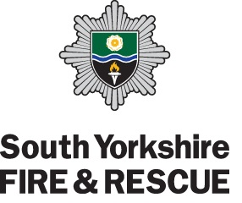
Station Visit Request Form

SV No.

PLEASE NOTE:

- No children under five years of age can be accepted on Station.
- An acceptable number of children attending Station should be no more than 20. For large groups, permission from Station is required.
- Visits to CPC (Close Proximity Crewing) Stations cannot take place in the evening, these Stations are: Lowedges, Aston Park, Tankersley and Edlington.

Contact Name:
Contact Address (including Postcode):
Contact Telephone Number:
Contact E-mail Address:
Group Name:
(i.e. Sheffield Cubs)
Which Fire Station do you want to visit?
Number of attendees expected on Station:
Preferred Date(s) for visit: | We require at least 21 days notice.
Preferred Time(s) for visit: | Please note the following:  - For a day time visit, the firefighters break time is approximately 1pm – 2pm.  - Visits take approximately 1 hour.  - Due to change of Watch at 7pm, no visits can be arranged that run into 6:30pm – 7:30pm (i.e. a visit can take place at 5:30pm for approximately 1 hour or 7:30pm for approximately 1 hour)
What is the purpose of your visit?
Do you have a specific subject that needs to be covered?
Details of person in authority attending with the group:  (if different from contact above) | Name:
 | Telephone Number (mobile preferred):
Any other information:
Please tick to confirm that enough responsible people are attending to supervise the group in case there is a call out and the Station needs to be evacuated in a safe manner.
Please return this form in either Word (dococx) or Adobe Reader (pdf) format.

