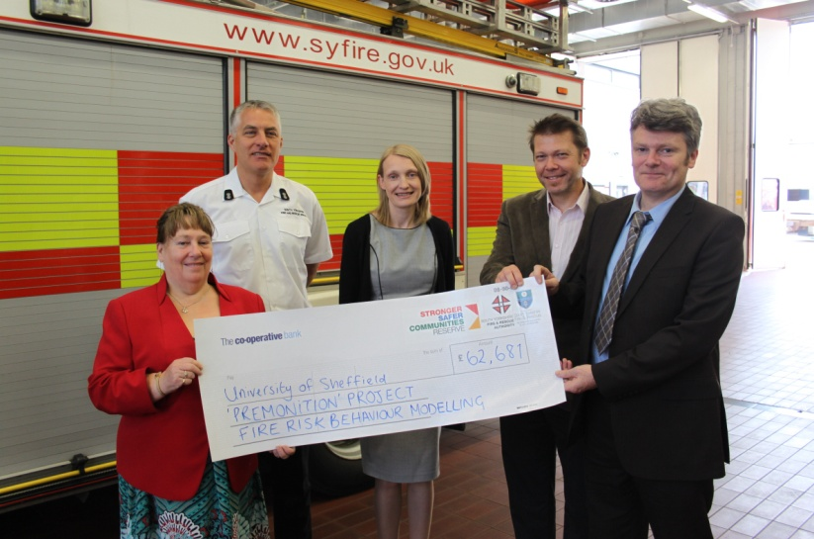

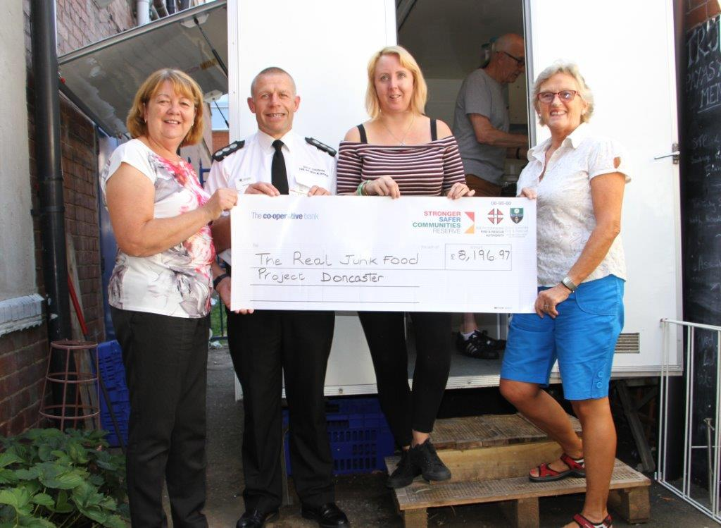

**Stronger Safer Communities Reserve (SCCR) Information Pack**

This document provides an introduction to the SSCR, what it is, and how to apply.

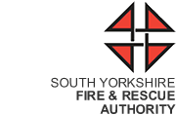

**Contents**

**Section 1**

Background p3

Key Objectives p4

Useful Links p4

Definition of Terms p5

Who can apply p7

What we will fund p7

Application process p8

**Section 2**

Expression of Interest guidance p9

**Section 3**

Assessment Criteria p10

Assessment Process p11

**Section 3**

Monitoring and Evaluation p12

Publicity p12

Standard Conditions p13

**Section 1**

**Background**

The Stronger Safer Communities Reserve fund is a South Yorkshire Fire & Rescue Authority (SYFRA) scheme which reinvests money into local communities to support our work to prevent emergencies. The money has been set aside from the Authority’s reserves.

The reserve seeks to add value to existing partnerships and to broaden and deepen our prevention and protection work. The fund will enable SYFRA and South Yorkshire Fire & Rescue (SYFR) to support not only its own strategic objectives but those of partners across South Yorkshire, to keep communities safe, healthy and resilient.

We have already delivered two rounds of SSCR funding benefiting more than 40 projects. Partner agencies, registered charities and community organisations are invited to submit expression of interest to deliver a new and innovative project up to two years in length. The maximum amount of funding available for each project is £100,000 the minimum amount of £5000.

SYFR will be the lead body and will develop service agreements with project sponsors to deliver agreed outcomes.

The funding for round three projects will be allocated according to clearly defined themes, based on analysis of the fire service’s risk criteria. These themes are:

* **Water Safety**– particularly targeting children and young adults.
* **Excluded Groups**– including BAME and faith communities, LGBT and Roma communities.
* **Mental Health**– including hoarding, social isolation, dementia and substance misuse being specific issues to address.
* **Arson**– particularly the deliberate setting of small fires by young people.
* **Road Traffic Collisions**– particularly focusing on young drivers.
* **Health and Social Care**– health related issues affecting older people, such as falls.

**Key Objectives**

* The focus for funding any proposed schemes is **Community Safety**
* **The most vulnerable in society** remain the absolute priority
* **Collaboration with other agencies** to derive maximum return on investment (social and financial)
* Maximise all opportunities for **match funding**
* **Explore** wherever possible, **data sharing opportunities** with other agencies to identify the most vulnerable in society to focus attention and resources
* Consider the **LEGACY** such initiatives might offer to individuals and communities across South Yorkshire
* Promote such initiatives in order to increase public awareness and understanding of the breadth of work SYFR are engaged in, particularly in the field of community safety
* Target prevention work on the high risk areas

**Useful Links**

**[South Yorkshire Fire and Rescue IRMP](http://www.syfire.gov.uk/performance/strategic-plans/)**

[**The UK Drowning Prevention Strategy 2016-2026**](http://www.nationalwatersafety.org.uk/strategy/info/uk-drowning-prevention-strategy.pdf)

[**Yorkshire & Humber Fire Death & Serious Injury report**](http://www.syfire.gov.uk/wp-content/uploads/2016/08/FINAL-Learning-from-Fatal-Fires-Yorkshire-and-the-Humber-Regional-Report.compressed.pdf)



[**South Yorkshire Safer Roads Partnership**](http://www.sysrp.co.uk/home/)

If you require South Yorkshire Fire Statistics please email **ttranter@syfire.gov.uk**

**Definitions**

**Community Safety**

In its broadest sense, community safety covers all our work on prevention and protection. It includes education work with children and young people ,work with partners to tackle anti-social behaviour, support for vulnerable people at higher risk of fire at home, and support for projects and partnerships that stop fires and other emergencies happening in the first place.

**Vulnerable People**

There is no single definition of what we mean by vulnerable, but what we do know is that the risk of fire death or injury is not evenly spread through communities and that people from some communities, environments or with certain lifestyles are more likely to experience a fire at home, or a road traffic accident.

We also know that behavioural risks to communities change, for instance new migrant workers may be more vulnerable to risk, but are also harder to reach with fire and home safety messages.

Other groups that come into this category include the elderly and people with limited mobility, disabilities, or a sensory impairment. It also includes people who are dependent on drugs and alcohol.

There is evidence that the current economic climate is a contributory risk factor, with people living in houses in poor repair and poverty increasing the likelihood of unsafe cooking practices.

**Collaboration and Match-Funding**

We are looking for Expressions of Interest that will create or enhance connections between existing projects, partner agencies, and individuals to get better value and sustainability from collaboration on shared outcomes.

Match-funding is not a requirement, but will be taken into account as part of the evaluation process.

**Legacy**

Legacy is an important aspect that we look at when funding projects through SSCR. By legacy we mean that the benefits and or activities of your project will continue once SSCR funding has ended. For example, educational packages developed allowing groups and schools to use after original project completion.

**Outputs and Outcomes**

Outputs are the products, services or facilities that result from your projects activities. ***Outputs*** are normally expressed as ***‘How much?’*** a project has achieved.  For example, if your project was to increase Fire Safety awareness within vulnerable families, outputs may be the range and amount of resources your project produces or the number of overall people participating in activities arranged by the project.

Outcomes are the changes, benefits, learning or other effects that result from what the project makes, offers or provides. ***Outcomes*** are normally expressed as ‘***What difference?’*** a project has made.  For example, for the same project, outcomes may be that vulnerable families have an increased awareness around fire safety or the project has improved its ability to extend its reach to other vulnerable groups.

**Who Can Apply?**

Applications are welcome from constituted voluntary organisations, charities and community groups based in and serving the community of South Yorkshire. The project must have a bank or building society account with 2 signatories (not related or living together) and be able to show that you have proper accounting procedures and are financially viable.

**What will we fund?**

The grant is available to support projects that will run for up to 24 months.

You can apply for between £5000 and £100,000. For Round 3 we have introduced a banding system which will see a maximum amount of successful projects per band.

|  |  |
| --- | --- |
| Funding Amount | Maximum amount of projects per band |
| 5-25K | Up to 8 |
| 25-50K | Up to 6 |
| 50-100K  **NB Please note that any application within this band will be required to present their project plan to the assessment board. Date TBC** | Up to 2 |

N.B. We are unlikely to fund projects that have received funding in rounds 1 & 2 that did not meet expectations or were not managed appropriately in line with our requirements.

We **WILL NOT** fund:

* Consultancy fees.
* Venue costs for an organisations own premises.
* One off events such as galas.
* Activities that are part of a statutory duty e.g. street lighting.
* Items of personal clothing such as sports kits for established groups.
* Grant giving to a 3rd party.
* ONGOING running costs such as rent, utility costs, insurance.
* Membership fees, subscriptions, feasibility studies.
* Work which has already taken place
* Prize money/funds
* Purchase of gifts

**The Application Process**

**Stage 1**

Applicants must submit an Expression of Interest application detailing the proposal for the project. We must receive your application no later than midday on the 29th September. Any applications received after this time will not be considered. Please send applications to Rhona Bywater at:

Post: South Yorkshire Fire & Rescue Authority, 18 Regent Street, Barnsley, S70 2HG

Email: [sscr3@syfire.gov.uk](mailto:sscr3@syfire.gov.uk)

**Stage 2**

Your application will be presented to the Assessment Board for evaluation, selection, and recommendations.

**Stage 3**

Recommendations will be made to the Fire Authority for approval. This is expected to take place on the 27th November.

**Stage 4**

Successful projects will be notified during the week commencing 27th November and invited to an Induction Day with SYFR during December.

**Stage 5**

Successful projects start 8th January 2018.

* Fund  open for applications  1 September
* Closing date for applications 12 noon  30 September
* Projects launch 1 January 2018

**Section 2**

**Expression of Interest Guidance**

The expression of interest guidance aims to support any agency/community/partner in submitting an application. Additional supporting information which may have been included alongside the expression of interest form will not be used in the assessment process. The quality of each application will be assessed on what is contained in the expression of interest application form.

As part of the evaluation process applicants are encouraged to speak to the SSCR team to consider how the proposed project is making links to existing local and sub regional initiatives. The team can provide pre-assessment support and advice. This may include sign posting to additional funding streams to encourage collaboration with other projects and programmes that have similar or shared outcomes. This could include broader cross cutting issues around well being, troubled families, restorative justice, and youth employment etc, although this list is not exhaustive. In addition, the team will provide support and advice about the application process.

**Contact details for the SSCR Team:**

Toni Tranter Email: [ttranter@syfire.gov.uk](mailto:ttranter@syfire.gov.uk) Tel: 07785 310943

Peter Jones Email: [pjones@syfire.gov.uk](mailto:pjones@syfire.gov.uk) Tel: 07747 456197

Rhona Bywater Email: [rbywater@syjs.gov.uk](mailto:rbywater@syjs.gov.uk) Tel: 01226 772851

Before submitting applications please consider the following:

* What opportunities are there to attract funding from other sources e.g. partner budgets with broadly similar objectives, part sponsorship?
* SYFR wish to build lasting relations with partners/break bureaucratic barriers, for example on data sharing to help identify the most vulnerable people within our communities.
* To what extent could your project be implemented across South Yorkshire to maximise impact and value for money?
* How you plan to promote/market/communicate your project, and the benefits of working in partnership?
* The project MUST demonstrate a sustainable impact beyond its original duration.
* All successful projects will need to be completed by the 8th January 2020

**Section 3**

**Assessment Criteria**

Assessment of applications will take place after the closing date by an assessment board. The assessment board will be made up of the following:

* 4 Elected Members of the Fire & Rescue Authority (one from each of the four South Yorkshire District Councils)
* SYFR Head of Prevention and Protection
* SYFR Head of Finance
* Deputy Clerk, SYFRA

The assessment board will consider all expressions of interest.

**The assessment, in part will be based on the following factors:**

* How the bid satisfies SYFR objectives in relation to its Community Safety Work
* Evidence of working with/benefitting vulnerable individuals/communities and targeting of higher risk neighborhoods
* Degree of match funding available
* Evidence of data sharing opportunities in support of community fire safety objectives.

**Consideration will also be given to the geographic spread of funding so that as many communities as possible across South Yorkshire are able to benefit.**

**Assessment Process**

The assessment board will score each expression of interest they receive. The scoring structure is below.

|  |  |
| --- | --- |
| Score | Criteria for awarding score |
| 0 | The submission falls significantly short of demonstrating how the project would comply with assessment criteria. |
| 1 | The submission suggests the project meets some of the requirements of the assessment criteria but there is at least one significant issue of concern. |
| 2 | The submission provides assurance that the project complies with the assessment criteria, but there are several smaller issues of concern. These maybe addressed in discussion with the applicant. |
| 3 | The submission provides clear assurance that the project complies with the assessment criteria. |
| 4 | The submission provides clear assurance that the project exceeds the requirements of the assessment criteria. |

**Any project scoring 0 in any section will automatically be excluded.**

|  |  |  |  |
| --- | --- | --- | --- |
| Assessment Areas | Weight | Score | Weighted Score |
| Protecting the most vulnerable | 25% |  |  |
| Ability to evaluate and measure  outcomes | 20% |  |  |
| Deliver value for money and drive  efficiencies | 20% |  |  |
| Demonstrates partnership approach  to delivery | 20% |  |  |
| Sustainability once funding is  Committed. | 15% |  |  |
| **TOTAL SCORE** |  |  |  |

Following evaluation and selection, further discussions will take place with successful applicants in relation to funding, delivery, and evaluation of the projects.

Successful applicants will be required to sign a Grant Agreement with South Yorkshire Fire and Rescue Authority.

**Section 4**

**Monitoring and Evaluation**

Monitoring and evaluation of your funded project is not only important to SYFR and SYFRA but also to the project especially if you wish to apply for further funding from other sources. This enables the project to highlight what’s working and what’s not. Projects will be required to submit quarterly progress reports with a final report being submitted at the end of the project. As well as an update on progress, projects will also be asked to include specific information enabling a full evaluation to be completed at the project end. For example this could be information around outputs and outcomes.

**Publicity**

South Yorkshire Fire & Rescue will work with each funded partner to publicise the funding award, particularly when funding is first awarded and at other key milestones for the project. We are happy for projects publicise their own activity, but ask that approval is sought from the SYFR communication team as appropriate.

If the funded projects involve producing any printed materials, videos or other marketing resources then the draft content must be approved by the SSCR Coordinator and SYFR communication team. If your project wishes to deliver fire safety messages through education or community talks the content will also need to approved by SYFR. This is to ensure SYFRs corporate identity is protected and the correct messages and most up-to-date information are being delivered.

We encourage that resources are designed to be as accessible as possible to us and our other partners. Also, where possible, those resources should be designed so that in such a way as they can be used by SYFR and others beyond the lifetime of the funded project.

A specific requirement of grant funding is that recipients acknowledge the support of South Yorkshire Fire & Rescue Authority.

**Standard Conditions**

* All individuals working with children must be enhanced DBS checked.
* Any award made must only be used for the purposes for which the grant is awarded.
* Those successful in their application shall be responsible for maintaining and submitting monitoring information at agreed milestone dates and at the conclusion of the project
* Payment of monies shall be made in staged payments in arrears and at agreed milestones, following the submission of monitoring information that sufficiently demonstrates evidence of clear outcomes.
* Failure to submit monitoring information could lead to suspension or withdrawal of funding.
* Those in receipt of funding must secure best value for money and shall act in a fair, open and non-discriminatory manner in all purchases of goods and services.
* Financial information shall be maintained during the life of the activity. Copies of receipts for all expenditure must be provided.
* The FRA is subject to the Freedom of Information Act 2000. This gives the public the right of access to information held by the Authority. Some information may be exempt from disclosure such as bank account details. The FRA will consult with third parties who supply such information but the final decision on the release of the information rests with the Clerk to the Fire Authority, and /Chief Fire Officer .
* Bank details are required in the name of the proposing organisation, requiring two unrelated signatories.
* Any unspent funding shall be reimbursed via BACS or in the form of a cheque made payable to SYFR within 30 days of any request for reimbursement.
* The Authority’s decision is final and there will be no right of appeal should an application be declined.
* The Fire and Rescue Authority will be notified and invited to any promotional events in connection with the project. SYFR and SSCR logos will be used when there is the opportunity to do so.
* Any organisation receiving funding accepts that failure to comply with the terms of the standard conditions may result in the recovery of monies paid and any future payments withheld.