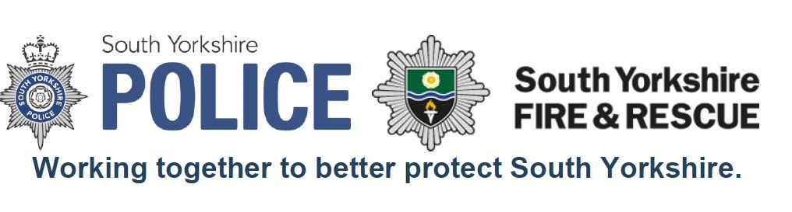

Community and
Business Fire Safety Strategy
2019-2020

Document Control

Title of Document | Community and Business Fire Safety Strategy  2019-2020
Document Class | Strategy
Document Owner | AM Steve Helps
Document Author | GM Simon Dunker / Amy Jenkinson
Approved By
Date Created | 12/2018
Issue Date | 01/2019
Current Version | V1
Review Period** | Annually
Next Review Date | 01/2020
Equality Assessment
Related Policies

Change Management

Name | Position | Organisation | Version | Comments | Date
 |  |  | 1.0

Contents

Subject | Page No
Introduction | 3
Purpose | 3
The Business Strategy  Our Aspirations | 3
2017 – 2020 IRMP | 4
Departmental Overview | 4
Monitoring and Evaluation | 6

Community and Business Safety Strategy

- INTRODUCTION

The activities undertaken by the Joint Community Safety Department (JCSD) and the Business Fire Safety function (BFS) provides the link between the Integrated Risk Management Plan (IRMP) and South Yorkshire Police ‘Plan on a Page’. Evidence is contained within the departmental plans.

- PURPOSE

The primary focus of the community / business fire safety function is making South Yorkshire safer and stronger. We recognise the impact that injuries and fatalities have on the community and play an active role within the community working to prevent them.

Our mission is working for a safer South Yorkshire and our work extends beyond the traditional role of firefighting and fire protection.

- BUSINESS STRATEGY

Our Aspirations which are aligned to SYFR’s 10 year vision (Our Story)

- Be a great place to work…
Our most valuable assets are the people who work and volunteer for us. Their safety and effectiveness is paramount. We foster a culture that encourages openness and honesty. We champion diversity within our teams which helps us to address the needs of our communities. Freedom and flexibility is given to our staff to allow them to be creative, think differently and do the right thing.

- Put people first…
We will continue to explore new and innovative ways of identifying and addressing risk within our communities. To do this we will look for opportunities to work collaboratively with partner agencies to help us engage with traditionally hard to reach communities, in order to reduce risk within the community.

- Strive to be the best in everything we do…
We expect the highest standards from our workforce and will recognise and acknowledge a job well done. To do this we employ the best possible people who receive the training and support to allow them to understand the needs of their local communities and deliver a service we are proud of.

- 2017 – 2020 IRMP

The 5 priorities for Community and Business Fire Safety, contained within the IRMP are as follows:
- Target home safety visits at the most at risk
- Expand safe and well visits
- Sprinkler advocacy
- Increase engagement with young people
- Collaborate with our partners

These 5 areas are contained within the departmental plans and local action plans for JCSD and BFS which, combined, outline 7 priority areas of work, which enable the progression of the department and SYFR maintain its IRMP commitments.

Joint Community Safety Department (JCSD):
- Partnerships
- Performance
- Prevention and Intervention
- Engagement

Business Fire Safety (BFS):
- Promote firefighter safety and competent operational decision making.
- Promote consistency and common application of the legislation by delivering clear processes and effective development of staff and guidance to protection managers and inspectors.
- Adapt to the changes in construction techniques to protect our business communities in new ways through proactive solutions.

- DEPARTMENTAL OVERVIEW

Joint Community Safety Department (JCSD)
The Joint Community Safety Department pools the expertise and dedicated staff of SYFR and South Yorkshire Police who undertake targeted activities in order to reduce vulnerability and demand. The JCSD team have years of experience in delivering quality early intervention programmes to all age groups, the work is dynamic and reflects the needs of the communities within South Yorkshire.

Department Aim
The Joint Community Safety Department (JCSD) work collaboratively to provide an efficient and effective approach to prevention and early intervention to reduce vulnerability and demand, keeping the communities of South Yorkshire safe.

Department Objectives
- Effectively target resources to support the most vulnerable in communities
- Through early intervention and targeted prevention activities the JCSD, in partnership with others, will aim to reduce the demand across both services
- Deliver a service which supports improved trust and confidence within communities

JCSD has prioritised its actions in its functional plan into four areas:
- Partnerships
- Performance
- Prevention and Intervention
- Engagement

Business Fire Safety (BFS)
The Business Fire Safety team work to reduce the risk of fire in non-domestic premises across South Yorkshire. Our work is undertaken in a targeted manner through the Risk Based Audit Program and contributes to the SYFR Community Risk model. Through education, engagement and enforcement, we aim to reduce the levels of risk across the County, focussing on high risk and vulnerability.

Our work with agencies such as Federation of Small Business also allows us to reach out to hard to reach community groups, in order that they too have access to information about improving fire safety and how to comply with legislation.

Using our knowledge of risk within the community, we provide support and training to our colleagues in Emergency Response in order to raise awareness of fire safety and the built environment.

These activities are in addition to what we would term ‘Business as usual’, which is outlined in the departmental strategy.

Department Aim
The main role of Business Fire Safety (BFS) is to enable South Yorkshire Fire Authority to discharge its statutory duty under various laws:
- Regulatory Reform (Fire Safety) Order 2005 (FSO)
- Petroleum Act
- Fireworks Act
- Building Regulations

Department Objectives
Business Fire Safety (BFS) has prioritised its actions in its functional plan into three areas:
- Promote firefighter safety and competent operational decision making
- Promote consistency and common application of the legislation by delivering clear processes and effective development of staff and guidance to protection managers and inspectors
- Adapt to the changes in construction techniques to protect our business communities in new ways through proactive solutions.

- MONITORING AND EVALUATION

Performance management and governance arrangements
Both JCSD and BFS contribute at authority level through the scrutiny and stakeholder planning board. Performance indicators are presented at CMB, the JCSD also presenting at the Collaboration assurance board and activity are monitored at departmental level on a quarterly basis. This allows both SYP and SYFR to scrutinise the performance of this joint team.

Local Performance Indicators that we contribute to:
LPI 1.1 – number of primary fires
LPI 1.2(i) – number of accidental dwelling fires
LPI 1.2(ii) – number of accidental dwelling fires that are cooking related
LPI 1.3 – number of fires in non-domestic premises
LPI 1.4 – number of fire deaths and injuries
LPI 1.5 – safe and well checks (HSC’s) completed
LPI 1.7 – arson incidents
LPI 1.9 – false alarms caused by automatic fire detection – non-domestic properties
LPI 2.2(a) – RTC incidents attended by the service
LPI 2.2(b) – number of incidents involve extrications

How we will know we’ve been successful, as we will have:
- Achieved the objectives as outlined in our Local Action Plans. This includes key areas such as:

  - Delivered the Business Safety Visits.
  - Operational staff will have a better understanding of fire safety objectives and the built environment.
  - We will continue to advocate the installation of sprinklers, and continue to see a change in culture in regard to sprinklers.
  - We will audit a high percentage of high risk buildings via the Risk Based Audit programme.
  - All Business Fire Safety Inspectors will gain their Level 4 Diploma in Fire Safety and continue personal development through dedicated training opportunities.
  - We will continue to see a fall in Unwanted Fire Signals and the implementation of the Charging Policy should it be warranted.
  - We will continue to explore opportunities to offer greater support to businesses in South Yorkshire.
  - Work with Partners to target the most vulnerable people in South Yorkshire.
  - Development of intervention packages to support the vulnerable in the community, such as those at risk of becoming a victim of fraud, scams or isolation.
  - Ensure Crucial Crew remains to be fit for purpose and the uptake by schools continues and content remains relevant.

This Strategy supports the actions and priorities within Community and Business Fire Safety and these are detailed across our Departmental and Local Action Plans.

These plans are jointly agreed with local managers to identify areas of activity, themes and target locations where interventions will be focused. These plans demonstrate our commitment to the communities they serve.

