

South Yorkshire Fire and Rescue

Procurement Strategy and Policy

2021 – 2024

Functional Head: | Stuart Booth, Director of Support Services
Date written: | 01/05/2021
Date ratified by Functional Head: | 01/06/2021
Date of next review: | 28/02/2025
Version No: | 1.5.1
EA Reviewed: | Not applicable

Contents
Section Page Number
1 Introduction 2
2 Executive Summary 3
3 Background 4
4 Procurement in South Yorkshire Fire & Rescue 5
5 Our Procurement Strategy 8
6 Our Policies 9
6.1 Collaboration ……9
6.2 Sustainable Procurement 10
6.3 P2P Process 10
6.4 Transparency 10
7 Improving Procurement 12
8 Benefits 13
9 Our Action Plan 14

Introduction

The authority’s vision is “To Make South Yorkshire Safer and Stronger”

A key consideration therefore when undertaking procurement exercises is:

- “Safety & Reliability” when sourcing supplies and services.

Procurement is also integral to delivering commercially advantageous and innovative solutions essential in meeting public expectations and in supporting front line emergency services. In addition we aim to ensure the effective use of reduced resources and the delivery of our corporate priorities as included within the Integrated Risk Management Plan (IRMP) 2021.

The purpose of this Procurement Strategy and Policy document is to inform suppliers and interested parties of the key principles that drive our procurements and to provide a governance framework for procurement activity throughout the authority whilst adhering to legislative and regulatory requirements.

The section entitled “Our Action Plan” provides examples to illustrate our plans for the future and commitment to continuous improvement.

The Strategy and Policy will be periodically reviewed to ensure continued relevance to the environment and society in which we provide Emergency Services.



Executive Summary

South Yorkshire Fire and Rescue (SYFR) spends circa 80% of its’ non-staffing related budget through national / regional framework agreements (these are lists of pre-approved suppliers).

The remaining 20% is managed through invitations to quote / tender as per Public Contract Regulations (PCRs) and Contract Standing Order (CSO) requirements. We aim to include two local suppliers from within the South Yorkshire area to stimulate / support the local economy where legislation allows.

We place more emphasis on quality/reliability (than price) when evaluating operationally critical supplies and services; with overall value for money being achieved through aggregation and leveraging of buying power with other public sector authorities (i.e. collaborative / joint procurements).

We effectively manage supply chain risks, gather market intelligence and support colleagues in Contracts Management on long term contracts or where supply chains are considered to pose a high risk to our emergency services.

In summary, the key drivers of the SYFR Procurement Strategy and Policy are:

- Collaboration: with other blue light services and public sector authorities.

- Quality weighted Value for Money: to emphasise the importance of “quality” throughout the fire service.

- Continuous Improvement: in our staff, systems, processes and supply chains.

The Executive Board have undertaken that future revisions to the Procurement Strategy & Policy shall be progressed via the Corporate Advisory Group before being formally presented to the Authority.

Background

SYFR employs circa 800 people that equates to 570 operational and the remainder being support staff. We provide a 24/7 emergency service, operating 27 fire appliances from 21 fire stations. We have a central command and control centre at Headquarters in Sheffield and a specialised Training and Development Centre in Handsworth, Sheffield.

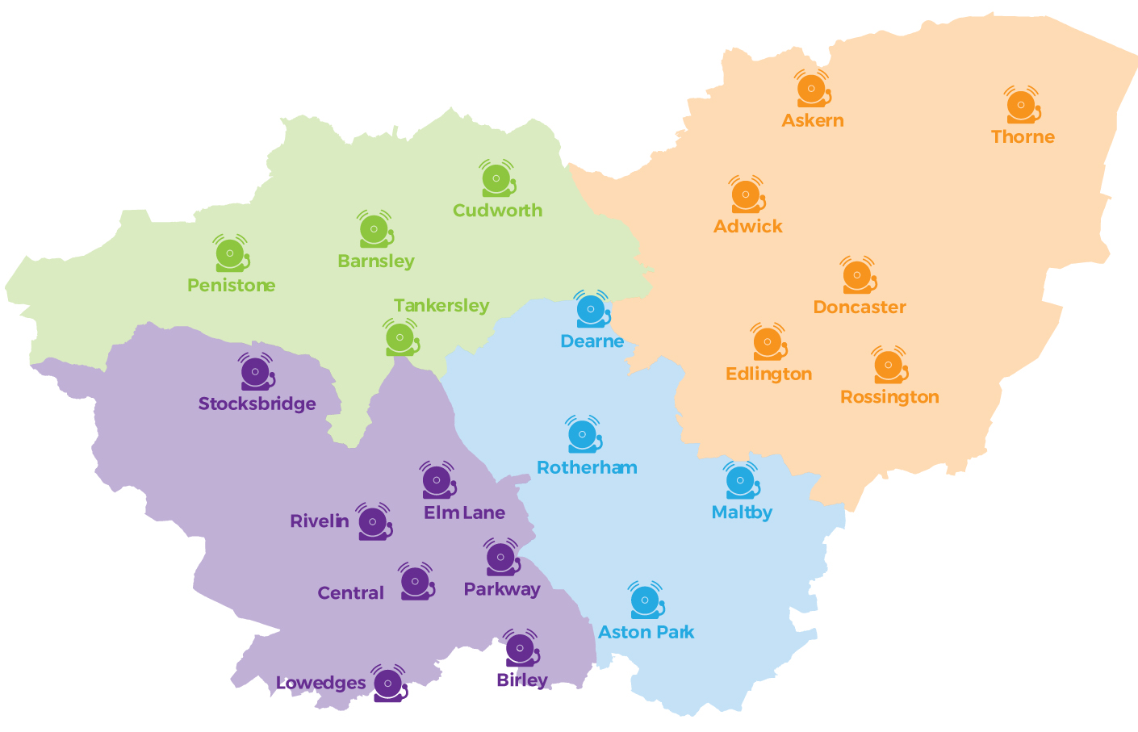
SYFR currently expends around £7.5m revenue budget each year (£4m supplies and services, £2.6m premises and £0.9m transport); and an average of £2m each year on a variety of works and other capital projects (excluding new build projects).

The financial challenges facing the public sector as a whole have been well publicised and the resulting pressures on budgets are ongoing. We continue to deliver responsive Emergency Services to the people of South Yorkshire in an efficient and effective manner whilst managing significant budgetary pressures.

As a public sector body, we are subject to Public Contract Regulations 2015 (PCRs) adopted into UK law during Brexit and that requires us to ensure all suppliers be treated equally and without discrimination, and to act in a transparent and proportionate manner without artificially distorting competition.

Our Contract Standing Orders and Financial Procedures provide a robust governance framework, ensuring the authority’s financial affairs including obtaining competitive quotations and tenders are conducted in a fair, open transparent and compliant manner and ensure value for money is achieved.

Procurement in South Yorkshire Fire & Rescue

We procure a wide variety of supplies, services and works from suppliers and contractors that range from office supplies, building maintenance and computer systems through to specialist operational fire fighting equipment, breathing apparatus and fire appliances. The nature of our business makes it vital that we ensure the right supplies are in the right place at the right time.

We work closely with partner organisations especially within the Yorkshire Region and have conducted collaborative procurements on Battery Cutting Tools, Structural PPE and a Care and Maintenance package for this kit and contracting with suppliers to deliver a strategic and professional service that meets the needs of all our stakeholders. The collaborations enables us to share experiences, best practice and management information critical to making informed procurement decisions.

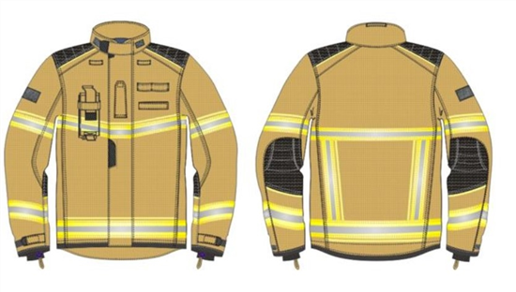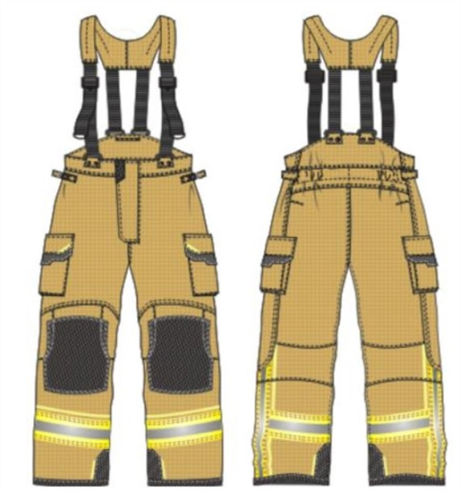

We maintain a contracts register and pipeline which are used to manage our procurement activity and ensure early stakeholder as well as supplier engagement. The contracts register is updated regularly and can be accessed from our web site / home page (www.syfire.gov.uk).

We award contracts based on the principle of “most economically advantageous tender” (MEAT) which is a balance between quality and price. The quality of supplies and services can be critical to the wellbeing of our firefighters and the safeguarding of the Public. It is imperative that SYFR is capable of responding to emergency situations rapidly and without any failures in processes, systems, supplies or equipment. As a general rule, our procurement processes place greater emphasis on quality over price for operationally critical supplies e.g. Personal Protection Equipment and Fire Appliances.

For non-critical supplies and services price is of increased importance due to budgetary pressures, but each procurement exercise is appropriately managed on a case-by-case basis, with clear criteria being communicated to each supplier at the start of each procurement exercise.

The chart below shows the relationship between quality and price and the illustrative / example weighting we may use for each category of spend e.g. for “ICT” we would usually apply a weighting of 60% quality and 40% price.

QUALITY | 70% | 60% | 50% | 40% | 30%
Operational Equipment
Personal Protection Equipment
Fleet
ICT
Construction
& FM
Professional
Services
Misc e.g. Office Supplies
 |  |  |  |  | 30% | 40% | 50% | 60% | 70% | PRICE

When contracts are awarded, the related supply chain is assessed for the level of potential risk to the authority and scored as low, medium or high risk and financial reports used when needed to provide added assurance. Each contract is subsequently managed commensurate with importance (based upon risk/impact/cost), client input and the need for any further mitigation measures such as use of Key Performance Indicators (KPI’s).

The following table illustrates typical risk mitigation measures that may be employed for each level of identified risk, e.g. where a particular supply chain is high risk, SYFR may choose to increase the volume of stock held in stores to reduce our reliance on the supply chain and/or may hold more frequent meetings with the supplier to plan and agree supply schedules etc. Contract management plans are established per contract based upon the level of risk with requirements included within individual contracts.
CONTRACT RISK ASSESSMENT | CONTRACT MANAGEMEWNT
Category A  Each category uses a rating of 1 to 5 to determine importance  Category A1 require formal quarterly meetings with KPI monitoring  Category C5 requires no formal management | - Quarterly formal meetings  - Performance Management (inc KPI’s)  - Appropriate Contractual Safeguards e.g. Parent Company Guarantees / Performance Bonds  Fee Retention / Warranties  - Alternative Suppliers Identified  - Buffer stocks held in stores
Category B | - 6 monthly or annual meetings  - Performance Management & Monitoring  - Appropriate Contractual Safeguards e.g.  Parent Company Guarantees / Performance Bonds  Fee Retention / Warranties  - Buffer stocks held in stores
Category C | - Light touch e.g. sample checks; occasional informal review meetings with suppliers etc.

The authority operates a central store for service critical supplies and this store helps mitigate any short-term supply risks and enables rapid gearing up in emergency situations that are large scale i.e. frequently required or prolonged in duration.

The authority operates a fleet of fire appliances and support vehicles that are maintained in-house. The authority operates a workshop store that is co-located with the vehicle servicing workshop and this arrangement enables vehicles to be turned around and back in service without undue delay.

Both central stores and workshop stores are integral to the authority’s procurement strategy to ensure delivery of the Integrated Risk Management Plan (i.e. corporate priorities).

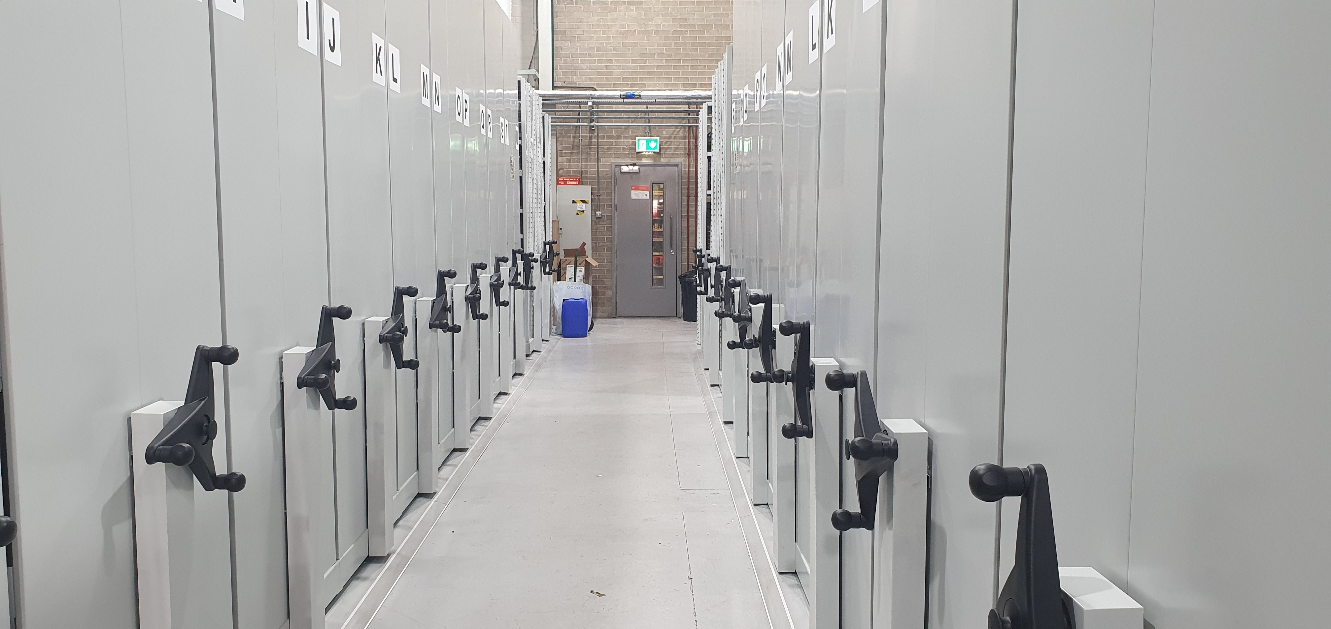

Our Procurement Strategy

The estimated value of the procurement will determine which procedures are permitted under Public Contract Regulations or as required by Contract Standing Orders.

Prior to undertaking a procurement exercise, the SYFR procurement team undertakes a market and options analysis to identify the most appropriate route to market, stakeholder and supplier engagement and consultation where possible with other Fire Services.

Primary considerations is given to prevailing market conditions and whether any pre-tendered framework agreements exist, that have been awarded by other fire authorities or through other public sector authorities that SYFR are permitted to utilise.

Provided that pre-tendered framework agreements offer best value for money, then SYFR shall look to conclude contracts in accordance with the framework terms and conditions. The benefits of using framework agreements:

- provide greater collaboration (Regionally and Nationally) between other Fire and Public Sector Authorities.

- provide relatively quick and efficient procurement solutions that are compliant with Public Contract Regulations.

- offer better value for money as a result of combined buying power of the public sector.

The frameworks we use most frequently include:

The National Fire Chief Council’s network:

CATEGORY | LEAD AUTHORITY
- Operational (Fire Fighting) Equipment | West Midlands FRS
- Fleet (Fire Appliances & Other Vehicles) | Devon & Somerset FRS
- Clothing (including PPE) | Kent FRS
- Construction and FM | Nottinghamshire FRS
- ICT | NFCC engaged employee
- Professional Services | Cambridgeshire FRS

And also Public Sector Buying Organisations such as:

- Rotherham MBC Construction and Minor Works Framework
- Yorkshire Purchasing Organisation (YPO)
- Eastern Shires Purchasing Organisation (ESPO)
- National Health Service (NHS)
- Crown Commercial Services (CCS)
- YORBuild / YORCivils

Where framework agreements are not utilised, SFYR invites quotations and tenders direct from the market in accordance with Public Contract Regulations and Contract Standing Orders requirements in order to optimise service delivery, quality and value for money.

Typically, SYFR places 80% of expenditure through collaborative framework agreements and 20% through locally managed quotations / tenders.

Our Policies

Collaboration

Collaboration is one of the most effective procurement tools available to the public sector and being a relatively small organisation in terms of expenditure. SYFR is able to achieve economies of scale by collaborating through framework agreements with other public sector authorities or jointly procuring requirements.

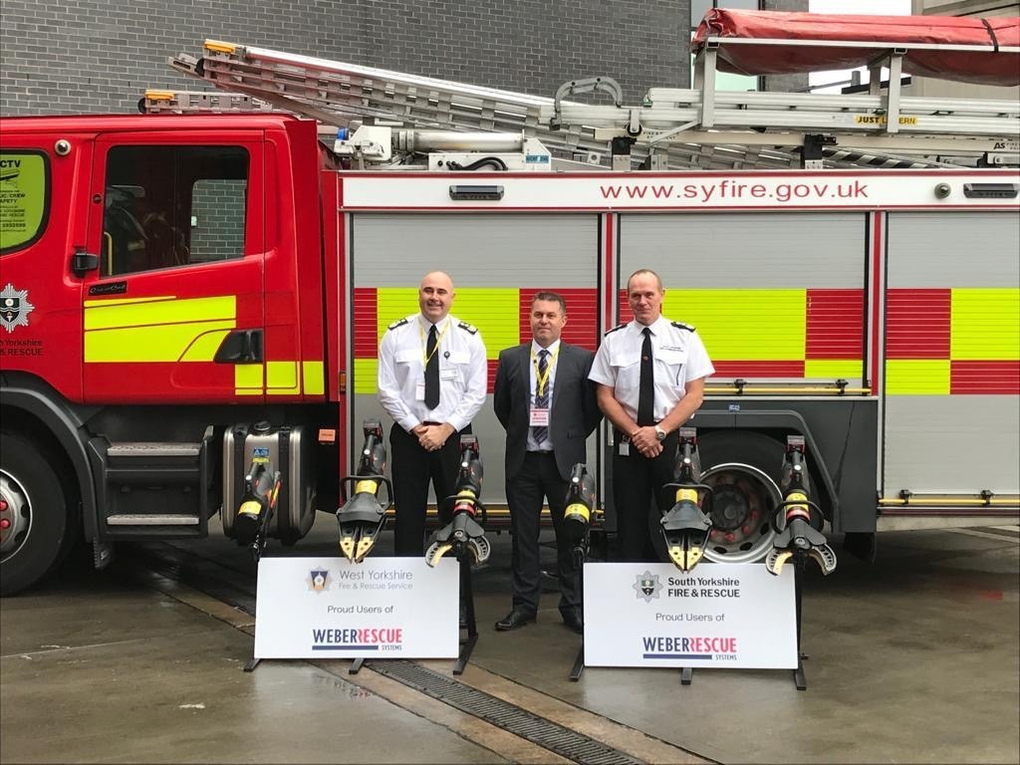

SYFR will endeavour to award contracts through framework agreements where these offer demonstrable value for money and meet the needs of the authority. SYFR will contribute knowledge and experience to framework development and thus increase the likelihood of the agreements meeting SYFR requirements.

If SYFR requirements cannot be adequately fulfilled through available framework agreements, the authority will approach the market direct in compliance with legislative and regulatory requirements.

Sustainable Procurement

Sustainable procurement involves procuring supplies, services and works with due consideration at the planning stage to the Social Value Act and in particular to environmental, economic and social factors. Where relevant to the procurement, a minimum weighting of 5% for each factor will be included within the quality evaluation criteria and applied. Additionally:

- When inviting quotations & tenders we aim to invite two local suppliers from the South Yorkshire region to participate.

- In protecting the environment, our contract specifications and operating procedures aim to safeguard the natural environment and avoid any adverse consequences.

- The authority works closely with charities and employment agencies to create apprenticeships, volunteering opportunities and work experience placements.

- SYFR Estates department are developing a “Green Plan” to reduce its’s carbon footprint and Procurement has a vital role to play in delivering our goals.

P2P Process

SYFR aims to establish a paperless Purchase-to-Pay (P2P) process in order to automate, streamline and maximise the efficiency of the transaction process whilst reducing impact on the environment and natural resources.

Suppliers will be increasingly encouraged to accept email Purchase Orders / Remittance Advices and to submit invoices, either electronically or as PDF email attachments.

Transparency

The Government’s Transparency Code requires local authorities (including fire and rescue authorities) to publish details of expenditure as follows:

- details of each individual item of expenditure that exceeds £500.

- details of every transaction / payment made using a Government Purchasing Card.

- details of current contracts and call-offs from a framework agreement with a total value in excess of £5k.
Each of the above information is published quarterly and can be located from our website home page (www.syfire.gov.uk).
When advertising contract opportunities direct to the market (and not via framework agreements), SYFR uses the following channels:

Supplies, Services and Works - £25k to Regulation thresholds:-  * £189,330 – Supplies & Services  * £4.733,252 - Works | Contracts Finder  Tender issued via YORtender | Contracts Finder is a Government portal
Above Regulation thresholds | Find a Tender Service  Contracts Finder  Tenders issued via YORtender | Find a Tender Services is a Government portal

YORtender (www.yortender.com) is free for suppliers to register and to receive automatic alerts to public sector opportunities. The Crown Commercial Services Public Procurement Note (PPN) encourages localisation and keeping spend within local boundaries:

Public Procurement Notice (PPN) 11/20 - Reserving Below Threshold Procurements state:

“In-scope Organisations may consider, where appropriate, the following options for the procurement of below threshold contracts:

Reserve the procurement by supplier location - this means being able to run a competition and specify that only suppliers located in a geographical area can bid.
This could be UK-wide to support domestic supply chains and promote resilience and capacity, or where appropriate, by county (metropolitan or non-metropolitan) to tackle economic inequality and support local recruitment, training, skills and investment. In-scope Organisations should not define by nations of the UK (i.e. England, Scotland, Wales, Northern Ireland) and where a county reservation is to be applied, only a single county may be reserved. Supplier location should be described by reference to where the supplier is based or established and has substantive business operations and not by location of corporate ownership.

AND

Reserve the procurement for Small and Medium sized Enterprises (SMEs) /
Voluntary, Community and Social Enterprises (VCSEs) - this means being able to run a competition and specify that only SMEs and VCSEs can bid.”

For contracts of £25k and below, we will endeavour to ring-fence to South Yorkshire based suppliers and minimise barriers to contracting.

For contracts above these values all opportunities with be advertised via Contracts Finder and above Regulation Thresholds also via Find a Tender Service, all quotations, tenders and related documentation / correspondence issued and received via the E-tendering portal and shall be saved electronically in YORtender for a minimum period of 5 years or the duration of the contract + 1 year (whichever is the longest).

Improving Procurement

The procurement service within SYFR has undergone change in order to meet external challenges and to better align with the general direction of travel of the public sector. A few examples are included for illustrative purposes in the last section of this strategy document.

Professional procurement leadership is now in place to plan and drive through much needed change and improvements and the new structure supports delivery of this through Category Management

Delegated authority to departments (Head of Service) permits purchase orders to be raised against established contracts or to seek quotations up to an estimated max. of £25k. (The use of YORtender is mandated for procurements above £25k). .

All procurements valued over £25k are now managed centrally by the procurement team.

The increased workload for the procurement team, resultant of the centralisation of procurement activity is offset by greater public sector collaboration and use of framework agreements; which also offers the SYFR procurement team time to focus more on forward planning, market strategies, adding value to the overall process & outcomes, risk and contract management.

The Purchase-to-Pay system (Integra) has undergone a significant refresh and reconfiguration to streamline the process, increase governance and enhance business intelligence and management reporting to inform decisions and monitor compliance.

The E-procurement system (YORtender) is being enhanced with the introduction of “quick quotes” which will result in the user experience being as quick and easy as using email whilst ensuring for a fair, open and transparent process.

The master vendor database has been rationalised and will be further reduced by 20% through supply chain aggregation for better value and reduced administration costs. A significant piece of work to understand SYFR low-value repetitive spend has begun aimed at ensuring compliance and best value.

The two stores have been relocated to improve business continuity and resilience and to introduce more flexible working. All materials are purchased against frameworks, contracts or formal quotation process within the main stores and recognised suppliers for none Original Equipment Manufacturers (OEM) and where warranty / price / quality require from OEM suppliers such as Scania for chassis components

New working procedures and standards have been introduced that places more emphasis on proactive forward procurement planning to deliver value for money outcomes as opposed to reactive repetitive and disaggregated purchasing. For example SYFR now have a ten year major equipment replacement program produced by Technical Services which will allow better collaboration, market intelligence and deliver savings.

Benefits

Implementation of our Procurement Strategy and Policies has delivered improvements in end user experience, better value for money and evidenced the following key business benefits:

- Regulatory Compliance (i.e. PCRs and CSOs)
- Reputation Protection by applying the principles of fairness, openness and transparency
- Maintain Quality (i.e. quality & reliability of supplies)
- Transparency (i.e. publication requirements)
- Total Cost Reduction through efficient procurement (i.e. value for money)
- Improved Service Levels
- Supply Chain Risk Mitigation / Management
- Purchase-to-Pay Efficiencies

Our Action Plan

Topics: | Projects: | Comments
Key Procurement Projects | Renewal of Front Line Appliances (27) | Circa £8m
Key Procurement Projects | FF Helmets, Gloves, Hoods and Boots | £1m
Key Procurement Projects | FF Uniforms and Managers Uniforms | £250k
Key Procurement Projects | Strategic Review of Fleet | £12m
Key Procurement Projects | Update Integra and In-house delivered software | Introducing new functionality i.e. to manage fire-fighter clothing entitlements, budget management etc and to increase efficiency.
Systems & Processes | Reduce active Supplier numbers by 20% to below 1,000 | Spend with suppliers below £500 pa will be reviewed for potential aggregation.
Systems & Processes | Strengthen Procurement Leadership and Strategy | Continued Professional Development
Systems & Processes | Invest in the development of staff to ensure professional and governance standards are consistently upheld and best practice routinely adopted. | The restructure of the procurement team’s roles, responsibilities; ensuring appropriate skills and competencies are inherent, and achievement measured against is complete and appropriately experienced and qualified staff are in place
Systems & Processes | Continue expenditure analysis and implement a category management approach. | Procurement staff are required to engage in continuous professional development (CPD).  Buyers and colleagues in departments with procurement responsibilities will receive ongoing refresher training.
People | Introduce procurement related performance & compliance indicators. | Spend analysis will reveal opportunities for further collaboration and the rationalisation of supply chains.
People |  | Spend through compliant arrangements are being measured and reported.  Spend against contract award values are being monitored and reported.  Savings are being captured and reported.

