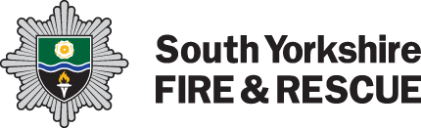
Privacy Notice: Local Resilience Forum
SYFR is a Category 1 responder under the Civil Contingency Act 2004 (CCA) has a duty to share information with other Category 1 and 2 responders in large scale emergencies, such as flooding or the recent Coivd-19 pandemic. This is required to fill the organisations duties under the CCA. Category 1 and 2 responders such as the emergency services, councils, health, and utilities form part of the Local Resilience Forum (for more information on South Yorkshires Local Resilience form please see: South Yorkshire Local Resilience Forum - SYP). Information sharing is a crucial element of civil protection work, underpinning all forms of co-operation. Category 1 and 2 responders should share information formally and as part of a culture of co-operation in responding to public emergencies. More information on this sharing can be found here: Chapter-3-Formal-information-sharing-revised-March-2012.pdf (publishing.service.gov.uk)

Is there anything else I need to know when it comes to my personal information?
To find out more about the rights you have when it comes to your personal information or who you can contact to discuss it further please see our full Privacy Policy, available under ’Your information’ on our website.

