EFFICIENCY & PRODUCTIVITY PLAN
24/25 and review of 23/24
31 March 2024
PRODUCTIVITY & EFFICIENCY PLAN

Contents

Title | Page No
About this plan | 2
SECTION ONE : EFFICIENCY
a - Medium Term Financial Plan | 3
- b - Reserves from the Medium Term Financial Plan | 4
- c - Setting the 2024/25 Budget | 4
- d - Efficiencies planned in the 2024/25 Budget | 6
- e - Delivering the Efficiencies in 2024/25 | 7
- f - Efficiencies achieved to 2023/24 | 7
SECTION TWO : PRODUCTIVITY
a – CRMP | 8
b – Resourcing | 9
c – Productivity monitoring | 9
d – Productivity improvements in 2023/24 | 10
Corporate Spending Review (CSR) Efficiencies | Annex A
Efficiencies 2023/24 (per Q3 Forecast) | Annex B
Efficiencies 2024/25 (per Council Tax and Budget report) | Annex C

About this plan
The National Framework requires combined and metropolitan Fire & Rescue Authorities (FRAs) to produce and publish Efficiency Plans. For 2024/25, all FRAs must produce plans for increasing productivity- not just creating efficiency.

As part of the ongoing government spending review, the National Fire Chiefs Council
(NFCC) and the Local Government Association (LGA) agreed that between 2021/22 and 2024/25, Fire and Rescue Services in England will create non-pay
efficiency savings of 2% and increase productivity by 3%.

Fire Productivity and Efficiency Plans (P&E Plans) will help the NFCC, LGA and Home Office to collate evidence and assess progress against the agreed targets nationally.

This plan explains how South Yorkshire Fire & Rescue will deliver these efficiencies and increase productivity against national targets, ensure a balanced budget and deliver value for money. It also includes a review of achievements against our 2023/24 plan.

This plan should also be considered alongside other strategic documents, including our Community Risk Management Plan and Service Plan, our Medium Term Financial Plan and the Annual Council Tax and Budget Report.

Section 1: Efficiency

PLANS FOR 2024/25

- Medium Term Financial Plan
The tables below summarise our Medium Term Plan 2024-2027, as approved by South Yorkshire Fire & Rescue Authority in November 2023. This plan was compiled by finance working with the budget holders. All budget reductions were captured in the efficiency column.

Table 1: Summary of the Medium Term Financial Plan approved by FRA in November 2023:

 |  | Movements 2023/24 to 2024/25 |  |  | MTFP
BUDGET DESCRIPTION | BUDGET 2023/24 | Efficiency | Inflation | Investment | 2024/25 | 2025/26 | 2026/27
TOTAL EMPLOYEES | 52,551,709 | (962,607) | 2,587,726 | 945,737 | 55,122,565 | 56,928,248 | 58,066,813
TOTAL PREMISES | 4,537,367 | (574,290) | 173,795 | 126,262 | 4,263,134 | 4,300,737 | 4,338,744
TOTAL TRANSPORT | 1,320,254 | (179,796) | 68,307 | 93,855 | 1,302,620 | 1,310,065 | 1,317,675
TOTAL SUPPLIES & SERVICES | 3,910,047 | (182,434) | 199,683 | 628,819 | 4,556,115 | 4,598,943 | 4,642,173
TOTAL EXPENDITURE | 65,403,543 | (1,899,127) | 3,044,153 | 1,860,335 | 68,408,904 | 70,411,349 | 71,648,261
TOTAL INCOME | (1,123,391) | (255,431) | 0 | 300,285 | (1,078,537) | (1,034,260) | (989,983)
NET EXPENDITURE | 64,280,152 | (2,154,558) | 3,044,153 | 2,160,620 | 67,330,367 | 69,377,089 | 70,658,278
FUNDING - MOST REASONABLE |  |  |  |  | (66,833,253) | (68,295,121) | (69,993,131)
CONTRIBUTION (TO)/FROM RESERVES |  |  |  |  | 497,114 | 1,081,968 | 665,147
POTENTIAL GAD VALUATION INCREASE (12% Employers Contr.) |  |  |  |  | 3,580,077 | 3,651,679 | 3,724,712
POTENTIAL GAD GOVT FUNDING |  |  |  |  | - 3,580,077 | - 2,921,343 | - 2,979,770
ADJ CONTRIBUTION FROM RESERVES AFTER GAD |  |  |  |  | 497,115 | 1,812,304 | 1,410,090

- Reserves from the Medium Term Financial Plan
Table 2 shows our reserves as approved in the Medium Term Financial Plan in November 2023.

Table 2 – Reserves from the approved MTFP
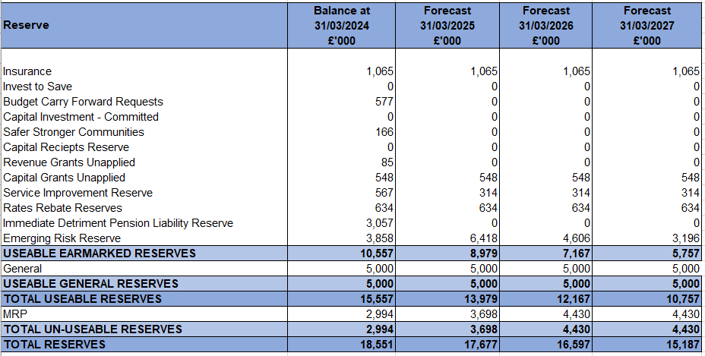
We anticipated our useable earmarked reserves reducing to just £5.7m during the planning period. In the medium term financial plan, we also highlighted risks to our financial projections mainly due to uncertainty over funding and inflation. So we recommended these reserves be kept (not used to fund capital investment) while significant financial uncertainty remains.

Our reserve levels are just below average, when benchmarked (in March 2022) against reserves held by other standalone fire and rescue authorities as a percentage of annual core funding.

We will be controlling investments and maximising the delivery of efficiencies where possible, to minimise the use of reserves to support deficits in the planning period.

- Setting the 2024/25 budget
We have continued to work with budget holders and senior leaders following approval of the medium term financial plan, adjusting the funding assumptions, efficiencies, inflation assumptions and investments which will be included in the budget.

Funding assumptions

These have been adjusted to reflect the local government funding settlement proposals.

Efficiency assumptions

The budget efficiencies have been reviewed at a strategic level by the Senior Leadership Team – with a focus on key pay assumptions and whether they are safe to deliver. We also included a summary of non-pay efficiency savings and no quality, equality or safety concerns were raised.
An efficiency ‘long list’ of more than 70 ideas was developed by leaders from across the service during 2023/24.These ideas have potential for both large and small savings- whilst others will not result in cash savings, or may be challenging to deliver. The list includes both income generation and cost saving ideas. The list is held by the Director of Finance & Procurement and is now being prioritised- with the highest impact and easiest to deliver savings considered first.

Overtime reduction is one of our priority areas for savings, with a project team established to review current arrangements. We have estimated the possible savings for 2024/25 and reduced this from the budget.

Other significant changes in use of property or other assets or staffing rotas are subject to development of the service’s new Community Risk Management Plan, which is now underway. While work is in progress which may deliver efficiencies in the future, these have not been built into the 2024/25 plan at this time.

Work will continue to gather ideas for further savings.

Inflation assumptions

We believe we have set these at a realistic level. Inflation assumptions of 3% have been used, with external forecasts anticipating a range between 4% and 3% this year.

Investment assumptions
The 2024/25 budget process has enabled us to identify all requested budget increases or ‘investments’. These increases have largely addressed changes in working practices and development of more accurate budget monitoring. Other budget increases, with discretionary increases, will be subject to a business case or other appropriate approval before they are added to budget holder budgets available to spend. Prior to this approval, budget will be held in a central contingency. An investment priority rating has been proposed, where statutory and regulatory requirements are approved and invest to save items will be approved. Other discretionary items will not be funded. This criteria will be agreed by the Senior Leadership Team and applied to all capital and revenue cases to ensure consistency.

Following the above process, the revised budget for 2024/25 is shown below.

Table 3: showing movement from prior year budget to proposed 2024/25 budget (as per Annex A of the Council tax report)

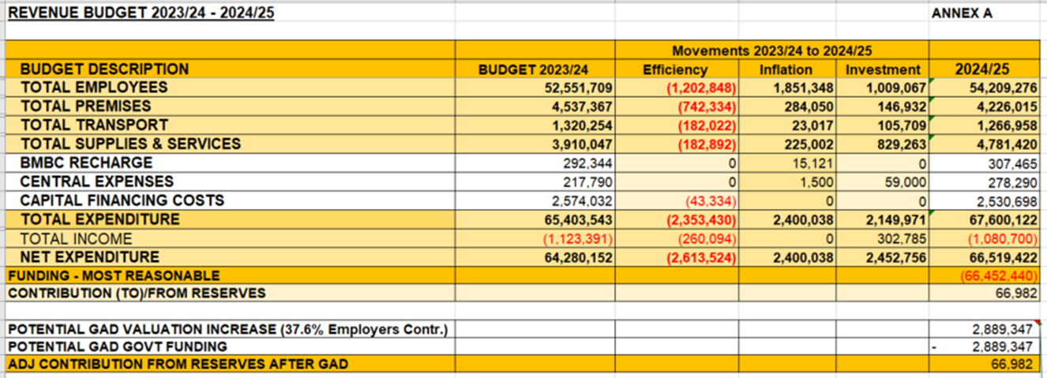

- Efficiencies planned in the 2024/25 budget
Appendix C shows the efficiencies included in the 2024/25 budget with a risk rating. All efficiencies reported release cash savings. No planned efficiencies are expected to have a negative service, quality or equality impact.

Those rated green are contracted savings, which are low risk to deliver.

Amber rated savings include a ‘vacancy factor’ for operational staff, with predictions based on trends relating to unexpected retirements, or a small number of new recruits not meeting the required standard at the end of their training course.

We are welcoming NHS South Yorkshire Integrated Care Board to the third floor of our HQ in 2024. This will enable closer working with NHS partners and also secure rental income and offset energy costs for part of our HQ. This is rated amber as the saving is dependent on completion of estates refurbishment, rental contracts and relocation. Letting arrangements are already in place with Age UK Sheffield, leasing part of HQ and Yorkshire Ambulance Service leasing parts of some fire station sites.

Premises budgets have been adjusted to reflect a net reduction, achieved through ongoing direct contracting for our premises maintenance and the continued benefits from our green plan. But savings are at risk if inflation for premises costs exceeds our expectations.

We also project a reduced fuel budget, but this is subject to diesel market prices.

In total, we’re planning a 20.% reduction in non-pay spending in 2024/25- exceeding the 2% spending review target. This excludes the £50k efficiency we plan for interest income as the Home Office Issued guidance specifies this should be excluded from this report*.

Over and above the cashable savings at Annex C, we continue to drive efficiency through:
- Use of technology. For example, we are considering investing in Microsoft Office 365 to improve workplace efficiency and integration across the service.
- Reviewing the use of our assets.
- Monitoring basic spending. For example, reviewing stock levels at our central stores with a particular focus on use of cleaning products, uniform and stationary items for fire stations.
- Working collaboratively. For example, in March 2024 a police and fire International Women’s Day event has taken place, with the SYFR and police women’s staff groups collectively organising and managing the event. We will continue this collaboration in 2024/25.
- A review of a Service Level Agreement with Barnsley Council, which provides support for a range of areas including people, financial services, legal and governance.

- Delivering efficiencies in 2024/25
Following the improvements in the 2024/25 budget setting process, we will further improve budget ownership and accountability by requiring budget holders to sign up to their budgets (stressing this is a maximum and not a target) and then enhance our monthly internal reporting and accountability process to avoid, minimise and mitigate any unfavourable variances. We will also identify, hold to account and report on our achievement of the identified efficiencies, line-by-line.

In addition to the internal service reporting, efficiencies will be itemised and tracked in the quarterly financial reporting to the Fire Authority through 2024/25.

ACHEIVEMENTS IN 2023/24

- Efficiencies achieved to 2023/24
In 2023/24 we planned to achieve non-pay savings of 1.6% against an overall budget of £64m.

Annex B details how we have delivered against the budgeted savings in 2023/24.

We are disappointed that we did not achieve all the savings we planned. This underperformance was due to inflation being above planned levels, which put pressure on budgets and increased the expected costs of most non-pay items. Pay increases were also higher than expected in 23/24 budgets.

In addition, we did not have embedded efficiencies tracking and reporting, which we are now rectifying- including named owners for delivering efficiencies.

However, the Annex shows that in addition to planned savings achieved (for example, energy costs due to an LED lighting project) significant underspends were achieved in 2023/24 on wholetime vacancies, corporate staff vacancies and vehicle running costs. In total, SYFR achieved £2.791m of savings against budgets (excluding interest*) or 17.81% of non-pay expenditure.

In addition to these cashable savings, there was some important preliminary work in the year which mitigated budget overspends and paved the way for improving productivity and efficiency, including:

- Collaboration arrangements with South Yorkshire Police for a Joint Community Safety Department and Joint Vehicle and Fleet Management
- A joint estates review, alongside South Yorkshire Police
- Involvement in a regional procurement group to identify and deliver on collaboration opportunities (e.g. vehicle, uniform and PPE procurements)
- Annual procurement review, demonstrating a high level of savings through robust procurement processes
- Hosting of Multi-Agency Gold Incident Command courses
- The fourth phase of a Digital Transformation Programme, to reduce paper and improve management reporting
- Introducing a modern online recruitment system
- Creating new People Services dashboards to more accurately project establishment staffing and workforce plans
- Implementing an e-expenses solution
- Preparatory work to sublet more space at our HQ which will lead to additional rental income in 2024/25.
- Delivery against our green plan, including swapping to LED and sensor controlled lighting and installing a building management system to control energy consumption and assessing the works needed to get to net zero which has allowed us to bid for further significant funding to support this work. We have also applied to join Sheffield’s district heat network.
- We have commissioned an external review which will support the development of a new CRMP for 25/26 onwards and will give an independent view on operational efficiency options and their impact on Risk management.
- Report and challenge excessive office printing and copying
- Review of a Service Level Agreement with Barnsley Council
- Continued agile working- saving on staff travel time, fuel consumption and office space required
- Establishing a sustainability committee to oversee investments to reduce carbon emissions and increase efficiency
- Contributing to the Emergency Services Network changeover. Though this is paused nationally, we expect it to deliver local efficiencies in the future.

Section 2: Productivity
We monitor performance and productivity using real-time information which is available at strategic, managerial and operational levels through live data. Workforce productivity is scrutinised at a watch, station, district and function level. We commit to increasing productivity by (at least) 3% in 2024/25.

The Fire Authority plays a particularly important role in scrutinising our performance. Its responsibilities are outlined in its Scrutiny & Assurance Protocol- which was updated in November 2023. The majority of the Fire Authority’s scrutiny work is discharged via its Performance & Scrutiny Board which meets quarterly and considers reports from the service relating to all of its local performance indicators (LPIs).

- Community Risk Management Plan

Much of the work we deliver for local people is outlined in our Community Risk Management Plan (CRMP). The CRMP explains how we allocate our resources to meet local risk and achieve our statutory objectives. We review our CRMP every year and are producing a new CRMP for 2024/25. We will assess the new CRMP by how it improves our productivity performance, using a suite of existing Local Performance Indicators (LPIs) which all parts of the service contribute to.

As part of the CRMP review we will consider how we match our response resources to identified risks, specialist assets and how they are managed and use of on-call firefighters.

Outcomes are expected to include recommendations for improving the efficiency of our operational response through the most effective deployment and distribution of wholetime firefighters and other assets.

A comprehensive, data-led review of all our fire stations is being undertaken by an independent, third party specialist to ensure we are continuing to use our resources in the most efficient ways possible.

We will also clarify and restate our objectives and what work we consider ‘productive’ for the purposes of our productivity reporting.

- Resourcing

The service uses on-call, day staffing and 2-2-4 duty systems to provide emergency response cover. We also maintain contingency arrangements in place for business continuity purposes- such as periods of industrial action.

Our resourcing models will be considered as part of our refresh of CRMP to ensure productivity targets are met (exceeded where possible).

- Productivity monitoring

We are required to deliver a wholetime productivity improvement by the end of the spending review period in 2024/25.

We also want to increase our productivity across the whole service- including prevention, protection, corporate staff and on-call firefighting teams. We will achieve this though better monitoring of productivity, using this process to identify opportunities for efficiencies. We record our public facing activity extensively, so by continuing to review this will be able to identify where improvements can be made.

We also aspire to monitor the quality of outcomes- for example through public engagement and feedback. We will work with the National Fire Chief’s Council to develop and follow national standards for quality-based productivity outcomes.

To increase productivity in 2024/25, we will review the targets that are set with the station and team plans, ensuring that priorities link to the organisation plan. This productivity will then be monitored through our internal governance structure -including targets in performance clinics and at Service Delivery Board.

To enable this the Service Delivery Board will:
- Review data systems and reporting to enable simple and then more sophisticated tracking of productivity vs targets
- Review work routines- on fire stations and beyond
- Review training time and budgets
- Review the allocation of Business Fire Safety and Community Safety work (including fitting of smoke alarms)
- Consider extending body worn cameras to other parts of the service, reducing time required to gather information and evidence
- Review opportunities to increase fire availability- such as driver training

- Wholetime productivity improvements achieved in 2023/24

Wholetime firefighter productivity is currently measured by the volume of productive activity undertaken by those firefighters (over and above response activity):

- Prevention activity including physical risk-based domestic Home Fire Safety Visits
- Protection activity including Business Fire Safety risk-based engagements and audits
- Local risk identification, management and recording activity including Site Specific Risk Information visits aligned to the FRS Act 2004 s7(ii)d.
- Learning and Development activities to maintain firefighter role competence.
- Recruitment activities in support of Positive Action

The performance for productivity activity over time is shown and described below.

Graph One: Home Fire Safety Checks (HSCs) performed by operational crews (from 2022/23 to 2023/24)

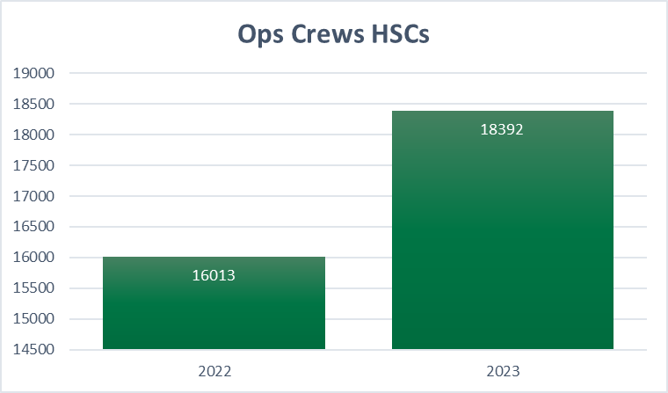

Graph one shows a 14.8% year-on-year increase in Home Fire Safety Visits, as activity recovers to pre-pandemic levels and target setting makes an impact. However, we aspire to become more efficient by developing partnership referrals to ensure we are reaching people most at risk. Districts and watches work towards agreed targets which are captured within station plans, allocating time and resources according to their local needs and risks. These are monitored frequently using live data, watch manager and district meetings.

Graph Two: Home Fire Safety Checks performed by Community Safety (CS) Teams (from 2022/23 to 2023/24)
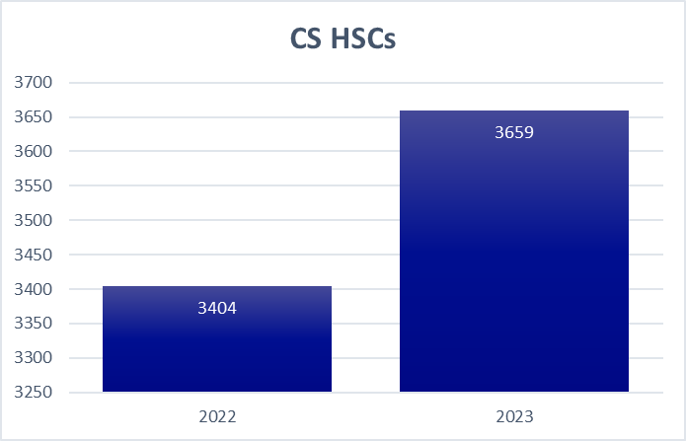

Home Fire Safety visits increased by 7.5% year-on-year. The community safety team focuses on higher risk members of the public who require additional support. The team work with partners to identify efficiency with the referral process, feeding this back into working practices. We are trialling the dispersal of community safety teams across the county, saving time on the road and increasing time spent in the community.

Graph Three: Home Fire Safety Checks performed by Operational Crews (from 2017/18 to 2023/24)

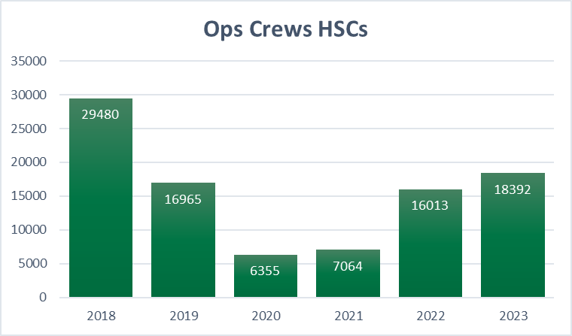

The service moved to a risk-based Home Fire Safety Visit offer in 2018/19 which affected the number of visits undertaken by operational crews. Previously, anyone in South Yorkshire who requested one would have received a Home Fire Safety Visit. Now, we have a set of risk-based criteria in place which helps us target our visits at those who most need our support. Those most at risk of fire continue to receive a physical visit, whilst the lowest risk residents receive alternative advice and support. Excluding the years of the pandemic, we are now above the pre-pandemic numbers of HSCs delivered, whilst still maintaining a risk based approach.

Graph Four: Home Fire Safety Checks performed by Community Safety Teams (from 2017/18 to 2023/24)

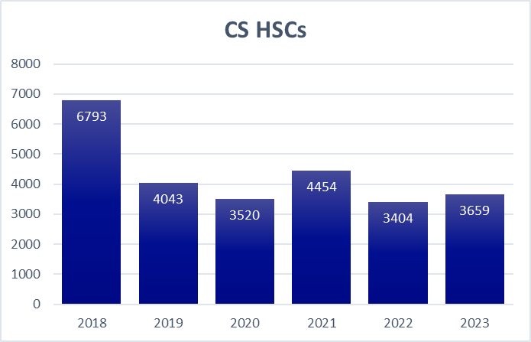

Visits carried out by the Community Safety Team focus on higher risk visits, whilst supporting High Risk Co-ordinators and crews. These visits can take considerably longer due to complex needs of those we are supporting. Regular performance monitoring is now taking place and targets are being implemented.

Business Fire Safety Engagements (from 2022/23 to 2023/24)

The majority of our business fire safety engagements are undertaken by a specialist team of business fire safety advisors and inspectors.

Graph Five: Business Fire Safety Inspections performed by Business Fire Safety Teams (from 2022/23 to 2023/24)

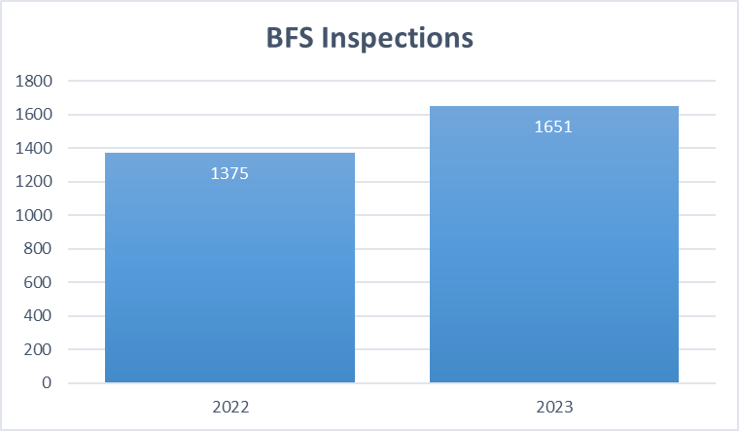

Graph Six: Business Fire Safety Inspections performed by Business Fire Safety Teams (from 2017/18 to 2023/24)

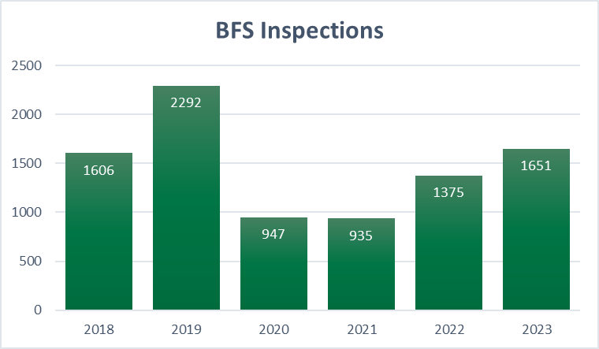

The graph shows a 20% increase in visits and productivity year-on-year. The reduction in inspections in 2020 and 2021 is largely explained by the impact of the Covid-19 pandemic.

Graph Seven: Operational Risk Inspections performed by operational crews (from 2022/23 to 2023/24)
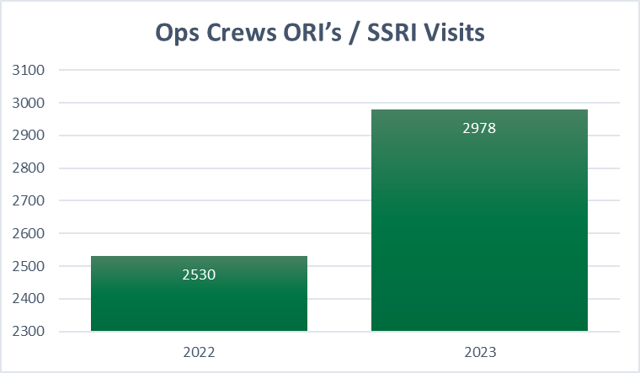

The graph shows an 18% increase in visits and productivity year-on-year.

This positive increase is linked to the clear identification of site risks and introduction of station plans, which include targets for this work. We are currently reviewing our process and criteria for reviewing risks.

Graph Eight: Operational Risk Inspections performed by operational crews (from 2017/18 to 2023/24)
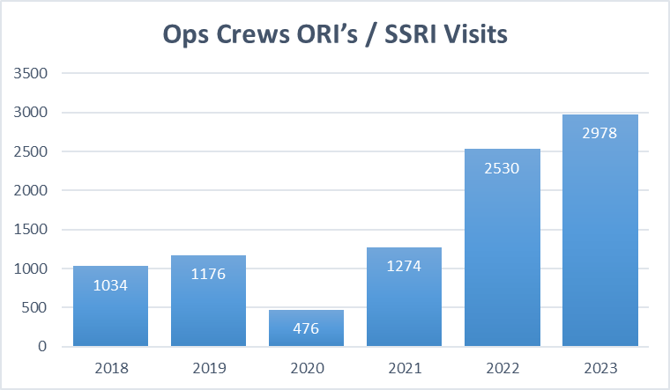

The graph shows an increase in Inspection visits and productivity of 18% year-on-year.

Graph Nine: Primary School Pupils visited by SYFR (from 2022/23 to 2023/24)
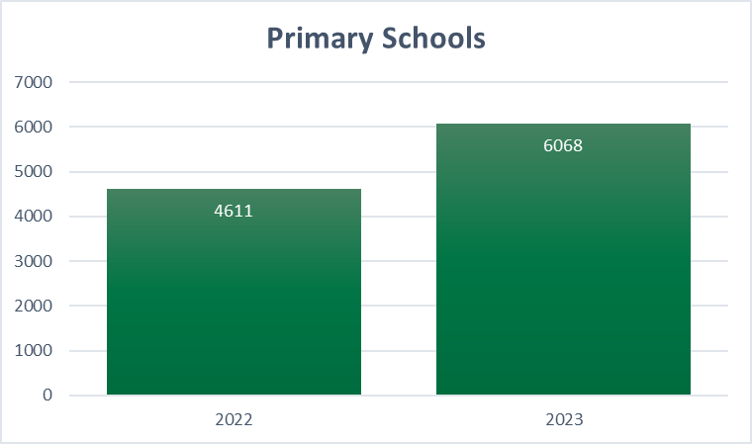

The community safety team work with schools to target specific age ranges and areas within South Yorkshire. Work continues to identify the areas where the communities may benefit the most. Schools we are unable to attend gain access to the materials online.

Graph Ten: Secondary School Pupils visited by SYFR (from 2022/23 to 2023/24)
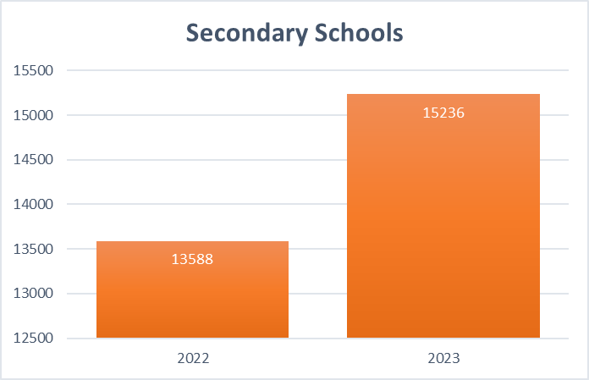

Graph Eleven: Total Primary and Secondary School Pupils visited by SYFR (from 2022/23 to 2023/24)
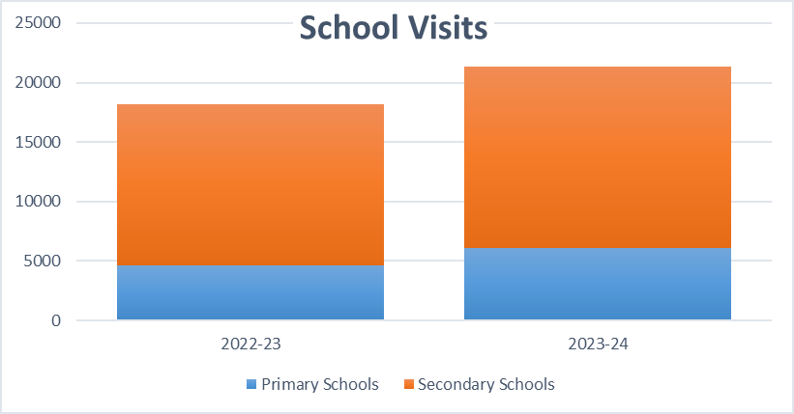
The graph shows a 17% increase in visits and productivity year-on-year.

Graph Twelve: Total Pupils attending SYFR Lifewise Centre (from 2022/23 to 2023/24)

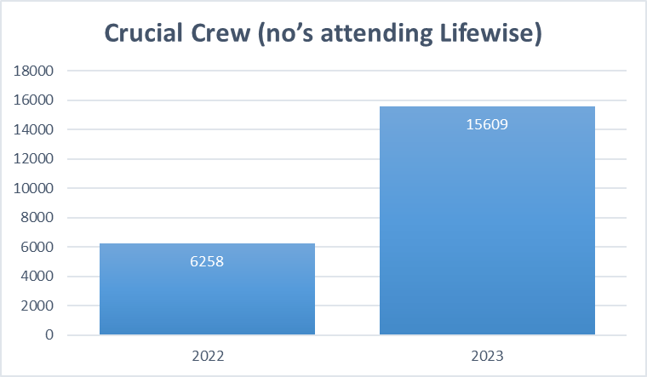

The graph shows a 149% increase in attendances compared to the previous year.
All schools in South Yorkshire are invited to attend Crucial Crew, which delivers bespoke scenarios. Over 90% of schools attend and we continue to engage those who do not currently take up this offer.

