Workforce Diversity Profile

1st April 2023 to 31st March 2024

September 2024

**Workforce Diversity Profile**

**2023/24**

**Contents**

Introduction 2

A Note on Intersectionality 3

Our Diverse County 4

Summary 5

Year-on-Year Summary 8

Age Diversity Profile 11

Disability Diversity Profile 14

Faith & Belief Profile 17

Race Diversity Profile 20

Sex Diversity Profile 24

Sexual Orientation Profile 28

Top 5% of Earners Diversity Profile 31

Discipline and Grievance Diversity 33

Leavers and New Starters Diversity 34

Part-Time Staff 37

Volunteers 38

Conclusion 40

# Introduction

Cultivating a diverse and inclusive workforce is a top priority for all fire and rescue services, especially given the sector's current emphasis on culture. At the heart of our core values is the belief that enhancing diversity within our Service introduces a variety of perspectives, ideas, and knowledge, ultimately improving how we serve our staff and communities. These values are reflected in our [2024-25 Service Plan](https://www.syfire.gov.uk/wp-content/uploads/2024/03/SYFR_Service_Plan_2024_Acc.pdf) priorities, which are bolstered by our People & Culture Strategy and EDI Annual Report.

This report analyses the diversity profiles of our employees. We focus on a range of key protected characteristics: age, disability, faith & belief, race, sex, and sexual orientation. Data was collected between April 1st, 2023, and March 31st, 2024.

This report includes:

* **Internal Data Analysis:** We examine the current composition of our workforce across protected characteristics.
* **Year-on-Year Comparisons:** We track progress towards a more diverse and inclusive fire service by comparing data to the previous year's report.
* **Benchmarking with Census Data:** We compare our workforce demographics against relevant data from the 2021 Census to understand how well we reflect the communities we serve.

By analysing this data, SYFR can identify areas for improvement and develop targeted strategies to achieve a workforce that truly reflects the diversity of South Yorkshire.

# A Note on Intersectionality

This report acknowledges that categorising employees into single demographic groups doesn't capture the full picture. While certain aspects of our identities can grant privilege, many employees will likely face marginalisation at some point due to overlapping aspects of their identities. This concept, known as intersectionality, is crucial for understanding the diverse experiences within our workforce.

Our data collection, language and analysis are constantly evolving to better reflect the diverse experiences of our workforce. This deeper understanding empowers us to proactively address potential issues and foster a safe, supportive, and relevant work environment. Ultimately, empowered employees translate to better service for the communities we serve.

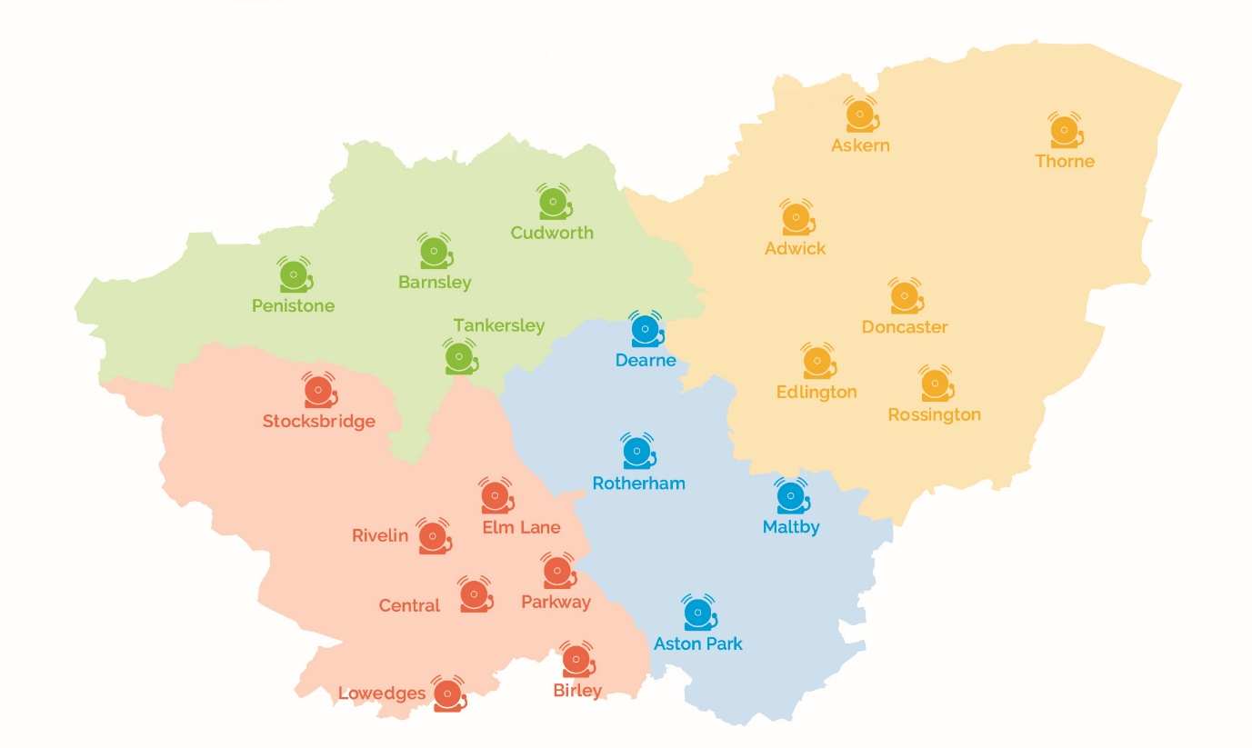

*Our Districts and Stations*

# **Our Diverse County**

South Yorkshire Fire & Rescue (SYFR) proudly serves the vibrant communities across our region. Operating 24/7 from 21 stations and a central Control Centre, we ensure fire safety for 1.4 million residents within the four districts: Barnsley, Doncaster, Rotherham, and Sheffield.

According to the 2021 Census, 17% of South Yorkshire residents are Black, Asian, or from mixed or other minority ethnic groups.

Around 21% of the population have disabilities or long-term illnesses.

The Census also revealed that 46% of South Yorkshire's population identify as Christian, while 42% reported no religious affiliation. Additionally, 6% of the population identify as Muslim.

In terms of sexual orientation, 3% of South Yorkshire's residents identify as Lesbian, Gay, or Bisexual.

Similar to most other counties, South Yorkshire has a balanced gender distribution.

Understanding the unique needs and potential fire risks faced by different groups is crucial. This allows us to fulfil our twin obligations: ensuring the safety of everyone in South Yorkshire and fostering a fire service that truly represents the people we serve.

# Summary

**The SYFR headcount is at 1019.** We are reporting on headcount rather than Full-Time Equivalent (FTE), so we are counting people rather than overall worked hours. We do not currently report on contingency workers, non-employees and agency members of staff.

For 2024 we have added in new reporting areas, covering part time staff and volunteers and enhanced other areas to include ethnicity by sex and disability by type.

|  |  |  |  |  |
| --- | --- | --- | --- | --- |
| **Headcount by Workgroup** | | | | |
| **Control** | **Corporate** | **Operational** | **On-call** | **Total** |
| 32 | 272 | 594 | 121 | 1019 |

To get a better picture of the makeup of our workforce we break down our data across different workgroups which are defined as follows:

**Control -** our employees who take emergency calls and dispatch our fire engines and crews

**Corporate** - our employees who support the running of the organisation. This includes people working in teams such as ICT, People, Finance, Communications, Procurement and Data. It also includes our uniformed Community Safety and Business Fire Safety teams

**Operational -** our wholetime (full time) operational employees who work a range of shift patterns. This includes the majority of our firefighters and uniformed officers.

**On-call** – our part-time operational employees. On-call firefighters live or work within five minutes of a fire station and respond to emergency calls.

The tables below outline the workforce diversity figures for SYFR in 2022-23, 2023-24 and the South Yorkshire comparison. When comparing the data for 2022-2023 and 2023-2024, we are showing a positive change across all protected characteristics, with an average above that of South Yorkshire for representation from LGB+ staff.

|  |  |  |  |  |  |  |  |
| --- | --- | --- | --- | --- | --- | --- | --- |
| **South Yorkshire Fire & Rescue Workforce Diversity Figures**  **2022-23** | | | | | | | |
| Disabled | 3.87% | Minority  Ethnic | 6.98% | Female[1] | 23.04% | LGB+[2] | 3.49% |
| Non-Disabled | 92.45% | White British | 92.82% | Male | 76.95% | Heterosexual | 78.75% |

|  |  |  |  |  |  |  |  |
| --- | --- | --- | --- | --- | --- | --- | --- |
| **South Yorkshire Fire & Rescue Workforce Diversity Figures**  **2023-24** | | | | | | | |
| Disabled | 6.67% | Minority  Ethnic | 7.16% | Female | 23.92% | LGB+ | 4.49% |
| Non-Disabled | 89.22% | White British | 91.86% | Male | 75.29% | Heterosexual | 79.48% |

|  |  |  |  |  |  |  |  |
| --- | --- | --- | --- | --- | --- | --- | --- |
| **South Yorkshire Diversity Figures**  **Based on 2021 National Census** | | | | | | | |
| Disabled | 20.5% | Minority  Ethnic | 16.7% | Female | 50.7% | LGB+ | 3.2% |
| Non-Disabled | 79.5% | White British | 83.3% | Male | 49.3% | Heterosexual | 90% |

Note: Age and Faith & Belief are not incorporated into this summary table as the range of options are so wide. Details of these areas can be found on the relevant sections.

**Disclosure**

At SYFR we value employee participation in building a diverse and inclusive workplace. To achieve this, we rely on staff to voluntarily share their protected characteristic information. While we understand some may choose "Prefer not to say," this can limit our ability to gather a fully comprehensive picture of our workforce demographics.

We've removed the option to "not complete" the equality data section. This ensures everyone has the opportunity to contribute to a more accurate picture of our staff.

We understand that sharing personal information can be a personal decision. We're committed to fostering an environment where employees feel comfortable disclosing their protected characteristics. We're actively promoting the benefits of data transparency and how it shapes our organisation.

**Positive Action**

The Equality Act 2010 allows us to support under-represented groups, promoting fair recruitment and building a workforce that reflects our communities. This is distinct from unlawful "positive discrimination," where selection solely depends on a protected characteristic.

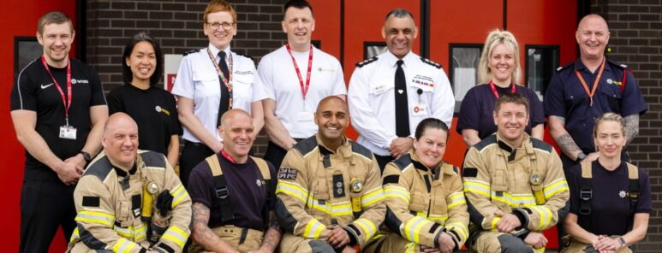

# Free Trending Icon - Free Download User Interface Icons | IconScoutYear-on-Year Summary

Entire workforce as at 31st March 2024

These charts provide a year-by-year comparison for each group. Further analysis and commentary are presented in the subsequent sections.

**Age Diversity**

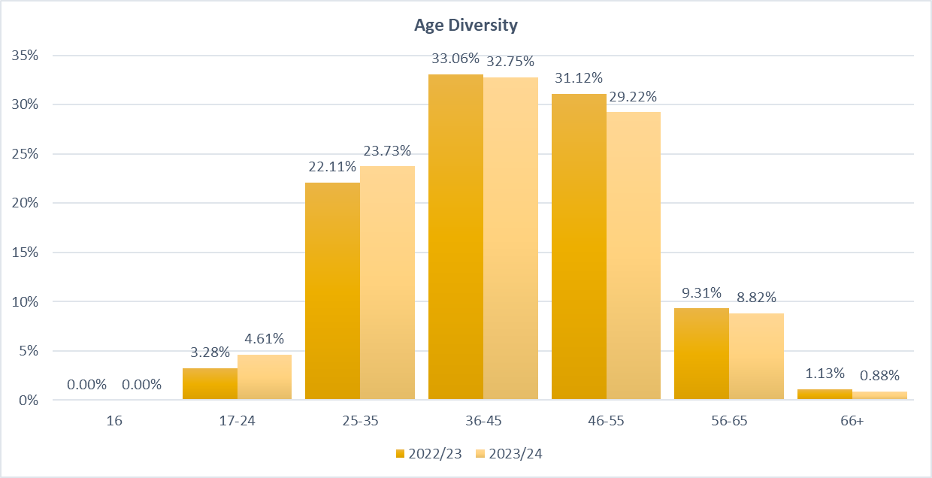

**Disability Diversity**

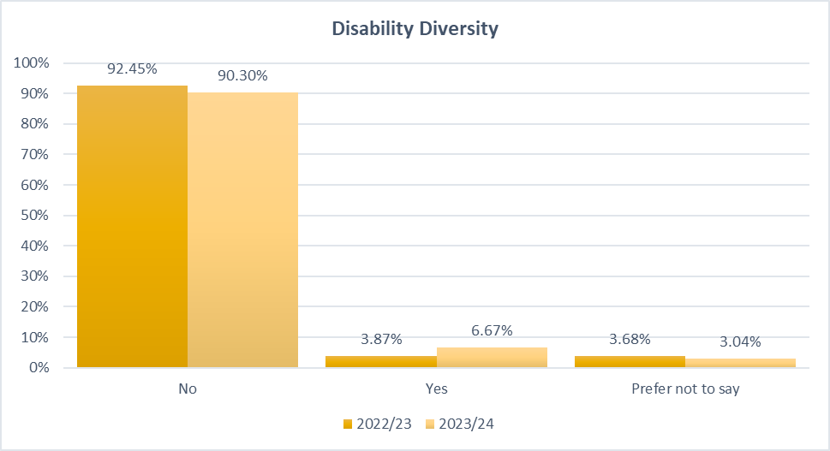

**Faith & Belief Diversity**

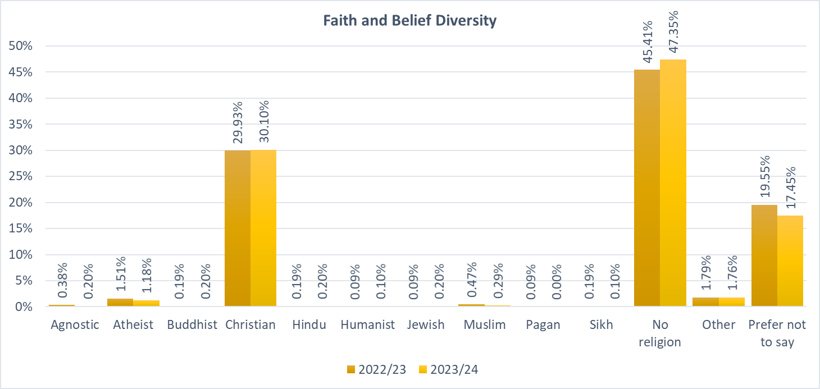

**Race Diversity**

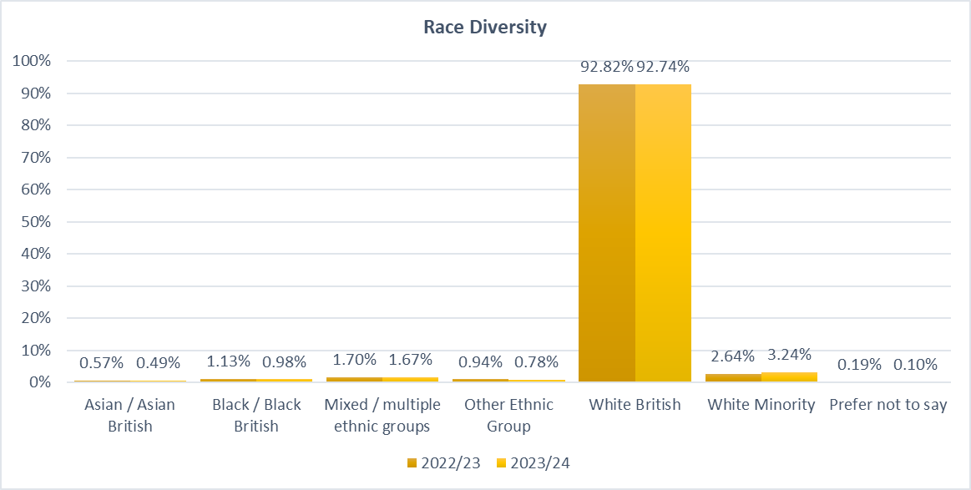

**Sex Diversity**

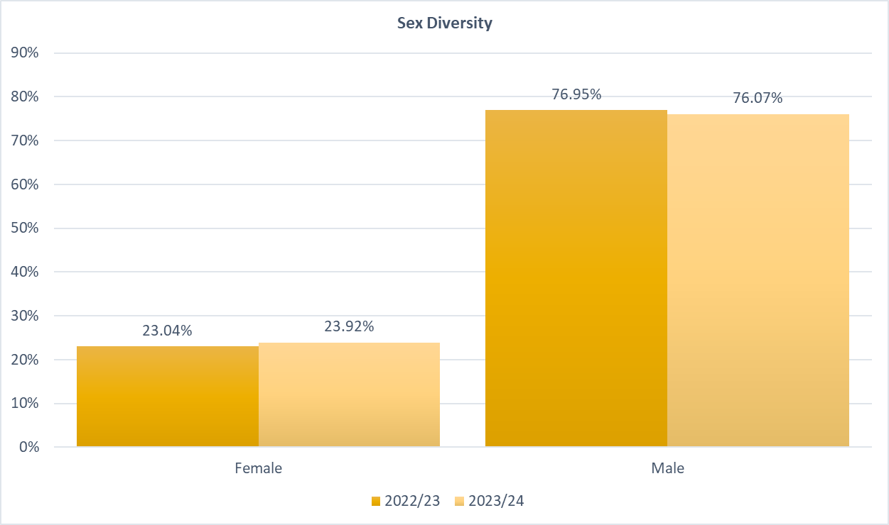

**Sexual Orientation Diversity**

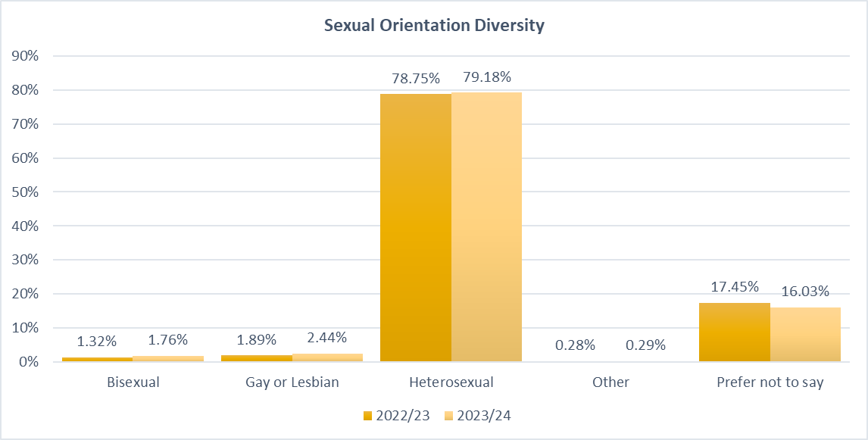

# https://media.www.kent.ac.uk/se/16493/Icon-1copy_800w.pngAge Diversity Profile

A person of a particular age group, whether by reference to a particular age or to a range of ages.[3]

**We have a 100% disclosure rate for employee age.** Age declarations for all employees are mandatory and a necessary legal requirement for employment.

|  |  |  |  |  |  |  |  |
| --- | --- | --- | --- | --- | --- | --- | --- |
| Whole Workforce – Age Range | | | | | | | |
|  | **16** | **17-24** | **25-35** | **36-45** | **46-55** | **56-65** | **66+** |
| 2022/23 | 0.00% | 3.28% | 22.11% | 33.06% | 31.12% | 9.31% | 1.13% |
| 2023/24 | 0.00% | 🡩 4.61% | 🡩 23.7% | 32.75% | 29.22% | 8.82% | 0.88% |



*Due to differences in data capture, the overall 2022/23 figures are based on leavers/new starters to provide a more accurate comparison*

**The mean age of all employees is 42 years.**

The data suggests a relatively stable age distribution within the workforce over the analysed period. A slight decrease in the percentage of employees in the 56-65 age group is observed in 2023/24 compared to the previous year.

The majority of the workforce falls within the 36-45 and 46-55 age groups, with both groups comprising over 60% of the total workforce combined. This could indicate an experienced workforce with a solid foundation.

The increasing number of younger employees indicates some success in attracting and retaining this demographic.

|  |  |  |  |  |  |  |  |
| --- | --- | --- | --- | --- | --- | --- | --- |
| **2023/24 – Age Range by Workgroup** | | | | | | | |
|  | **16** | **17-24** | **25-35** | **36-45** | **46-55** | **56-65** | **66+** |
| **Control** | 0.00% | 3.13% | 31.25% | 21.88% | 25.00% | 18.75% | 0.00% |
| **Corporate** | 0.00% | 6.62% | 19.85% | 21.69% | 27.21% | 21.32% | 3.31% |
| **Operational** | 0.00% | 2.53% | 22.73% | 38.89% | 32.32% | 3.54% | 0.00% |
| **On-Call** | 0.00% | 10.74% | 35.54% | 30.58% | 19.01% | 4.13% | 0.00% |

**Control:** Control has a balanced distribution with a significant proportion of employees 25-55.

**Corporate:** Corporate has a wider age range distribution, including a notable presence of employees aged 66+.

**Operational:** Operational staff are heavily concentrated in the 36-55 age range.

**On-Call:** The On-Call group has the youngest workforce, with a significant proportion under 35.

**Age Updates**

The first Age Staff Group meeting was held in May 2023 with an initial focus on:

1. Our younger employees and their experience of working in the service and how we can attract more young people to join and stay with us.
2. Recognising we have an aging workforce, our older employees and their experience and challenges in role in their later years of employment with the service.

Our Fire Cadet records are moving to an electronic management system, allowing us to analyse diversity data of our Youth Engagement work.

Our new Positive Action & Community Engagement database has gone live, allowing us to better capture details of engagement, including in schools and education settings.

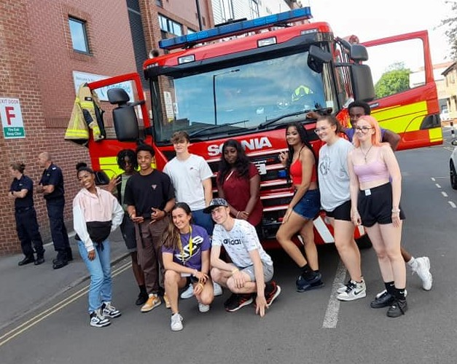

# Protected Characteristics - Equality, Diversity and Inclusivity ...Disability Diversity Profile

…a physical or mental impairment that has a 'substantial' and 'long-term' effect on your ability to do normal daily activities.[4]

**Disability declarations have increased to 6.67% from 3.87%.** This could indicate increased awareness as well as an increase in the number of individuals with disabilities. The slight decrease in 'Prefer not to say' might suggest increased comfort or trust in disclosing disability status.

|  |  |  |  |
| --- | --- | --- | --- |
| Whole Workforce – Disability | | | |
|  | **No** | **Yes** | **Prefer not to say** |
| 2022/23 | 92.45% | 3.87% | 3.68% |
| 2023/24 | 90.30% | 🡩 6.67% | 🡫3.04% |

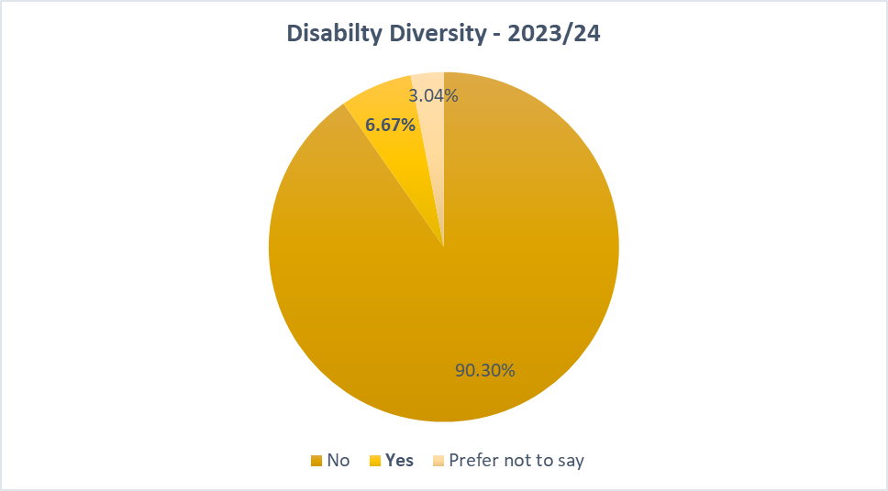

Without additional context, it's challenging to determine the reasons behind the changes in disability declarations. Individuals can now indicate the type of disability they identify with.

|  |  |
| --- | --- |
| Disability Type | % |
| Hearing | 4.23% |
| Learning | 47.89% |
| Mental health | 14.08% |
| Physical | 11.27% |
| Prefer not to say[5] | 12.68% |
| Progressive condition | 8.45% |
| Visual | 1.41% |

Learning disabilities are the most prevalent, constituting **47.89%** of reported disabilities. It is important to note that this is just a brief overview of each disability type, and there is a wide range of variation within each category. Additionally, some individuals may have multiple disabilities.

|  |  |  |  |
| --- | --- | --- | --- |
| 2023/24 – Disability by Workgroup | | | |
|  | **No** | **Yes** | **Prefer not to say** |
| Control | 87.50% | 9.38% | 3.13% |
| Corporate | 84.19% | 11.76% | 2.94% |
| Operational | 91.25% | 4.38% | 3.20% |
| On-Call | 90.91% | 5.79% | 2.48% |

The differences in disability rates between workgroups likely reflects factors such as job roles and work environments, although this could potentially indicate disparities in workplace culture.

**Disability Updates**

Types of disability have been included in our diversity analysis for the first time giving us some insight into how our disabled staff identify.

Our Disability, Carers and Neurodiversity staff group has supported and promoted Neurodiversity Celebration Week and Young Carers Action Day.

New Neurodiversity and Reasonable Adjustment policies are in draft to be launched in 2024/25.

New eLearning *Skillbooster* modules have been launched which include subjects such as disability, neurodiversity and mental health.

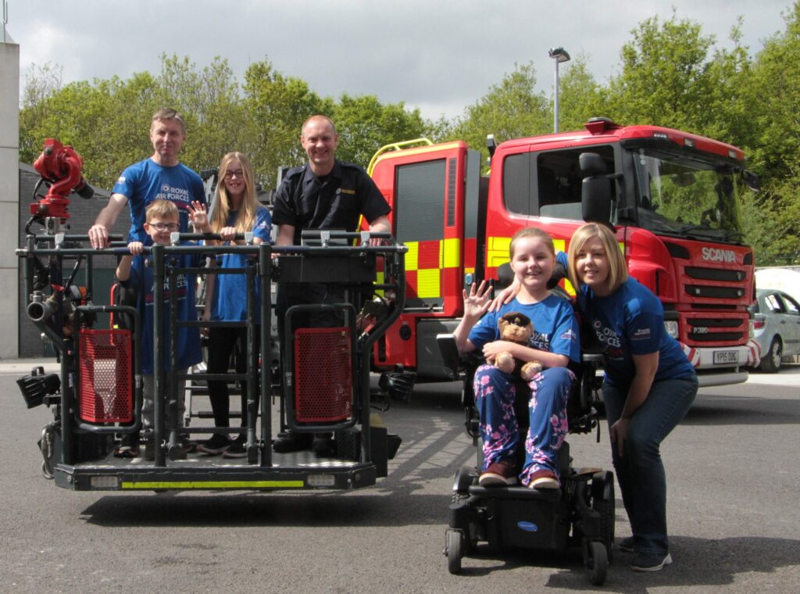

# https://media.www.kent.ac.uk/se/16567/Icon-7_800w.pngFaith & Belief Profile

Any religion or religious or philosophical belief, including a lack thereof.[6]

**82.55% of employees disclosed their religious belief information, an increase of 2.1% on the previous year.**

Christianity remains the largest religious group, while the proportion of employees with no religion saw a small increase. The proportions of employees identifying with minority religions (Hindu, Buddhist, Jewish, Sikh, etc.) remain relatively stable with minor fluctuations.

**Muslims are underrepresented in the workforce.**

This data fits with our ethnicity data which shows a disparity around Asian/Asian British communities which many of our Muslim employees are likely to be from.

|  |  |  |  |
| --- | --- | --- | --- |
| Workforce / Census Comparison – Faith & Belief | | | |
|  | **2022/23** | **2023/24** | **South Yorkshire Census 2021** |
| Agnostic | 0.38% | 0.20% | 0.00% |
| Atheist | 1.51% | 1.18% | 0.00% |
| Buddhist | 0.19% | 0.20% | 0.30% |
| Christian | 29.93% | 30.10% | 45.60% |
| Hindu | 0.19% | 0.20% | 0.40% |
| Humanist | 0.09% | 0.10% | 0.00% |
| Jewish | 0.09% | 0.20% | 0.10% |
| Muslim | 0.47% | 0.29% | 5.70% |
| Pagan | 0.09% | 0.00% | 0.10% |
| Sikh | 0.19% | 0.10% | 0.20% |
| No religion | 45.41% | 47.35% | 41.60% |
| Other | 1.79% | 1.76% | 0.30% |
| Prefer not to say | 19.55% | 17.45% | 5.60% |

*Comparison Note: Census 2021 counts Agnostic, Atheist and Humanist as* '*no religion*'

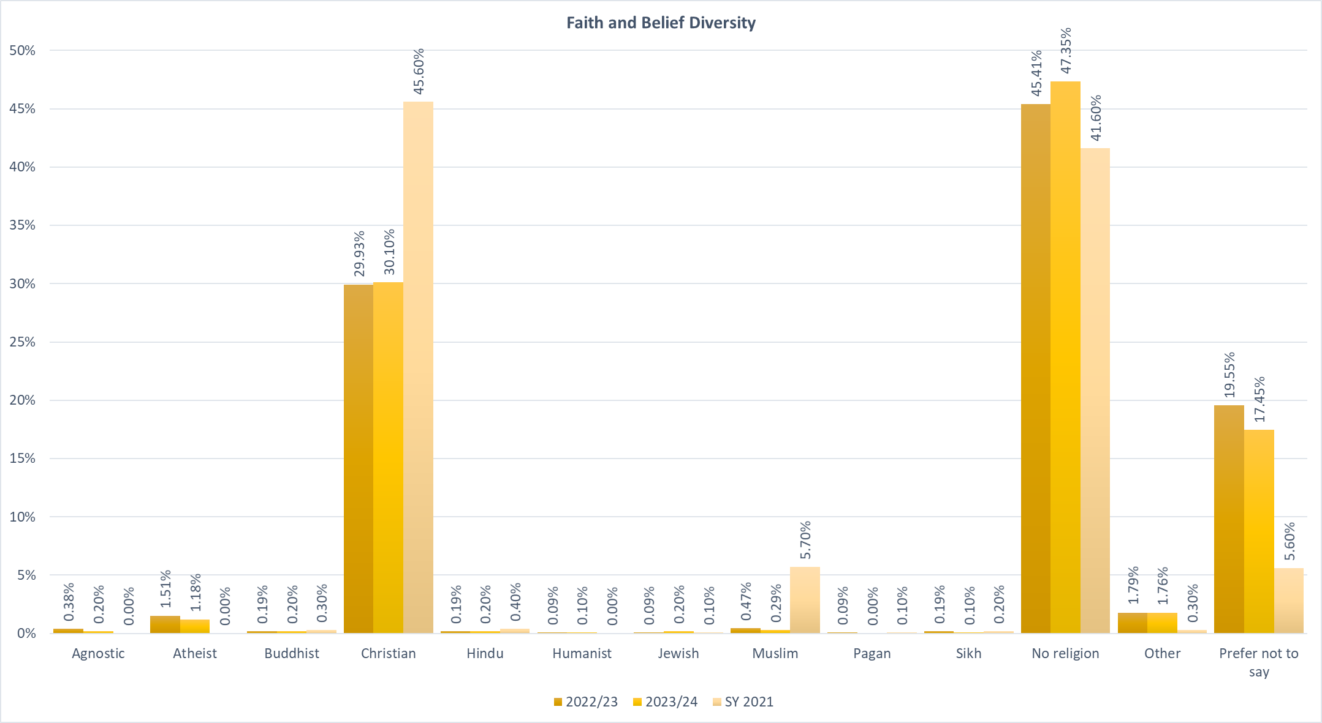

**Faith & Belief Updates**

We continue to attend community events such as the Doncaster Vaisakhi Parade, Barnsley Community Iftar and Madina Masjid Open Day.

Safety advice related to specific religious and cultural festivals including Ramadan, Diwali and Chinese New Year is promoted at the relevant times of year, alongside our recruitment messaging.

We have worked with the Asian Fire Service Association (AFSA) to circulate their Ramadan Resource Toolkit and Top Tips to support our own guidance documents.

Our Faith & Belief Staff group have produced internal communications about different religious festivals and events throughout the year. The group has spearheaded a collaboration with other staff groups to review the purpose, standard and use of our multi-faith rooms across our estate.

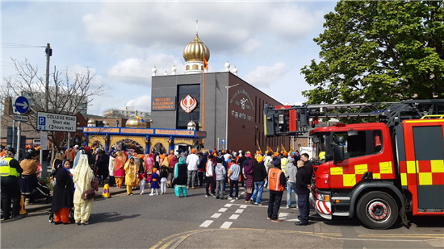

# https://media.www.kent.ac.uk/se/16566/Icon-6_800w.pngRace Diversity Profile

Race includes colour; nationality (including citizenship); ethnic or national origins.[7]

**Minority Ethnic representation has increased again from 6.98% to 7.16%.** When reporting on different ethnicities we separate out White British so all other ethnicities are included as minorities. This is because White British represents the ethnic majority for South Yorkshire and that some white ethnicities, such Roma, are among the most vulnerable communities when it comes to marginalisation.

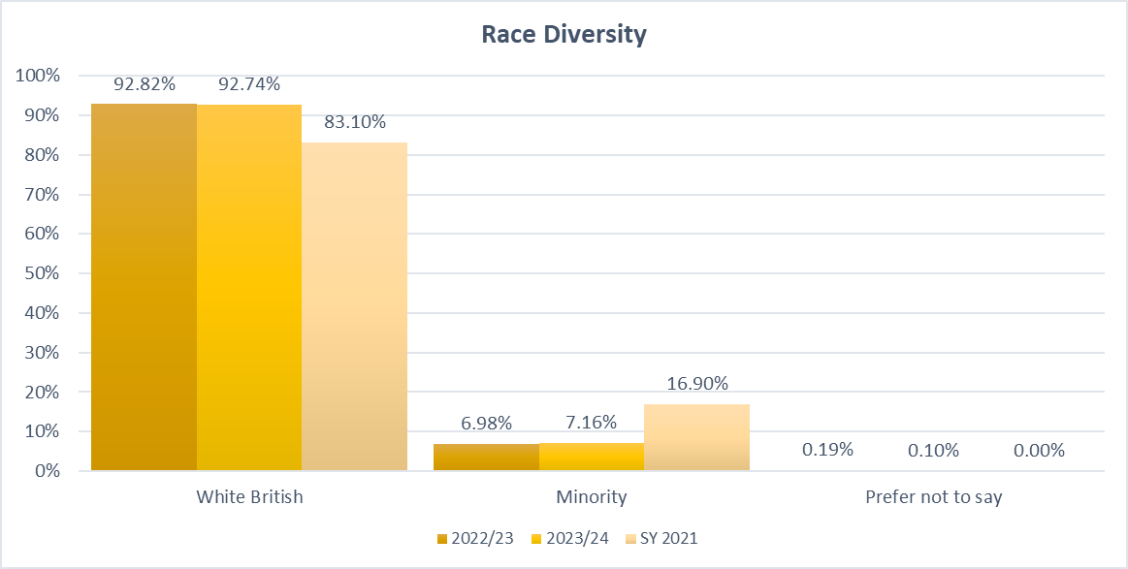

**The workforce has a significantly higher proportion of White British employees compared to the regional census data.**

There's a slight increase in the percentage of employees identifying as White Minority. The percentages of other ethnic groups have remained relatively stable.

Asian/Asian British is the most significantly underrepresented group.

|  |  |  |  |  |  |
| --- | --- | --- | --- | --- | --- |
| Workforce – Minority Ethnic Breakdown | | | | | |
| . | **Asian/Asian British** | **Black/ Black British** | **Mixed/Multiple Ethnic Groups** | **Other Ethnic Group** | **White Minority** |
| 2022/23 | 0.57% | 1.13% | 1.70% | 0.94% | 2.64% |
| 2023/24 | 🡫 0.49% | 🡫 0.98% | 🡫 1.67% | 🡫 0.78% | 🡩 3.24% |
| SY 2021 | 5.80% | 2.50% | 2.20% | 1.80% | 4.60% |

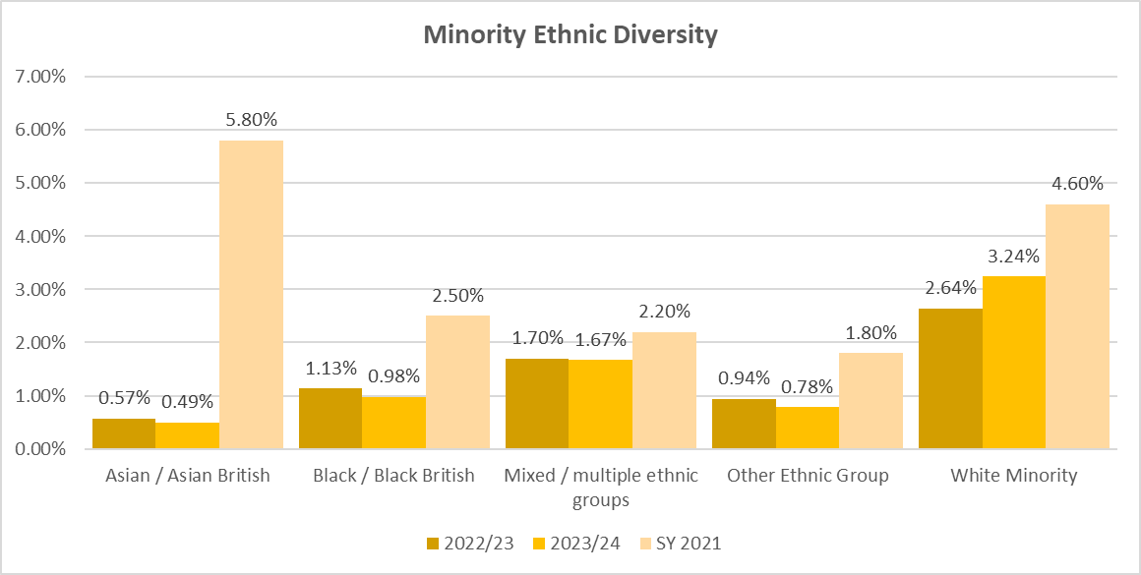

|  |  |  |  |  |  |  |
| --- | --- | --- | --- | --- | --- | --- |
| Minority Breakdown by Workgroup | | | | | | |
|  | **2022/23** | | | **2023/24** | | |
| . | **White British** | **Minority** | **Prefer not to say** | **White British** | **Minority** | **Prefer not to say** |
| Control | 97.06% | 2.94% | 0.00% | 96.87% | 🡩 3.13% | 0.00% |
| Corporate | 88.97% | 10.34% | 0.69% | 90.81% | 🡫 8.82% | 🡫 0.37% |
| Operational | 93.70% | 6.31% | 0.00% | 92.92% | 🡩 7.08% | 0.00% |
| On Call | 96.21% | 3.79% | 0.00% | 95.03% | 🡩 4.97% | 0.00% |

There is a slight increase in minority representation across most workgroups except Corporate.

|  |  |  |
| --- | --- | --- |
| Minority by Operational Role | | |
|  | **2022/23** | **2023/24** |
| Principal Officer | 0.00% | 0.0% |
| Area Manager | 0.00% | 0.0% |
| Group Manager | 0.00% | 0.0% |
| Station Manager | 3.70% | 🡩 4.0% |
| Watch Manager | 1.85% | 🡩 3.9% |
| Crew Manager | 2.34% | 🡫 2.0% |
| Firefighter | 3.37% | 🡩 7.7% |

There remains no Operational minority ethnic representation above Station Manager. A notable increase at Watch Manager and Firefighter level may indicate a trend towards increased diversity in this workgroup.

**Race Updates**

Our Race Staff Group hosted another successful Black History Month Event attended by our staff and partners across the region. A collaboration with South Yorkshire Police (SYP) is already underway for a bigger event in 2024.

We partnered with various groups to attend talks and events with a focus on recruitment and home safety. This has included working with Barnsley Migration Partnership, Israac Somali Community Association and ADIRA.

Our Community Safety team worked with SYP and New Era Square to provide safety and recruitment advice to Chinese students. We also attended a Chinese New Year event in Sheffield and our Business Fire Safety Team continued efforts to engage with small business owners from this community.

Our existing partnership with AFSA continued and we attended conferences and development events throughout the year.

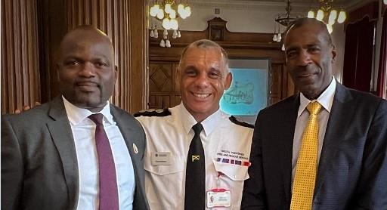

# https://media.www.kent.ac.uk/se/16563/Icon-3_800w.pngSex Diversity Profile

A person or group of people of a particular binary sex, either male or female.[8]

**23.92% of the workforce is female.** While this is a slight increase on last year, it is still not representative of the South Yorkshire population which is 49.3% male and 50.7% female.[9]

|  |  |  |
| --- | --- | --- |
| Gender Diversity - Workforce | | |
|  | **Female** | **Male** |
| 2022/23 | 23.04% | 76.95% |
| 2023/24 | 🡩 23.92% | 76.07% |

Historically, the firefighting workforce has been predominantly male. Despite progress being made in recruiting more female members of staff to operational firefighting roles, the sector continues to face a significant gender imbalance.[10]

|  |  |  |  |  |
| --- | --- | --- | --- | --- |
| Gender Diversity by Workgroup | | | | |
|  | **2022/23** | | **2023/24** | |
|  | **Female** | **Male** | **Female** | **Male** |
| Control | 76.47% | 23.53% | 78.13% | 🡫 21.88% |
| Corporate | 54.48% | 45.51% | 56.62% | 43.38% |
| Operational | 7.79% | 92.21% | 🡩 8.42% | 91.58% |
| On Call | 9.85% | 90.15% | 🡩 13.22% | 86.78% |

There continues to be a small, yet positive trend towards increasing female representation. The most notable increase is in the On Call workgroup, where the percentage of female employees rose by 3.37 percentage points.

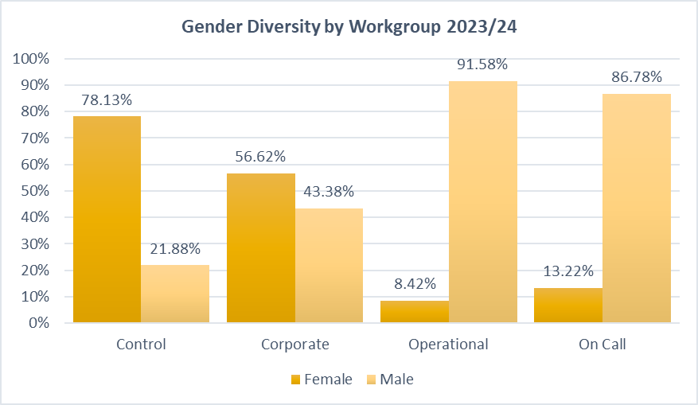

**There is a higher female representation in Control and Corporate.** While both Control and Corporate have a majority of female employees, Corporate demonstrates a more balanced gender distribution. Control have experienced a decrease in the proportion of male employees.

|  |  |  |
| --- | --- | --- |
| Gender Diversity – Wholetime & On-Call Combined | | |
|  | **Female** | **Male** |
| 2022/23 | 8.16% | 91.84% |
| 2023/24 | 🡩 9.23% | 90.77% |

Nationally, on 31st March 2023 8.7% of firefighters were women, compared to 8.1% in the previous year, 5.7% five years ago and 4.3% ten years ago.

|  |  |  |
| --- | --- | --- |
| Wholetime & On Call – Female by Operational Role 2023/24 | | |
|  | **Total** | **%** |
| Principal Officer | 0 | 0.00% |
| Area Manager | 1 | 20.00% |
| Group Manager | 1 | 9.09% |
| Station Manager | 3 | 12.00% |
| Watch Manager | 12 | 11.76% |
| Crew Manager | 3 | 3.06% |
| Firefighter | 47 | 13.95% |

13.95% of our staff at Firefighter level are female. This figure is crucial as it shows the impact of diversity initiatives and highlights the progress made towards a more balanced and inclusive workforce.

Our female employees are more ethnically diverse than males.

|  |  |  |
| --- | --- | --- |
| Workforce Ethnicity by Sex – 2023/24 | | |
|  | **Female** | **Male** |
| Minority | 9.24% | 5.51% |
| White British | 89.96% | 94.36% |
| Prefer not to say | 0.80% | 0.12% |

**Sex Updates**

Our Women’s Staff Group hosted an International Women’s Day event in collaboration with South Yorkshire Police. Our Women of Fire exhibition was relaunched to coincide with the event.

Delegates attended the annual Women in the Fire Service Training and Development Event at The Fire Service College.

Female Fitness sessions were held in the run up to Wholetime recruitment.

Firefighter Bronte Jones garnered national attention by getting to the final of TV's *Gladiators*.

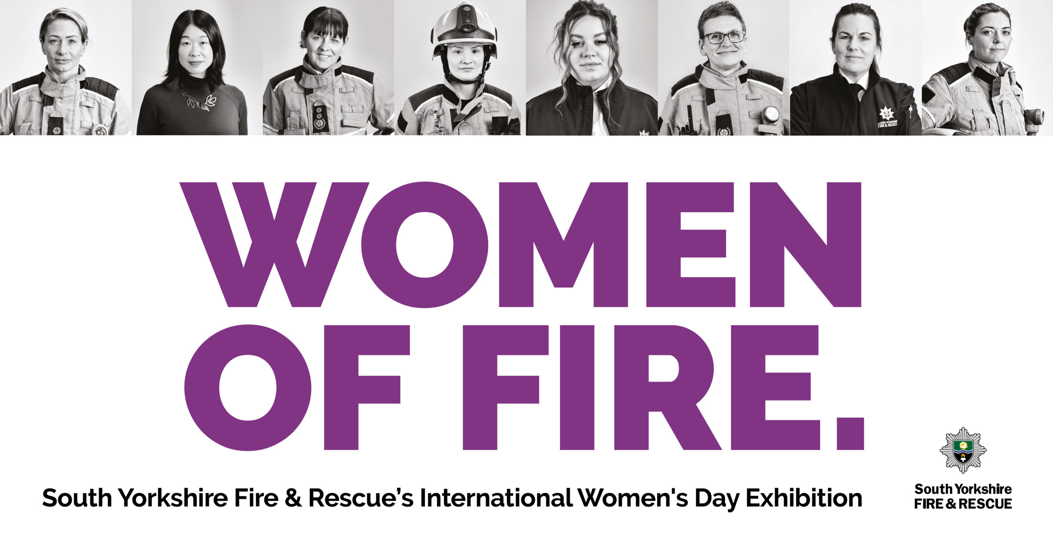

# https://media.www.kent.ac.uk/se/16569/Icon-9_800w.pngSexual Orientation Profile

A person's sexual orientation towards persons of the same sex, the opposite sex or either sex.[11]

**Sexual orientation has the lowest disclosure rate of all protected characteristics, with 16.03% choosing 'prefer not to say'.**

|  |  |  |
| --- | --- | --- |
| Sexual Orientation - Prefer not to say | | |
|  | **2022/23** | **2023/24** |
| Control | 3.03% | 3.13% |
| Corporate | 9.77% | 8.46% |
| Operational | 23.78% | 22.05% |
| On-Call | 9.73% | 9.92% |

This is noticeably higher in our Operational workgroup at 22.05%, although has improved on the previous year.

This could stem from various factors, but it does mean the data may not be entirely conclusive.

**4.49% of the workforce identify as LGB+.** This compares favourably with the county comparator which is 3.2% and suggests our workforce is representative in terms of sexual orientation.

|  |  |  |  |  |  |
| --- | --- | --- | --- | --- | --- |
| Sexual Orientation Diversity - Workforce | | | | | |
|  | **Bisexual** | **Gay or Lesbian** | **Heterosexual** | **Other** | **Prefer not to say** |
| 2022/23 | 1.32% | 1.89% | 78.75% | 0.28% | 17.75% |
| 2023/24 | 🡩 1.76% | 🡩 2.44% | 79.48% | 🡩 0.29% | 🡩 16.03% |
| SY 2021 | 1.30% | 1.50% | 90.00% | 0.40% | 6.90% |

Our data splits down sexual orientation categories further, however the categories used in this report are directly comparable to the Census 2021 data and also limit personally identifiable responses.

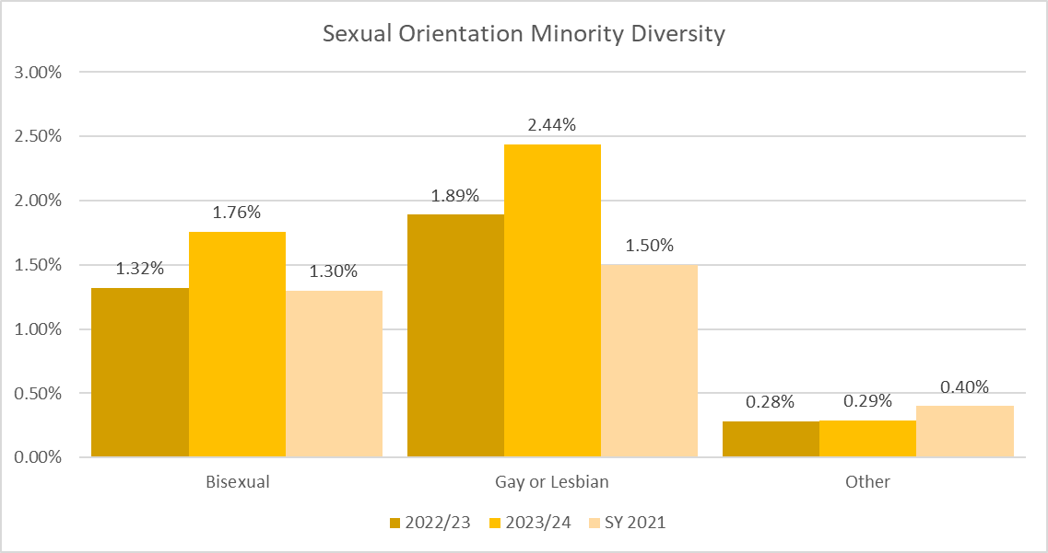

|  |  |  |  |  |  |  |
| --- | --- | --- | --- | --- | --- | --- |
| Minority Breakdown by Workgroup | | | | | | |
|  | ***2022/23\**** | | | **2023/24** | | |
| . | **Bisexual** | **Gay or Lesbian** | **Other** | **Bisexual** | **Gay or Lesbian** | **Other** |
| Control | *0.00%* | *6.06%* | *0.00%* | 0.00% | 6.25% | 0.00% |
| Corporate | *1.95%* | *2.34%* | *0.00%* | 2.57% | 3.68% | 0.37% |
| Operational | *1.39%* | *1.57%* | *0.35%* | 1.52% | 1.52% | 0.34% |
| On Call | *1.52%* | *1.52%* | *0.00%* | 0.00% | 2.48% | 0.00% |

*\* This data was not presented in 2022/23 and the historical data provided here may not include individuals who have since left the service*

Stonewall's Rainbow Britain Report[12] suggests that only 71% of Gen Z identify as being straight. They are also likely to express a wider range of identities than older age groups. Although the data for SYFR is not as pronounced as the data from this report it does appear to be moving in a positive direction with the Gen Z age groups having the highest proportion of LGB+ and lowest proportion of 'prefer not to say' disclosures.

|  |  |  |  |
| --- | --- | --- | --- |
| Workforce Sexual Orientation by Social Generation* | | | |
|  | **LGB+** | **Heterosexual** | **Prefer not to say** |
| Gen Z | 9.20% | 89.66% | 1.15% |
| Millennials | 5.47% | 82.28% | 12.25% |
| Gen X | 2.33% | 73.49% | 24.19% |
| Baby Boomers | 0.00% | 85.37% | 14.63% |

*\* Social Generations are defined by birth years as follows: Baby Boomers 1946-1964; Gen X 1965-1980; Millennials 1981-1996; Gen Z 1997-2012*

**Sexual Orientation Updates**

We have sponsored and attended Pride events across the county, delivering recruitment and fire safety messages.

As in previous years the Progress Pride flag has been flown on our buildings during February for LGBT+ History Month and Pride Month in June.

We joined the UK Fire Pride national LGBTQ+ Staff Group and attended the first conference where the chair of our LGBT+ staff group was a panel member.

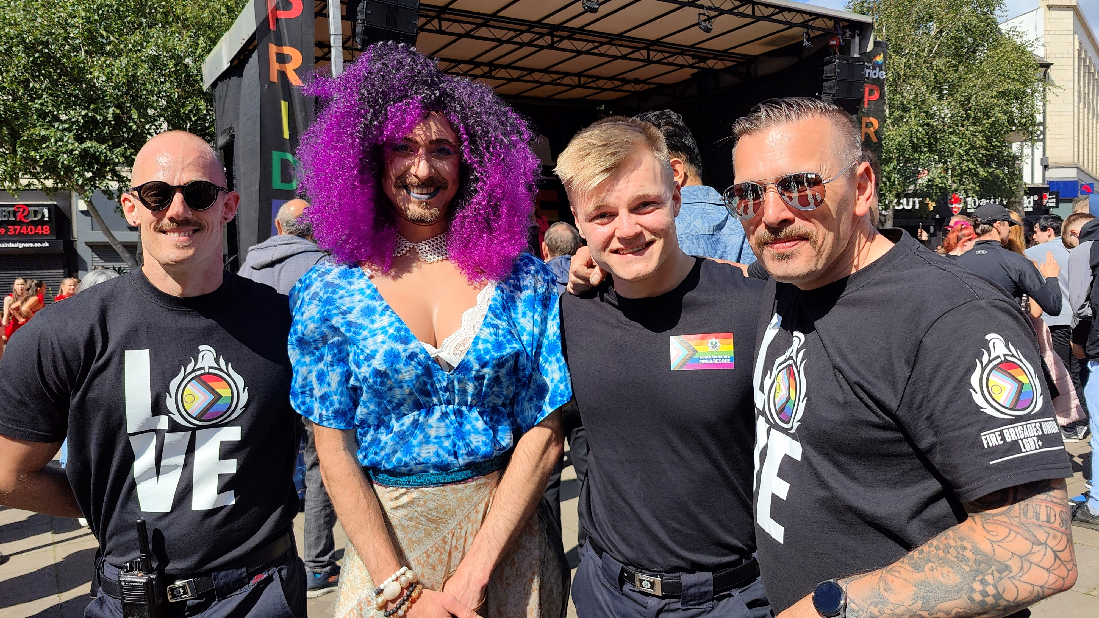

# https://encrypted-tbn0.gstatic.com/images?q=tbn:ANd9GcRoLQ3_7FJjPAYH7sKvIPWsSw278k-VPgToNnU7y56UQuo4G_n9qnZ6bOQF_Zo2fOXUSwg&usqp=CAUTop 5% of Earners Diversity Profile

This includes Group Manager equivalent and above for both Operational and Corporate staff.

**The 46-55 age group is increasingly the largest in the top 5% of earners, likely due to experience and seniority.** Older and younger employees have seen a decline in representation.

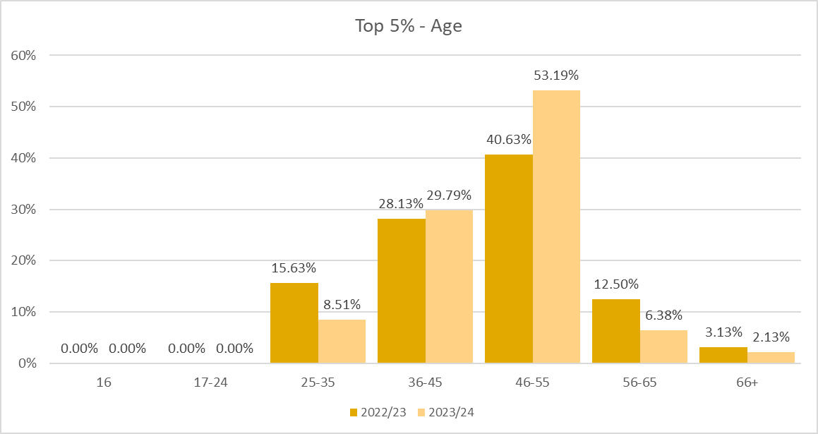

**There has been an improvement in the representation of disability in the top 5% of earners.** Other categories have seen some smaller fluctuations, and there remains no LGB+ representation.

|  |  |  |
| --- | --- | --- |
| Top 5% of Earners | | |
|  | **2022/23** | **2023/24** |
| Female | 41.67% | 🡫 40.43% |
| Ethnic Minority | 2.06% | 🡩 4.26% |
| Disabled | 6.25% | 🡩 12.77% |
| LGB+ | 0.00% | 0.00% |

It is worth noting that there is a larger proportion of women in the top 5% of earners (40.43%), in comparison to the overall workforce at 23.92%. This is heavily made up by Corporate staff however, as only 6.25% of top earning Operational staff are female.

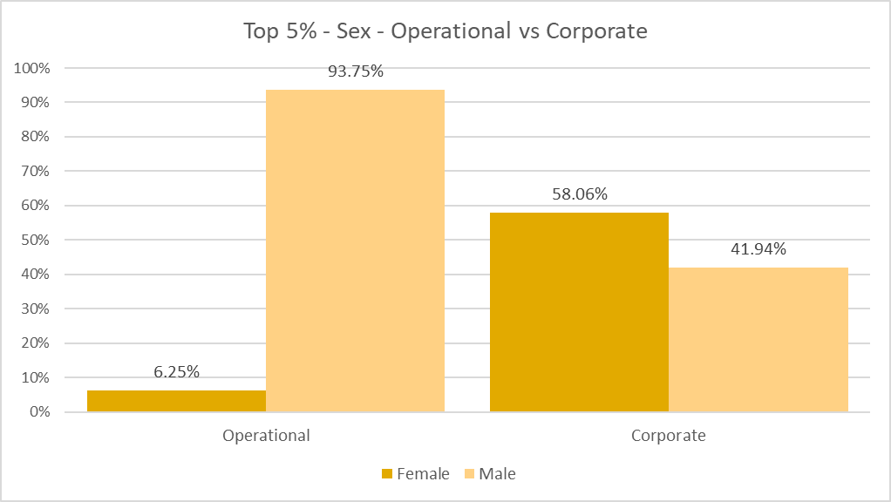

The Faith & Belief of the top 5% remains primarily made up of those with no religion and Christians.

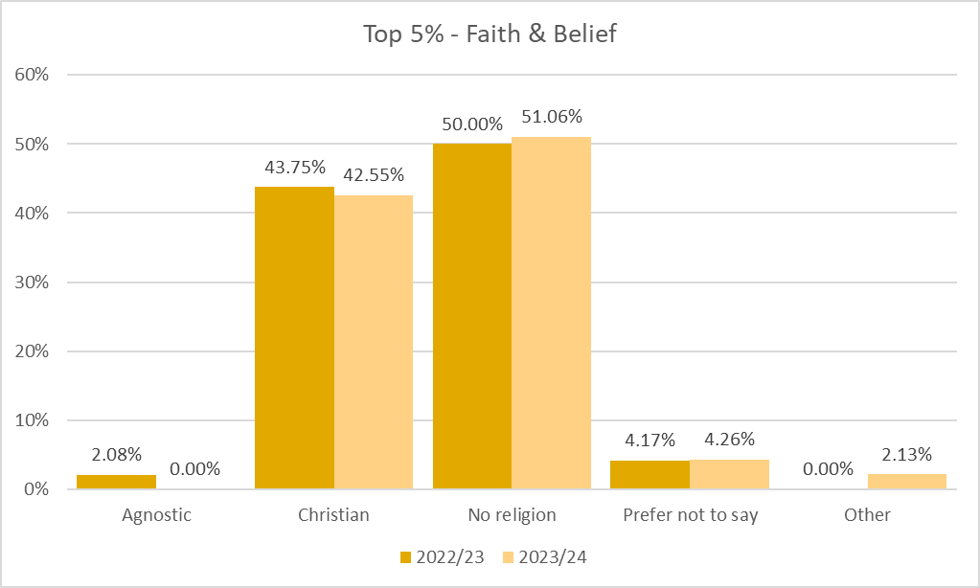

# https://encrypted-tbn0.gstatic.com/images?q=tbn:ANd9GcRYLL4YRLBKymsQ_bYWzHco_9zM-bMbkx7x5A&sDiscipline and Grievance Diversity

People Function Case Work commenced during the 2023/24 reporting period

46 employees were subject to disciplinary investigation during 2023/24, of these eight were from a minority group, including seven females.

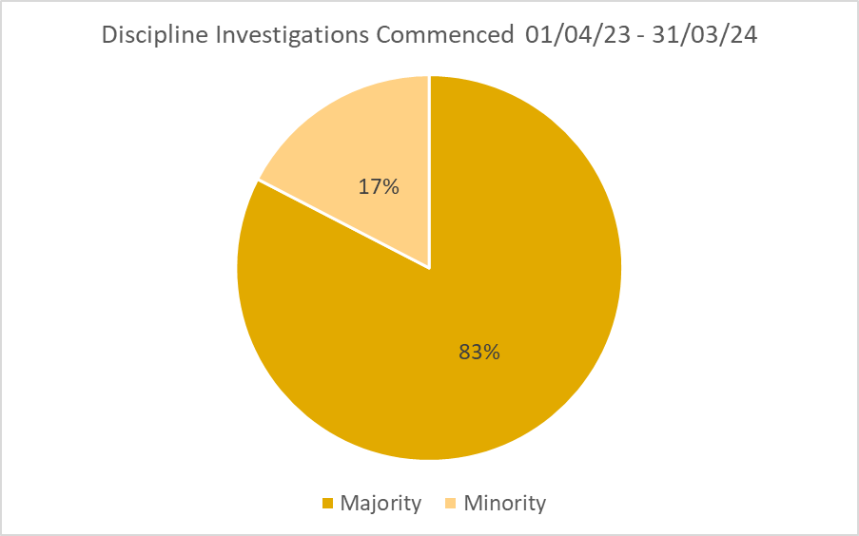

25 employee-led grievance cases commenced during 2023/24, including two collective grievances. Eight of these employees were female.

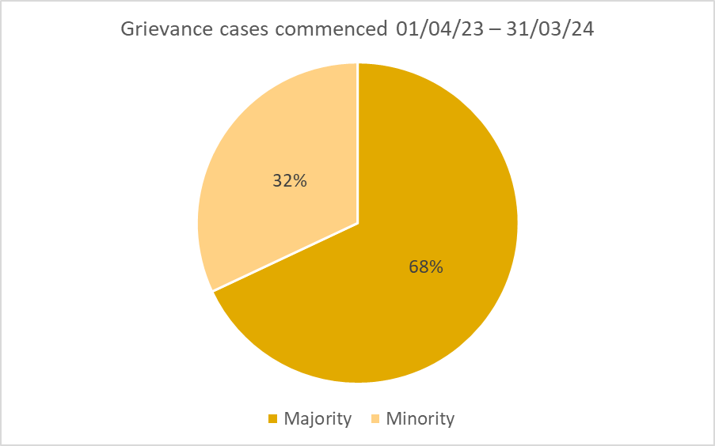

It should be noted that individuals may not have been under-represented within their own workgroup.

# Entrance, exit door way with arrow icon vector illustration. Stock Vector | Adobe StockLeavers and New Starters Diversity

Those leaving or joining the organisation during the 2023/24 reporting period

**There were 43 more employees who joined SYFR than who left in 2023/24.** There were 74 leavers and 117 new starters.

|  |  |  |  |  |  |  |  |  |
| --- | --- | --- | --- | --- | --- | --- | --- | --- |
| Leavers by Reason | | | | | | | | |
| Resignation | | | **Retirement** | | | **Other** | | |
| Males | **Total** | **%** | | **Total** | **%** | | **Total** | **%** |
|  | 29 | 27.03% | | 20 | 39.19% | | 6 | 8.11% |
| Females | 15 | 20.27% | | 2 | 2.70% | | 2 | 2.70% |

Resignations accounted for the highest number of leavers for both males and females.

|  |  |  |  |  |  |
| --- | --- | --- | --- | --- | --- |
| Leavers and New Starters by Age | | | | | |
| Leavers | | | **New Starters** | | |
|  | **Total** | **%** |  | **Total** | **%** |
| 16 | 0 | 0.00% | **16** | 0 | 0.00% |
| 17-24 | 5 | 6.76% | **17-24** | 20 | 17.09% |
| 25-35 | 16 | 21.62% | **25-35** | 42 | 35.90% |
| 36-45 | 16 | 21.62% | **36-45** | 27 | 23.08% |
| 46-55 | 24 | 32.43% | **46-55** | 18 | 15.38% |
| 56-65 | 10 | 13.51% | **56-65** | 9 | 7.69% |
| 66+ | 3 | 4.05% | **66+** | 1 | 0.85% |

The highest influx of new starters is in the 25-35 age group suggesting we are attracting younger employees. There was a noticeable turnover in the 46-55 age group

|  |  |  |  |
| --- | --- | --- | --- |
| Leavers and New Starters by Disability | | | |
| Leavers | | **New Starters** | |
| Yes | 0.00% | **Yes** | 11.97% |
| No | 95.95% | **No** | 86.32% |
| Prefer not to say | 4.05% | **Prefer not to say** | 1.71% |

No employees with a declared disability left the organisation. 11.97% of new starters identified as having a disability and there was a smaller proportion of new starters who preferred not to say. This shows a relatively strong representation of individuals with disabilities among new hires.

|  |  |  |  |
| --- | --- | --- | --- |
| Leavers and New Starters by Race | | | |
| Leavers | | **New Starters** | |
| Asian / Asian British | 4.05% | **Asian / Asian British** | 1.71% |
| Black or Black British | 1.35% | **Black or Black British** | 0.85% |
| Mixed / multiple ethnic groups | 0.00% | **Mixed / multiple ethnic groups** | 0.85% |
| Other Ethnic Group | 1.35% | **Other Ethnic Group** | 1.71% |
| White British | 91.89% | **White British** | 90.60% |
| White Minority | 1.35% | **White Minority** | 4.27% |

While still underrepresented, there's a slight increase in the percentage of new starters from minority ethnic groups compared to leavers. There was a higher proportion of leavers from an Asian/Asian British background than new starters.

|  |  |  |  |
| --- | --- | --- | --- |
| Leavers and New Starters by Sex | | | |
| Leavers | | **New Starters** | |
| Female | 25.68% | **Female** | 33.33% |
| Male | 74.32% | **Male** | 66.67% |

While men still represent the majority of both leavers and new starters, there is a noticeable increase in the percentage of women among new hires compared to those leaving. This could reflect an organisational shift towards better gender diversity, particularly in recruitment efforts.

|  |  |  |  |
| --- | --- | --- | --- |
| Leavers and New Starters by Sexual Orientation | | | |
| Leavers | | **New Starters** | |
| Heterosexual | 78.38% | **Heterosexual** | 82.91% |
| LGB+ | 2.70% | **LGB+** | 10.25% |
| Prefer not to say | 18.92% | **Prefer not to say** | 6.84% |

There is a notably higher percentage of new starters identifying as LGB+ compared to leavers, with fewer preferring not to say.

# Clock Icon Images – Browse 982,967 Stock Photos, Vectors, and Video | Adobe StockPart-Time Staff

Someone who works fewer hours than a full-time equivalent in the same role

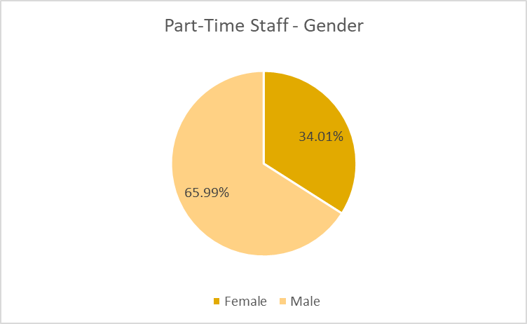Part-time workers are majority male, however the proportion of women in part-time roles is noticeably higher than in the workforce overall at 34.01%.

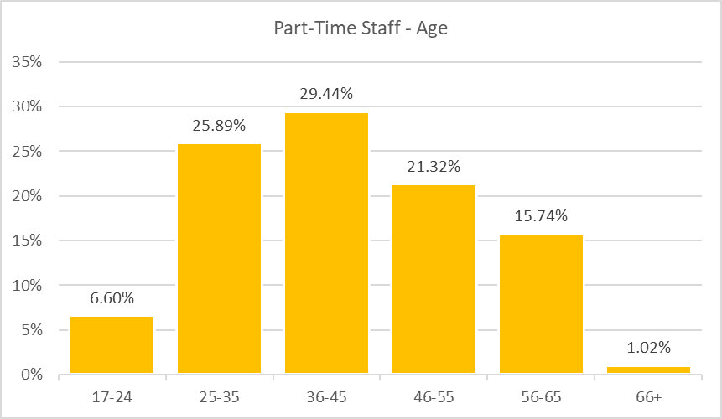

Although there is a similar distribution pattern of ages across our part-time employees, the younger age groups (17-24 and 25-35) have a higher percentage in part-time roles compared to their representation in the overall workforce.

# Volunteer Icon PNG Images, Vectors Free Download - PngtreeVolunteers

Volunteers play a valuable supporting role to our existing community safety teams and in delivering our safety messages.

**We have 56 individuals who volunteer some of their time to support our campaigns and initiatives.** These are not counted in our workforce data, however the diversity of this group is important when considering our community engagement. The analysis provided is based on optional monitoring data captured at join date.

Half of our volunteers fall into the 17-24 range which is significantly higher than our paid workforce. This may indicate a strong emphasis on student engagement and an opportunity for recruitment.

|  |  |  |  |  |  |  |
| --- | --- | --- | --- | --- | --- | --- |
| Volunteer Profile - Age | | | | | | |
| 16 | **17-24** | **25-35** | **36-45** | **46-55** | **56-65** | **66+** |
| 2.00% | 50.00% | 8.00% | 10.00% | 12.00% | 10.00% | 8.00% |

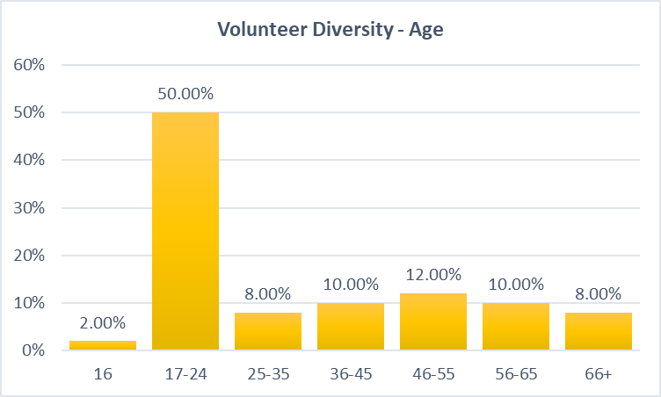

|  |  |
| --- | --- |
| Volunteer Profile – Disability | |
| No | 78.85% |
| Yes | 17.31% |
| Prefer not to say | 3.85% |

A significant proportion - 17.31% - of our volunteers have indicated they have a disability.

Christianity and no-religion are the largest Faith & Belief groups within our volunteers, with few other groups represented. The proportion of Muslim individuals is higher than in our workforce, although still not representative. There is a similarly small amount of ethnic diversity within our volunteer group, although Black/Black British are represented.

|  |  |
| --- | --- |
| Volunteer Profile – Faith & Belief | |
| Christian | 48.98% |
| Muslim | 2.04% |
| No religion | 38.78% |
| Other | 2.04% |
| Not stated | 8.16% |

|  |  |
| --- | --- |
| Volunteer Profile – Race | |
| Black/Black British | 4.08% |
| White British | 93.88% |
| White Minority | 2.04% |

|  |  |
| --- | --- |
| Volunteer Profile – Sex | |
| Female | 26.00% |
| Male | 74.00% |

Mirroring our main workforce, our volunteers are mostly male.

|  |  |
| --- | --- |
| Volunteer Profile – Sexual Orientation | |
| LGB+ | 4.17% |
| Heterosexual | 81.25% |
| Prefer not to say | 14.58% |

LGB+ volunteers are well represented; again we see a high proportion who prefer not to say.

# -Conclusion

**The Workforce Profile provides a valuable snapshot of the organisation's employee demographics.** By analysing data on age, gender, ethnicity, and other relevant factors, we can identify trends, strengths, and areas for improvement. This analysis serves as a foundation for understanding the organization's workforce composition and informing strategic decisions.

While progress has been made in improving diversity and representation across SYFR since 2022/23, we acknowledge that challenges remain. Notably, we have seen an increase in individuals disclosing disabilities, and modest improvements in ethnic, gender, and sexual orientation representation.

Encouragingly, disclosure rates have risen, but ongoing efforts are needed to foster open conversations about the importance of sharing this information.

This year's report expands on previous analyses by including data on volunteers and part-time workers. We hope to include data on Fire Cadets and employees with caring responsibilities in future reports. We also aim to provide more intersectional insights while acknowledging the limitations of comprehensive coverage. Additionally, we are developing tools to understand staff retention better.

We hope this report has highlighted some of the data behind our strategic aims and the ongoing work required to ensure we are representative of our South Yorkshire communities.

If you have any questions, comments or suggestions please contact the EDI team.

1. Also includes non-binary
2. Trans data (gender reassignment) is collected separately
3. [Equality Act 2010 (legislation.gov.uk)](https://www.legislation.gov.uk/ukpga/2010/15/section/5)
4. [Definition of disability under the Equality Act 2010 - GOV.UK (www.gov.uk)](https://www.gov.uk/definition-of-disability-under-equality-act-2010)
5. Includes undeclared
6. [Equality Act 2010 (legislation.gov.uk)](https://www.legislation.gov.uk/ukpga/2010/15/section/10)
7. [Equality Act 2010 (legislation.gov.uk)](https://www.legislation.gov.uk/ukpga/2010/15/section/9)
8. [Sex discrimination | EHRC (equalityhumanrights.com)](https://www.equalityhumanrights.com/equality/equality-act-2010/your-rights-under-equality-act-2010/sex-discrimination)
9. [Build a custom area profile - Census 2021, ONS](https://www.ons.gov.uk/visualisations/customprofiles/draw/)
10. [EDISectorReport.pdf (nfcc.org.uk)](https://nfcc.org.uk/wp-content/uploads/2023/09/EDISectorReport.pdf)
11. [Equality Act 2010 (legislation.gov.uk)](https://www.legislation.gov.uk/ukpga/2010/15/section/12)
12. [Rainbow Britain Report (2022) | Stonewall](https://www.stonewall.org.uk/resources/rainbow-britain-report-2022)