Productivity and Efficiency Plan

2025/26 Plan and 2024/25 Review

April 2025

**PRODUCTIVITY & EFFICIENCY PLAN**

**Contents**

|  |  |
| --- | --- |
| **Title** | **Page No** |
| About this plan | 2 |
| SECTION ONE : EFFICIENCY |  |
| a – Overview and Primary Information | 3 |
| b – Efficiency – how Annex C reconciles to other reporting | 4 |
| c – Outline of efficiency initiatives in 2024/25 and duration | 4 |
| d - Non cashable savings | 5 |
| e - future efficiency projects | 6 |
| f - collaboration with financial and operational benefits | 7 |
| g – income | 8 |
| h - Assessment of efficiencies achieved (incl factors impacting ability to make savings | 9 |
|  |  |
| SECTION TWO: PRODUCTIVITY |  |
| a – CRMP | 10 |
| b – Resourcing | 11 |
| c – Productivity monitoring | 11 |
| d – Productivity improvements in 2023/24 | 14 |
|  |  |
| Budgets 2023/24 to 2025/26 | Annex A |
| Reserves 31 March 2024 to 2028 | Annex B |
| Efficiencies 2023/24 to 2025/26 | Annex C |
| Income Efficiencies 2023/24 to 2025/26 | Annex D |

**About this plan**

The National Framework requires combined and metropolitan Fire & Rescue Authorities (FRAs) to produce and publish Efficiency Plans. For 2025/26, all FRAs must produce plans for increasing productivity and creating efficiency savings.

As part of previous government spending reviews, the National Fire Chiefs’ Council (NFCC) and the Local Government Association (LGA) have agreed that Fire and Rescue Services in England will create non-pay efficiency savings of 2% and increase (wholetime) productivity by 3% per year.

Fire Productivity and Efficiency Plans (P&E Plans) will help the NFCC, LGA and Home Office to collate evidence and assess progress against the agreed targets nationally.

This plan should also be considered alongside other strategic documents, including our Community Risk Management Plan (CRMP), our [Medium Term Financial Plan](https://syjagu.moderngov.co.uk/documents/s7764/Medium%20Term%20Financial%20Plan%202025-28.pdf?zTS=A) (MTFP) and the [Annual Council Tax and Budget Report](https://syjagu.moderngov.co.uk/documents/s8201/Council%20Tax%20and%20Budget%20Report%202025-2026%20v2.pdf?zTS=A).

This report is prepared in line with the Home Office Productivity and Efficiency Survey Guidance issued in February 2025.

**Section 1: Efficiency**

1. **Overview and Primary Information**

Annex A and B contain the Budget and Reserves for the Service as published in the [Medium Term Financial Plan](https://syjagu.moderngov.co.uk/documents/s7764/Medium%20Term%20Financial%20Plan%202025-28.pdf?zTS=A) (MTFP) 2025/26 to 27/28. Annex A includes the non-pay expenditure against which our efficiency savings will be measured against to assess our performance against the 2% saving target (as a proportion of non-pay expenditure). Annex C shows our Non-Pay expenditure is £12.8m rising to £13.5m over the period shown.

Annex B shows South Yorkshire Fire and Rescue (SYFR) reserves. The target level of reserves is set by a Service’s Section 151 Officer each year. This must include statutory Minimum Revenue Provisions and a General Reserve amount which will allow the organisation to maintain liquidity through the year. Additional Reserves may also be needed to hold unused grants for specific purposes. There may also be discretionary amounts held in reserves to cover future expenditure.

SYFR had £20.1m in reserves at 31 March 2024. The S151 officer suggests the minimum reserve (MRP and General) within this is £7.9m. There is also an insurance reserve set aside for potential historical claims of £1m. £9m of our reserves is more discretionary and as approved in the MTFP Reserves policy – this value will be spent on capital or planned future operating deficits and reduced to nil by March 2028. After this point we aim to be breaking even or generating a small surplus. We expect our ability to invest and to continue generating efficiency savings after this point will reduce.

1. **Efficiency – how Annex C reconciles to other reporting**

Annex C reports Efficiency savings in line with the Home Office guidance issued in February 2025. SYFR has embedded efficiency reporting in the Quarterly Financial Performance Reporting to the FRA. The Annex contains the information reported to FRA in the [Financial Performance Reporting Outturn 2023-24](https://syjagu.moderngov.co.uk/documents/s6619/Financial%20Performance%20Report%20Quarter%204%20Outturn%202023-24%20Apppendix%20A.pdf?zTS=A), [Financial Performance Report for Quarter 3 2024-25](https://syjagu.moderngov.co.uk/documents/s8204/Financial%20Performance%20Report%20Quarter%203%202425.pdf?zTS=A) and the [Budget Setting and Council Tax Report 2025-26](https://syjagu.moderngov.co.uk/documents/s8202/Appendices%20A%20to%20G%20-%20Annual%20Revenue%20Budget%20and%20Council%20Tax%20Setting%20202526.pdf?zTS=A) excluding the income efficiencies which are shown separately at Annex D and excluding negative efficiencies (efficiencies previously reported but subsequently reversed) which are not required by Home Office Guidance.

1. **Outline of efficiency initiatives and duration in 2024/25**

This section gives a brief outline of how each 2024/25 efficiency (in Annex C) was achieved and the duration of the saving made.

* Reduction in protection, prevention and response delivery (recurrent savings £245k and non-recurrent £931k), includes a non-recurrent Wholetime vacancy factor £721k based on anticipated gaps to establishment from recruitment gaps, lag in turnover replacement and the savings from top of scale to new recruitment pay rates on turnover. Other recurrent savings were reduced from other budgets for some allowances and holiday pay increments based on trending spend. The recurrent saving is a medium term planned reduction in the overtime budget through increased management scrutiny and challenge and higher staffing levels.
* All Indirect Employee costs – uniformed development training budget was reduced by £27k based on previous spending trends.
* Premises £274k – reactive and non- reactive contracts budgets were reduced and underspent based on reduced costs following the failure of a maintenance contractor and the service directly contracting with contractors to provide services.
* Utilities £569k – savings from green plan initiatives, sharing premises and price reductions from budget.
* Fleet £27k – savings on repairs due to less accidents and on mileage claims as remote working policies continue.
* Fuel £203k – savings on fuel usage and price vs planned as remote working continues and hybrid vehicles are introduced.
* Supplies and Services (decreased usage) £95k’ – savings include removing a contract for additional carparking, reducing a contingency budget for legal fees and reducing some operational equipment budgets based on trend.
* Suppliers and Service Technology Improvements £111k – including reduced phone budgets as M365 is introduced.
* Capital Financing – Net revenue costs £43k down as the capital programme is slower to deliver than planned.

1. **Non cashable savings**

In addition to these cashable savings, there were the following non-cash savings which gave us higher quality output for the same price or savings through the procurement process which avoided additional cost increases including:

* Annual procurement review, demonstrating a high level of procurement savings through robust procurement processes
* The latest phase of a long standing Digital Transformation Programme, to reduce paper and improve management reporting
* Reporting and challenge excessive office printing and copying
* Continued agile working - saving on staff travel time, fuel consumption and office space
* A new HQ cooling and uninterrupted power supply (UPS) replacement project will deliver long term carbon and financial savings
* The continued rollout of Microsoft Office 365 is generating productivity and efficiency gains across the service - particularly in corporate functions
* Artificial intelligence is currently being evaluated with a view to generating further productivity gains
* Adoption of new meeting and governance software, which is expected to improve the facilitation of meetings and associated documentation
* Implementation of more terminals and dual screens on fire stations to aid the completion of non-operational training and tasks
* We have also reported £162k of savings on procurements carried out in 2024/25 using Blue Light Commercial methodologies

1. **Future efficiency projects**

In 2025/26 we will also:

* continue work to conclude the **leave and availability project** which should result in further overtime reductions.
* Bring **finance and governance functions in house** from 1 April 2025 which will reduce costs but also increase governance oversight and streamline the constitution.
* Review **Operational training** provision vs met peers and FRS who have conducted recent reviews to understand the apparent margin to average cost and consider alternate methods of delivery.
* Review **Catering provisions** to ensure best value investment and fair access to it.
* Review **re-charging landlords for Alarms** fitted.
* Begin a project with key **community rooms** to generate more income and community engagement through the use of rooms.
* Change the location of our small incident unit from Cudworth to Dearne fire station.

In February 2025 a new CRMP was approved. Detailed analysis undertaken to deliver the CRMP identified that savings could be made to operations without significant impact to the response times or expected required operational cover.

In the same month, our Council tax and budget report approved in 2025/26 showed that over 3 years we are forecasting a deficit of £5.6m. Work will begin across the Service to asses where additional efficiencies could be made, this may include but is not limited to, options in emergency response as identified by the work to support our current CRMP. Any such proposals will be subject to Fire Authority approval.

We will continue to work with NFCC to refine Fire Service Peer benchmarking. We will use existing benchmarking to identify efficiency opportunities in our Service and approve efficiency savings and investment with reference to benchmark. We will use benchmarking to ensure proportionate and safe savings are made across our organisation to move towards benchmark in all functions except where a deliberate justification can be made.

1. **Collaboration with financial and operational benefits**

In addition to these cashable savings, there was collaboration activity with financial and operational benefits including:

* Collaboration arrangements with South Yorkshire Police for a Joint Community Safety Department and Joint Vehicle and Fleet Management.
* Involvement in a regional procurement group to identify and deliver on collaboration opportunities (e.g. vehicle, uniform and PPE procurements).
* Hosting of Multi-Agency Gold Incident Command courses.
* Contributing to the Emergency Services Network changeover. Though this is paused nationally, we expect it to deliver local efficiencies in the future.
* Training partnership with Sheffield Hallam University, which sees trainee firefighters and student paramedics train together to improve interoperability at various operational scenarios.
* Larger scale training exercises have also been set up at fire stations across South Yorkshire to help rehearse responses to incidents where firefighters and paramedics are likely to be present - including road traffic collisions, rescues from height and water incidents.
* South Yorkshire Police continue to run first aid sessions for SYFR, and SYFR continue to run driving training for the police, with this mutual support saving both organisations training costs.
* Local blue light services continue to collaborate for staff and equality group events.

1. **Income**

Income efficiencies were reported to FRA in the Financial Performance Report Q3 2024/25. The Home Office Guidance requires us to report these separately at Annex D.

In the year we achieved more income £167k from renting out floors in our head quarters building which we now share with the NHS and Age UK.

Income from interest on investments was £150k higher than prior years due to higher interest rates.

Income generated from other sources was up £70k as officers were seconded to other fire sector bodies.

1. **Assessment of efficiencies achieved in 2024/25**

Annex C shows that SYFR is forecast to exceed efficiency targets in 2024/25 achieving savings of £2.5m nearly 17% as a proportion of non-pay expenditure. In addition to these savings there were further £2.1m non-recurrent savings against original budget which we used to directly fund capital in the year. The proportion of savings achieved through active savings plans/ projects has increased on previous years and more savings initiatives are being developed for future years to ensure targets continue to be met and the service continues to be in a sustainable financial position.

**Section 2: Productivity**

We monitor performance and productivity using real-time information which is available at strategic, managerial and operational levels through live data. Workforce productivity is scrutinised at a watch, station, district and function level and then the Fire Authority’s Performance and Scrutiny Board.

1. **Community Risk Management Plan**

Much of the work we deliver for local people is outlined in our Community Risk Management Plan (CRMP). The CRMP explains how we allocate our resources to meet local risk and achieve our statutory objectives. We published a new CRMP in March 2025 following Fire Authority approval and a period of staff and public consultation. The CRMP is reviewed every year.

The CRMP also sets three strategic objectives for the service to achieve between now and 2028. The first of these is:

**Efficiency and productivity**

**Identify and remove inefficiencies across the service and improve productivity to provide best value.**

We will:   
a) Set clear targets and report against our efficiency and productivity plan every year

b) Develop our processes for identifying and realising efficiencies

c) Scrutinise recruitment as part of existing workforce planning processes

d) Prioritise our capital spending in line with this CRMP, reviewing it annually

e) Deliver the objectives set out in our Green Plan

1. **Resourcing**

The Service utilises on-call, day staffing and 2-2-4 duty systems to provide emergency response cover. We also have a small pool of staff working in an operational resource team who provide availability to reduce the impact / cost associated with overtime.

The Service also maintains its contingency arrangements for business continuity purposes - such as periods of industrial action.

1. **Productivity monitoring**

**Emergency Response Staff**

We will be reviewing our data management systems to make sure that the data presented for response is consistent and accurate.

We will look to find how we can increase productivity within the response function, one element for 2025/2026 will be to increase operational training and exercising.

A review of the wholetime work routine, as planned within our CRMP, will take place and be effective within 2025/26. The overall aim is to increase productivity by adjusting tasks within the day and night shifts. Our CRMP data will drive this process and reduce response times to incidents when we know our demand increases.

Performance measures will be set within the station and district plans. These are monitored on a frequent basis by district management teams and scrutinised by service delivery managers throughout the year and captured within our corporate performance metrics.

**Prevention staff**

The main priority for the Joint Community Safety Department (Prevention) in 2025/26 is the ongoing departmental review, which aims to improve productivity and effectiveness by streamlining processes, removing duplication and aligning delivery models to a new structure. This will ensure that the department’s people, systems, and procedures are fit for purpose and focused on maximising impact across our prevention work.

Alongside the review, the department will prioritise increasing the number of Home Fire Safety Visits (HFSVs) delivered to individuals identified as high or very high risk through the triage system. We will also target remote and underrepresented communities, ensuring equity of access to our services and reducing risk in the most vulnerable populations.

In the last financial year, significant efficiencies were achieved. Safeguarding processes were streamlined following a change in reporting to Local Authorities, moving from five separate Section 11 returns to a single NFCC Safeguarding Self-Assessment—saving an estimated 200 to 300 hours annually. Additionally, partnership training was moved to virtual delivery, saving 87 hours in travel, 3,197 miles, and over £3,300. These changes reflect a more strategic approach to safeguarding and partnership engagement, focusing resources where they make the biggest difference.

**Business Fire Safety staff**

BFS has delivered an increase in the number of fire safety audits in general, thanks to filling vacancies which has brought the team up to nearly full establishment.

A great deal of work has been undertaken by team managers in regards to performance management and quality assurance of all work undertaken by the fire safety inspectors and business safety advisors. A suite of Personal Effectiveness documents has been produced, which clearly outlines expectations, departmental targets, as well as specifications on how the work should be carried out. Managers hold meetings with all staff on a bi-annual basis to discuss personal performance against departmental targets, which are outlined in Departmental Key Performance Indicators (KPIs) and Local Performance Indicators (LPIs). Overall performance is a standing agenda item on all BFS team meetings, as well as monthly Manager / Governance meetings. The quality assurance and governance work has been widely received by the team and has seen a progressive increase in the overall work being undertaken by team.

With the development of our most recent recruits nearing completion, we expect to see a steady increase in productivity, as these staff become competent to carry out their own personal workloads.

With emphasis also being put on the amount of high risk work being undertaken by the team, we are also now, with the use of ORCA reports, able to separate out the high risk work being completed from the standard auditing work undertaken by the team. This will allow managers to assess performance towards our targets, and specifically address any issues in order to realign our work in order to meet our targets.

Fire safety audits are only a small part of the overall work that BFS do though. We are also tasked with carrying out inspections on specialist sites such as petroleum and explosive stores, sports grounds and complex buildings such as hospitals and shopping centres. The team also carries out work in relation to Business Engagement and training as well as consultations on building regulations and complex premises. As part of the Management and Governance process, all areas of fire safety work are scrutinised with the view to look for ongoing ways to improve effectiveness, efficiency and productivity.

1. **Wholetime productivity improvements achieved in 2024/25**

Wholetime firefighter productivity is currently measured by the volume of productive activity undertake by those firefighters (over and above response activity):

* Prevention activity including physical risk-based domestic **Home Fire Safety Visits**
* Protection activity including **Business Fire Safety** risk-based engagements and audits
* Local risk identification, management and recording activity including **Operational Risk visits** aligned to the FRS Act 2004 s7(ii)d.
* **Learning and Development** activities to maintain firefighter role competence.
* **Recruitment** activities in support of Positive Action

The performance for productivity activity overtime is shown and described below.

**Home Fire Safety Visits** (from 2023/24 to 2024/25)

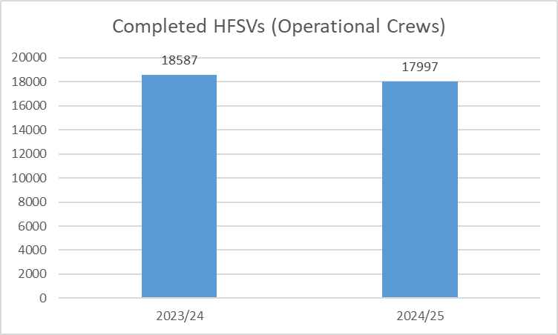

The number of HFSVs completed by operational crews has remained relatively static, with a slight decrease of 3.2%. This small reduction reflects a targeted shift toward prioritising those most at risk, with 70% of visits now classed as Very High or High Risk. This is further supported by a significant increase in safeguarding referrals to Local Authorities, shown later in the report.

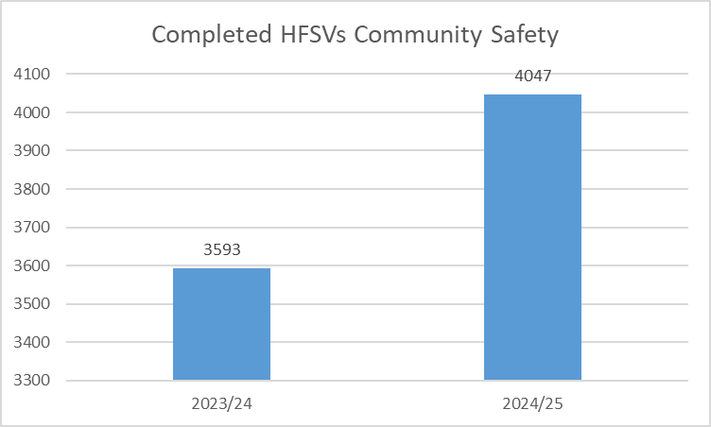

The number of Home Fire Safety Visits completed by the Community Safety team has increased by 12.6% year-on-year. This growth reflects the department’s strategic focus on identifying and targeting those at higher risk, supported by refined referral processes and strengthened partner collaboration. The team continues to trial the district based working model, which reduces travel time and increases community-facing activity.

In 2024/25, 70% of all completed Home Fire Safety Visits were delivered to individuals assessed as Very High or High risk. This demonstrates the continued success of our risk-based approach, ensuring that our resources are targeted where they can have the greatest impact. This marks a significant improvement in prioritisation and evidences how triage tools and partnership referrals are supporting smarter, risk-led prevention work.

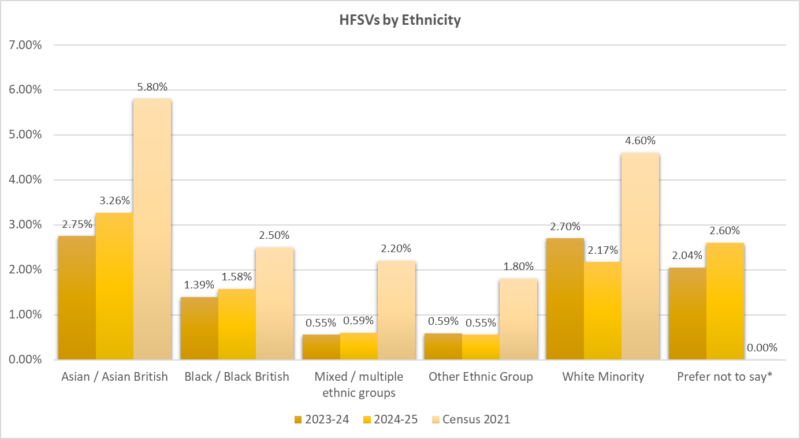

To ensure our services are accessible and reflect the communities we serve, we have prioritised reaching underrepresented ethnic groups. This has led to year-on-year increases across multiple minority groups, including a rise in HFSVs delivered to Asian/Asian British residents from 2.75% to 3.26%. While there is still work to do to align more closely with South Yorkshire's population profile, this improvement demonstrates clear progress and the impact of targeted prevention activity.

**Site Specific Risk Information (from 2023/24 to 2024/25)**

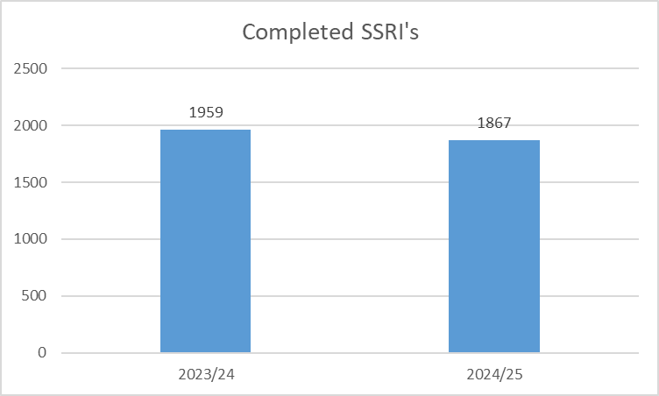

The number of completed SSRIs has remained relatively stable, with a slight decrease of 4.7%. Despite this, crews continue to focus on higher-risk premises, ensuring efforts are targeted where they add the greatest value. This consistent performance supports our ongoing review of SSRI processes and risk prioritisation criteria.

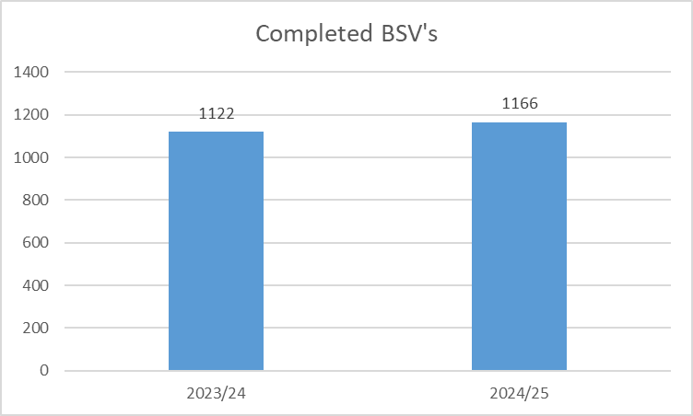

Business Safety Visits (BSVs) focus on inspecting smaller commercial premises to ensure they are safe for both staff and the public. In 2024/25, the number of BSVs increased by 3.9% compared to the previous year (from 1,122 to 1,166), reflecting the department’s continued commitment to engaging with local businesses and improving fire safety standards in lower-risk premises across South Yorkshire.

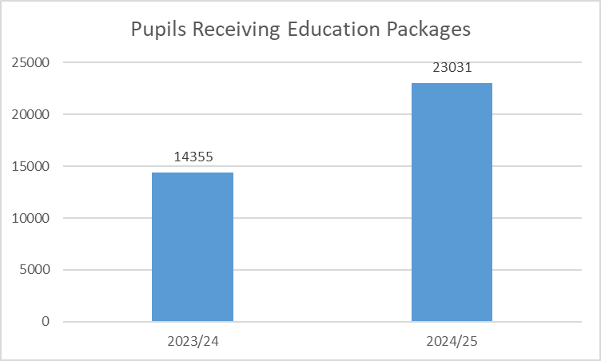

In 2024/25, SYFR delivered safety education to 23,031 pupils, representing a 60.4% increase from the 14,355 pupils engaged in 2023/24. This substantial growth reflects the successful relaunch of the Play It Safe package, increased delivery of Crucial Crew across districts, and wider school engagement. The education programme now covers key topics such as fire, road and water safety, alongside targeted interventions addressing anti-social behaviour.

The new delivery model - focusing on smaller class-based sessions - has improved quality and interaction, with excellent feedback received from schools and pupils. These efforts ensure more young people benefit from vital safety education and align with our aim to target the schools and communities with the greatest need.

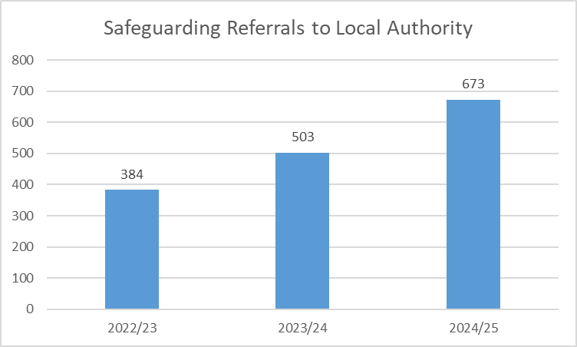

Safeguarding referrals to Local Authorities have increased significantly for the second consecutive year—rising by 34% in 2024/25 (from 503 to 673) and 75% since 2022/23. This increase reflects improved targeting of high-risk individuals, greater crew awareness, and the delivery of effective safeguarding training. SYFR is now recognised as a key partner in the early identification and support of vulnerable people, with safeguarding becoming a substantial area of our prevention work.

**Business Fire Safety Engagements**

Business Fire Safety Inspections

The above table represents the overall fire safety audit work undertaken by BFS Inspectors over the past 2 years. Alongside the number of audits is a representation of the total hours spent delivering these. We have seen a steady increase in the number of audits being completed, due to positive recruitment to bring the team up to full establishment. What this table doesn’t show, is the significant increase in high risk audits, that have occurred over the past two years. We have delivered an increase in high risk audits, due to the ability of being able to identify higher risk buildings and having an increased number of competent staff to carry out this work.

The above table is a breakdown of the total number of fire safety audits undertaken by BFS Inspectors over the past 6 years. The table shows the total number of physical fire safety audits that could be undertaken by the team during the COVID 19 period, and how, over the last few years, this figure has increased as the community has recovered. On average, there has been a 30% increase in fire safety audits, year on year. There has been a 10% increase over the last 12 months as the team is now nearly at full establishment, although we still have a few staff still in development and not yet competent to carry out fire safety audits independently.

The table above demonstrates the overall work undertaken by the BFS team from 23/24 to 24/25. This is not just audits, but is ALL workstreams. We can see that from 23/24 to 24/25, there has been an overall increase of 9% across all workstreams, with an overall increase of 8% in total hours worked.

Annex A - Budgets 2023/24 to 2025/26

|  |  |  |  |
| --- | --- | --- | --- |
| **BUDGET (£000)** | | | |
|
| **Revenue Expenditure** | **2023-2024** | **2024-2025** | **2025-2026** |
| Direct Employee | 50,577 | 54,400 | 58,300 |
| Indirect Employee | 1,975 | 2,749 | 2,596 |
| Premises | 4,537 | 4,226 | 4,377 |
| Transport | 1,320 | 1,267 | 1,120 |
| Supplies and Services | 3,910 | 4,781 | 5,197 |
| Capital Financing | 2,574 | 2,531 | 2,557 |
| Other | 510 | 586 | 303 |
| **Total** | **65,403** | **70,540** | **74,450** |
| **Income** | **2023-2024** | **2024-2025** | **2025-2026** |
| Actual Received from Precept | -30,909 | -32,381 | -34,521 |
| Local Government Finance Settlement | -25,816 | -30,248 | -30,607 |
| Other Grants | -6,135 | -6,857 | -6,377 |
| Income Raised Locally | -1,125 | -1,080 | -1,218 |
| **Total** | **-63,985** | **-70,566** | **-72,723** |

Annex B - Reserves 31 March 2024 to 2028

|  |  |  |  |  |  |
| --- | --- | --- | --- | --- | --- |
| **RESERVES (£000)** | | | | | |
|
|  | **31/3/2024** | **31/3/2025** | **31/3/2026** | **31/3/2027** | **31/3/2028** |
| General Reserves | 5,000 | 5,000 | 5,000 | 5,000 | 3,340 |
| Earmarked Revenue Reserves | 14,837 | 14,453 | 8,648 | 5,697 | 5,603 |
| of which MRP reserve | 2,891 | 3,395 | 3,850 | 4,254 | 4,607 |
| Earmarked Capital Reserves | 311 | 311 | 311 | 311 | 311 |
| Other Reserves | 0 | 0 | 0 | 0 | 0 |
| of which revenue |  |  |  |  |  |
| of which capital |  |  |  |  |  |
| **Total** | **20,148** | **19,764** | **13,959** | **11,008** | **9,254** |

Annex C – Efficiencies 2023/24 to 2025/26

|  |  |  |  |  |  |  |
| --- | --- | --- | --- | --- | --- | --- |
| **EFFICIENCY DATA (£000)** | | | |  |  |  |
|  | **Actual 2023-24** | | **Actual 2024-25** | | **Forecast 2025-26** | |
| Opening Revenue Expenditure Budget (Net) | 65,403 | | 70,821 | | 74,450 | |
| Less Total Direct Employee Costs | 52,552 | | 55,754 | | 60,896 | |
| Non Pay Budget | 12,851 | | 15,067 | | 13,554 | |
| Efficiency Target (2% of non-pay budget) | 257 | | 301 | | 271 | |
|  |  |  |  |  |  |  |
| **Efficiency Savings** | **Recurrent** | **Non-recurrent** | **Recurrent** | **Non-recurrent** | **Recurrent** | **Non-recurrent** |
| Direct Employee |  |  |  |  |  |  |
| Reduction in Prevention/Protection/Response Staff |  | -10 | -245 | -931 | -622 |  |
| Reduction in Support Staff |  |  |  |  | -36 | -150 |
| Indirect Employee (e.g. training, travel etc.) |  |  |  |  |  |  |
| All Indirect Employee Costs |  | -180 | -27 |  | -132 |  |
| Premises |  |  |  |  |  |  |
| Utilities | -250 |  | -569 |  | -159 |  |
| Rent/Rates | -64 |  |  |  | -1 |  |
| Other Premises Costs | -138 |  | -274 |  |  |  |
| Shared Premises |  |  |  |  |  |  |
| Transport |  |  |  |  |  |  |
| Fleet |  |  | -27 |  |  |  |
| Fuel |  |  | -203 |  | -45 |  |
| Other Transport Costs | -20 |  |  |  | -122 |  |
| Supplies and Services |  |  |  |  |  |  |
| National Procurement Savings |  |  |  |  |  |  |
| Local Procurement Savings |  |  |  |  |  |  |
| Other Technology Improvements |  |  | -111 |  |  |  |
| Decreased Usage | -320 |  | -95 |  | -281 |  |
| Capital Financing |  |  |  |  |  |  |
| Revenue Expenditure Charged to Capital |  |  |  |  |  |  |
| Net Borrowing Costs | -79 |  | -43 |  |  |  |
| Other |  |  |  |  |  |  |
| Other Savings 1 (Please Specify) |  |  |  |  | -52 |  |
| Other Savings 2 (Please Specify) |  |  |  |  |  |  |
| Other Savings 3 (Please Specify) |  |  |  |  |  |  |
| **Total Efficiency Savings** | **-1,061** | | **-2,525** | | **-1,600** | |
| Efficiency Savings as a Percentage of Non-Payroll Budgets | 8.26% | | 16.76% | | 11.80% | |
| Efficiency Savings Target | 2.00% | | 2.00% | | 2.00% | |
| Over/(Under) | 6.26% | | 14.76% | | 9.80% | |

Annex D - Income Efficiencies 2023/24 to 2025/26

|  |  |  |  |  |  |  |
| --- | --- | --- | --- | --- | --- | --- |
| **INCOME** | | | | | | |
|
|
| **£000** | | | | | | |
|  | **Actual 2023-24** | | **Actual 2024-25** | | **Forecast 2025-26** | |
| **Recurrent** | **Non-recurrent** | **Recurrent** | **Non-recurrent** | **Recurrent** | **Non-recurrent** |
| Income generated from charging policies | 0 | 0 | 0 | 0 | -62 | 0 |
| Income generated from trading operations | 0 | 0 | 0 | 0 | 0 | 0 |
| Income generated from shared premises | 0 | 0 | -167 | 0 | -77 | 0 |
| Income generated from interest on investments | 0 | 0 | -150 | 0 | -100 | 0 |
| Income generated from other sources | 0 | 0 | -70 | 0 | -1 | 0 |
| **Total** | **0** | **0** | **-387** | **0** | **-241** | **0** |