4

**Equality, Diversity & Inclusion Strategy**

**2024 - 2027**

**Document Control**

|  |  |
| --- | --- |
| Title of Document | Equality, Diversity & Inclusion Strategy |
| Document Class | Strategy |
| Document Owner (Name, Job Role) | Sue Kelsey, Director of People and Culture |
| Document Author (Name, Job Role) | Andrea Greensmith, Senior People Partner (OD) |
| Approved By | People & Culture Board |
| Date Created | 1st February 2024 |
| Issue Date | 12th March 2024 |
| Current Version | 3.0  (previous versions not numbered: #514627, #486922 - Interim) |
| Review Period** | Evaluated annually, refreshed every 3 years |
| Next Review Date | 12th March 2027 |
| Equality Assessment | Page 26 below. |
| Related Policies | People Strategy; Workforce Development Strategy; Health and Wellbeing Strategy |

*\*delete as appropriate*

*\*\* Policies should be reviewed annually where possible.*

**Change Management**

|  |  |  |  |
| --- | --- | --- | --- |
| **Name** | **Position** | **Version** | **Date** |
| L Hayhurst | People Partner | #514627 |  |
| L Hayhurst | People Partner | #486922 - Interim | 1 April 2022 |
| A Greensmith | Senior People Partner | 3.0 | 1 Feb 2024 |
|  |  |  |  |

**Contents**

|  |  |  |
| --- | --- | --- |
| **No** | **Subject** | **Page No** |
| 1. | Introduction | 4 |
| 1.1 | Our Key Messages | 6 |
| 2. | Strategic Purpose | 7 |
| 3. | Alignment to Strategic Priorities | 8 |
| 4. | Professional Fire Standards | 10 |
| 5. | Service Delivery | 11 |
| 6. | Language | 21 |
| 7. | Accountability and Governance | 22 |
| 8. | Staff and Equality Networks | 23 |
| 7. | How we will measure success | 24 |
| 8. | Appendix A: Equality Impact Assessment | 26 |

**Equality, Diversity & Inclusion Strategy 2024 - 2027**

1. **Introduction**

Welcome to the Equality, Diversity & Inclusion Strategy (EDI) for South Yorkshire Fire & Rescue (SYFR) for 2024 - 2027. Our vision is ‘Making South Yorkshire safer and stronger’ and we will strive to achieve this by delivering a professional, innovative and effective service with our communities at the heart of everything we do.

Our Equality, Diversity & Inclusion People Strategy plays a critical role in recognising the diverse needs of the communities we serve and gain their trust with a workforce that reflects them and understands their needs. This is why we are working hard to embed equality, celebrate diversity and be inclusive in everything that we do. Our aspirations and behaviours (below) are at the heart of this and **how** our staff do things is as important as **what** we do.

The EDI Strategy is integral to the wider People Strategy which sets out six inter-related strategic themes which will support the delivery of our service strategic priorities to be a leading Fire and Rescue Service (FRS) and further embed our aspirations and behaviours:

Our aspirations:

***Be a great place to work*** *– creating the right culture, values and behaviours to make this a brilliant place to work that is inclusive for all.*

***Put people first*** *– spending money carefully, using our resources wisely and collaborating with others to provide the best deal to the communities we serve.*

***Strive to be the best in everything we do*** *– work with others, make the most of technology and develop our leaders to help us to become the very best at what we can be.*

To achieve these aspirations we will:

***Employ the best people*** *– attract and retain the best people and support our current staff to deliver our aspirations.*

***Be brave*** *– have the courage to do things differently. Doing the right thing not just the easiest thing and learn from our mistakes.*

***Put our communities first*** *- put the interests of the public, the community, and service users first.*

***Champion Equality, Diversity, and Inclusion (EDI)*** *- we will continually recognise and promote the value of EDI, both within SYFR and the wider communities in which we serve. We will stand against all forms of discrimination, create equal opportunities, promote equality, foster good relations, and celebrate difference.*

We need all our staff, regardless of rank and role, to display the behaviours:

***Honesty*** *– be open and honest in everything*

***Integrity*** *– do what we say we will do and follow through on promises*

***Respect*** *– respect people and trust them to do a good job*

***Leadership*** *– be positive role models, always demonstrating flexibility and resilience and challenging behaviour that falls short of the highest standards.*

The South Yorkshire Fire & Rescue (SYFR) diversity profile for our workforce is improving, currently 22.95% female, 3.49% LGBT+ and 6.98% ethnic minority across the whole organisation. This said, these figures demonstrate that SYFR remain underrepresented in relation to the communities of South Yorkshire.

1. **Our Key Messages**

The **moral case for equality diversity and inclusion** in the workplace is around ensuring everyone is treated equally, with dignity and has their fair share of resources (whether that be access to work or our services) and is simply the right thing to do. Work is a key aspect of our lives, so when work is not good for everyone it has the ability to create barriers, such as marginalisation and discrimination that impact on different groups in society. An inclusive organisation enables anyone, regardless of their identity, background and circumstance, to thrive at work and have equal access to jobs that positively benefit them; everyone should have equal opportunity to develop, progress, and be rewarded and recognised at work.

The **business case for equality, diversity** **and inclusion** is that we want to access every part of our communities to ensure we recruit the most talented people. With the widest pool of talent, we can select the best. That means we bring in people to work for us who have diverse backgrounds, with different skills, knowledge, and life experiences. Valuing difference helps us create a better community and a stronger workforce and being inclusive and supporting diversity, brings a range of benefits such as retention of diverse talent, employee satisfaction and well-being. This then supports us in our aim to create a working environment that values each community member and employee, ensuring that our services are delivered to suit all sections of the community.

Inclusion involves everybody, and we all have a part to play. Attending employee support network groups, hosting community groups on station, holding open days, completing Equality Impact Assessments (EqIAs) for new activities, taking part in training sessions and using inclusive language, are all inclusive acts that we can participate in.

Engaging our communities is at the heart of reducing risks and providing inclusive services. Effective engagement with both our communities and partners will help us to better understand the risks our communities face and support the development and delivery of inclusive prevention activities.

By continuing to promote an inclusive and accessible culture and service, we will provide the best community safety advice that we can, recruit the best people for the job and allow people to be themselves at work.

1. **Strategic Purpose**

Our Equality, Diversity & Inclusion Strategy sets out six inter-related strategic themes which will support the delivery of our service strategic priorities and further embed our aspirations and behaviours:

* Culture
* Leadership
* Inclusion & Diversity
* Wellbeing
* Development
* Flexibility

1. **Alignment to Strategic Priorities**

SYFR’s Community Risk Management Plan (CRMP)

Both our People Function and Joint Community Safety Department support the development, delivery, and review of the Community Risk Management Plan. This includes:

1. Supporting the development, implementation and review of duty systems and team structures to ensure we have appropriate and flexible resources across the service.
2. Facilitating the recruitment of staff across all areas of the service to ensure we have the required level of resources.
3. Supporting the identification of training needs and helping to co-ordinate the delivery of learning and development to ensure we have the required skills to meet identified risks.
4. Embedding inclusivity across the service and leading on positive action planning to bring about an increase in diversity in all roles, so that we understand better and meet the needs of our diverse communities.
5. Working with all managers to ensure we have effective workforce and succession planning arrangements in place for long-term planning.
6. Providing support and advice to all staff on their health and wellbeing and helping to manage attendance and productivity at work.
7. Ensuring that the People Strategy supports the development and delivery of the CRMP and all other service strategies.
8. Understanding the needs of our communities and the barriers they may face in accessing our services
9. Working with a wide range of referral partners who help us reach those residents who are at an increased risk of fire

Service Plan

All our activities support the organisations agreed Service Plan 2024-2025 with a particular focus on:

* **Leadership**: The People Function supports the delivery of training and development for all our managers and leaders, whether through in-house short courses and workshops; e-learning; apprenticeships and external training; coaching and mentoring. We have a number of current projects and programmes focusing on development and pathways to progression that will further develop and enhance the capabilities of all our managers.

This includes managing behaviours and performance so that we are embedding a culture where everyone is treated equally with dignity and has their fair share of resources therefore ensuring everyone can thrive and be their very best at work.

* **Inclusion, diversity and culture:** The People Function, in consultation with key stakeholders, develops the strategy and direction for all our work on inclusion, diversity and culture and will support the entire workforce to deliver on our targets and desired outcomes. We currently have an overarching culture programme that co-ordinates all of this work, with a number of projects and work-streams that support this.
* **Performance information:** The People Function works closely with other corporate teams to provide real time people-related data and intelligence to inform decisions of leaders and drive improvements across the service. This includes data to inform workforce planning, skills and competencies, absence management, health and wellbeing and case management.
* **Efficiency:** The People Function supports the service to achieve required efficiencies through effective management of people-related issues that impact on performance and productivity and through effective workforce planning.
* **Service delivery improvements**: In addition to the above, our People Function and Joint Community Safety Department support all service delivery initiatives as inevitably most have a people element to them.

1. **Professional Fire Standards**

The Fire Standards Board has been set up to oversee the identification, organisation, development and maintenance of professional standards for fire and rescue services in England. Many of the Fire Standards apply to the People Function to some extent.

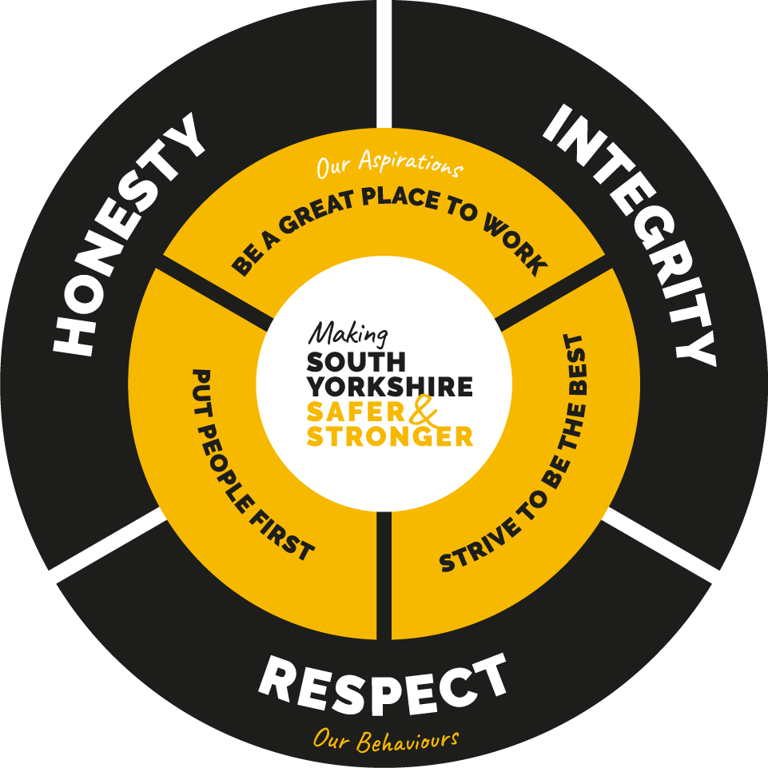The People Function are particularly involved in the identification, mapping, or implementation of the following Fire Standards.

* Code of Ethics
* Leading the Service
* Leading and Developing People

Our Joint Community Safety Department also supports our progress against the Prevention Standard.

1. **Service Delivery**

The Equality, Diversity & Inclusion Strategy has been developed in collaboration with managers, individuals and members and our representative bodies, resulting in a framework of shared EDI priorities: - **Organisation**, **People**, **Communities** and **Partners** which are SYFR aspirations focussed and share inclusivity.

The table below sets the plan for how we will deliver the strategy and how we know if we have achieved this.

| **Strategic Objective:**  **ORGANISATION** | **Strategic Priority:**  **We will:** | **Key measures**  **of success:** |
| --- | --- | --- |
| We will make South Yorkshire Safer and Stronger by improving trust and confidence in our services that are inclusive, safe and professional  We will strengthen our leaders to champion our commitment to EDI and celebrate EDI in everything that we do  We will work hard to make this an inclusive and safe place to work, where all our people are valued, supported and able to thrive | Embed EDI and Positive Action into our Culture Programme  Reinforce the embedding of our Equality Impact Assessment process  Consider EDI within SYFR infrastructure and facilities developments  Provide mandated and supplementary training and development focussing on EDI  Ensure our leaders visibly and effectively champion our commitment to EDI  Encourage our people to have a voice, contribute and offer constructive challenge, through a variety of channels  Share best practice in regional and national EDI forums  Improve availability and analysis of EDI information and statistics | Survey staff to capture confidence levels in EDI  Develop EDI dashboard to report against EDI LPIs  More frequent and impactful consultation on EqIAs  Survey staff to capture confidence levels in EDI  Demonstrable appropriate EDI actions implemented at all stages of infrastructure and facilities developments  More frequent and impactful consultation on EqIAs  Numbers of staff completing EDI training / activity / intervention  Monitoring feedback from training provided  Having EDI activity incorporated into function plans.  Use of PR system to capture EDI focussed activity  Having a strategic lead for all staff groups/networks  Demonstrable appropriate EDI actions implemented at all stages of infrastructure and facilities developments  Survey staff to capture confidence levels in EDI  Increased awareness of Culture Programme initiatives and delivery of HMIC recommendations e.g. Speak Up Service  Develop a dashboard that reports against EDI LPIs  Involvement in key external groups, bodies and partnerships  Develop a dashboard that reports against EDI LPIs |

| **Strategic Objective:**  **PEOPLE** | **Strategic Priority:**  **We will:** | **Key measures**  **of success:** |
| --- | --- | --- |
| SYFR will be a leading fire and rescue service that is able to attract, recruit and retain a diverse workforce  Create the right culture, values and behaviours to make this a brilliant place to work that is inclusive for all. | Embed a comprehensive education programme to provide knowledge and understanding of EDI  Embed inclusive language in policies, procedures and guidance documents  Adopt creative and innovative process to attract diversity  Further empower all staff groups to help us drive workplace improvements  Set realistic goals and measures for EDI and Positive Action initiatives to be delivered by all areas of the service  Improve the accountability for effective Equality Impact Assessments to allow for greater monitoring and outcomes  Improve awareness across the service of disability in the workplace, particularly neurodiversity, and review and improve support provided  Identify gaps in knowledge and prepare guidance/toolkits to support EDI knowledge growth and initiative delivery  Develop LPIs which allow for a worthwhile data and transparency which align with strategic plans | Complete the 3 year roll out plan of mandated EDI training  Review and refresh policies and associated literature including the new Application Tracking System (ATS) and recruitment Process to encourage the best talent to apply for roles  Goals are achieved or exceeded and we see improvements in diversity in recruitment, retention and in progression opportunities  Review and refresh policies and associated literature including the new Application Tracking System (ATS) and recruitment Process to encourage the best talent to apply for roles  Continued growth and success of employee engagement through our staff groups, surveys, watch & team visits  Positive feedback from all staff groups and joint staff group  Goals are achieved or exceeded and we see improvements in diversity in recruitment, retention and in progression opportunities  Positive results when monitoring and reporting on SYFR diversity profile  SMART objectives within the PR system set and achieved  Internal and external scrutiny of Equality Impact Assessment’s identifies improvements in quality and impact and delivery of outcomes  Positive feedback from all staff groups and joint staff group  Positive results when monitoring and reporting on SYFR diversity profile  Increase in declaration of disabilities and evidence that staff are being supported appropriately  Continued growth and success of employee engagement through our staff groups, surveys, watch & team visits  New strategy communicated to all staff and aims understood, evidenced by the pulse survey and reporting on SYFR diversity profile |

| **Strategic Objective:**  **PARTNERS** | **Strategic Priority:**  **We will:** | **Key measures**  **of success:** |
| --- | --- | --- |
| Improve our understanding of our diverse communities and their needs to create best practice | Identify partners and community groups to target safety and recruitment messages  Hold and attend community events to promote opportunities to join SYFR  Utilise guidance, best practice and feedback to improve the way we deliver our services  Work with partners to provide learning and development opportunities for all  Engage with national bodies and NFCC to share best practice | Collaborative working with partners  Develop a system to allow better data capture of EDI focussed community event attendance/engagement by SYFR staff  Engagement in EDI and similar events across South Yorkshire  Develop a system to allow better data capture of EDI focussed community event attendance/engagement by SYFR staff  Introduction of the NFCC Person Cantered Framework  Use of HMIC Positive Practice Portal  Learning & Development opportunities are inclusive  Best practice incorporated into EDI related activity |

| **Strategic Objective:**  **COMMUNITIES** | **Strategic Priority:**  **We will:** | **Key measures**  **of success:** |
| --- | --- | --- |
| Put the interests of the public, community, and service users first by championing and valuing EDI  Stand against all forms of discrimination, create equal opportunities, promote equality, foster good relations, and celebrate difference | Consult when developing plans, policies etc.  Reinforce our dedication to combating racism in all its forms  Make better use of data to support local plans, performance measures and frontline work  Prioritise leadership development to support the championing of EDI  Ensure Positive Action is translating into genuine recruitment outcomes | Involvement at conception and evaluation stages of plans, policies etc.  Expression of our commitment to actively opposing racism and promoting racial justice  Recommendations in Sheffield Race Equality Commission Report  Monitoring data to plan resources and provide tools for wider and more effective community interaction  Prioritised leadership development to support the championing of EDI  Community engagement SLT level  Change in our diversity profile |

1. **Language**

The language that we use is vital in ensuring that we support development of organisational learning within EDI. Current practice around the fire sector and wider is moving to utilise the term equity. Listed below are a number of definitions that give some context:

**Equality** is defined as “ensuring that every individual has an equal opportunity to make the most of their lives and talents”.

**Equity** is about giving people what they need, in order to make things fair. It is about recognising that some people may need extra help to get the same opportunities as others.

**Equality vs. Equity** can be compared as follows: “Although both promote fairness, equality achieves this through treating everyone the same regardless of need, while equity achieves this through treating people differently dependent on need. This different treatment may be the key to reaching equality”.

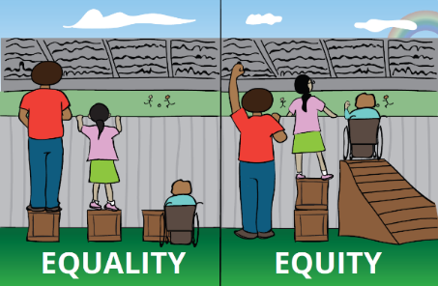

**Positive Action** our commitment to achieve a workforce that more closely represents the diversity of our communities and our approach to eliminating discrimination, advancing equality of opportunity and developing positive relationships between different groups of people, as well as how we promote access to our services.

1. **Accountability and Governance**

Responsibility for EDI within SYFR is shared across our People Function and Joint Community Safety Department (JCSD). People function has responsibility for providing corporate governance and compliance with the Equality Act 2010 and associated duties. Responsibilities also include coordination of all workforce related EDI activity. Community Safety has responsibility for developing, implementing and evaluating EDI activities within diverse communities, including provision of effective community safety interventions and community engagement activities.

The Equality, Diversity & Inclusion Strategy directs and informs the ‘EDI Action Plan’ and ‘Positive Action’ action plan, supporting the delivery of SYFR People Strategy which in turn plans and directs the work of the people function.

The Equality, Diversity & Inclusion Strategy is approved by the Corporate Management Board and progress against objectives are scrutinised by the People & Culture Board.

An evaluation of progress, updates and outcomes is presented each year via the EDI Committee, People & Culture Board, FRA, Performance & Scrutiny Board and Corporate Management Board.

Our legal and best practice compliance is evaluated against the following:

* Equality Act 2010,
* Public Sector Equality Duty
* Human Rights Act,
* Disability Confident,
* Armed Forces Covenant

The Director of People & Culture oversees the implementation of the strategy and is accountable for the delivery, via the work of the People function management team.

1. **Staff and Equality Networks**

Our Staff Network Groups provide support and guidance to our workforce enabling networking, creating a sense of community and tangible changes. Past events have included Black History Month, supporting religious festivals, health and mental wellbeing events and community events such as Pride.

Our Staff Network Groups include:

* SYFR Race Network
* Lesbian, Gay, Bisexual and Trans+ (LGBT+)
* Disability, Carers & Neurodiversity Staff Group (DCN)
* Women’s Group
* Faith & Belief
* Age
* Pregnancy & Parenting

In addition, SYFR partner with a number of equality support groups and mechanisms such as:

 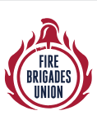 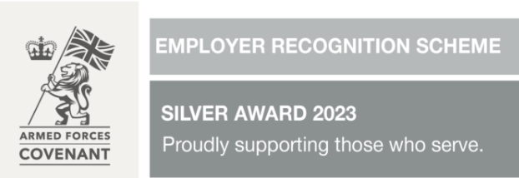 

  cid:image001.png@01DA1DFD.D7447450

1. **How we will measure success**

People function managers and teams will proactively assess and monitor performance by utilising local knowledge and the various services’ intelligence databases.

This strategy will be measured via the **key measures of success captured in section 5**, and via new or existing performance measures built into the service, including:

LPI 3.41 - The Percentage of Applications for Vacancies from Underrepresented Groups

LPI 3.42 - The Percentage of Leavers from Underrepresented Groups

LPI 3.40 - The Percentage Completion of Equality, Diversity and Inclusion (EDI) Training

* Service improvement and HMICFRS Areas for Improvements will primarily be managed by the SHOAL system, the Service Improvement Board and via the relevant governance.
* People function reporting as outlined within the CRMP
* Successful completion of EDI Objectives for ALL staff within the Performance Review (PR) process

**Appendices**

Appendix A: Equality Impact Assessment (EqIA) for the Equality, Diversity & Inclusion Strategy

|  |  |  |  |  |  |  |  |  |  |  |  |
| --- | --- | --- | --- | --- | --- | --- | --- | --- | --- | --- | --- |
| **Policy / Project / Function** | Equality, Diversity & Inclusion Strategy 2024 - 2027 | | | | **Date of Analysis** | | | | December 2023 | | |
| **Analysis Rating: please tick 1 box ✓***(The analysis rating is identified after the analysis has been completed - See Completion Notes*). | | **RED** |  | **AMBER** | | **✓** | **GREEN** |  | | Proportionate means achieving a legitimate aim/can be objectively justified. |  |
| Please list methods used to analyse impact on people (e.g. consultations forums, meetings, data collection) | | The impact of the work to deliver the Equality, Diversity & Inclusion People Strategy will be on a wide range of stakeholders, including all areas of the People Function. There will be an additional range of stakeholders that will provide advice, guidance and support in many areas. The identification of the stakeholders will form part of function and team plans.  Data collection will continue to be undertaken and work with BI to better analyse data and develop dashboard information will take place.  Staff Groups will continue. Terms of Reference and Agenda formatting has taken place and will be subject to review as appropriate.  This is an overarching analysis as individual actions within the strategy will also have EqIAs completed. | | | | | | | | | |
| Please list any other policies that are related to or referred to as part of this analysis | | Most of the people policies will be impacted in some way by the new Equality, Diversity & Inclusion Strategy and as review dates come up or legislative changes dictate, the polices will be reviewed with this in mind. | | | | | | | | | |
| Please list the groups of people potentially affected by this proposal. (e.g. applicants, employees, customers, service users, members of the public) | | The delivery of the Equality, Diversity & Inclusion Strategy is for the benefit of all employees and potential employees and will result in a better service to the members of public accessing and receiving our services. | | | | | | | | | |

|  |  |
| --- | --- |
| What are the aims and intended effects of this proposal (project, policy, function, service)? | |
| Our Equality, Diversity & Inclusion People Strategy plays a critical role in recognising the diverse needs of the communities we serve and gain their trust with a workforce that reflects them and understands their needs. This is why we are working hard to embed equality, celebrate diversity and be inclusive in everything that we do.  The EDI Strategy is integral to the wider People Strategy which sets out four inter-related strategic themes which will support the delivery of our service strategic priorities to be a leading Fire and Rescue Service (FRS) and further embed our aspirations and behaviours:  Our aspirations and behaviours (below) are at the heart of this and how our staff do things is as important as what we do:  We want to be a leading fire and rescue service. To achieve this, we have a set of aspirations which form the basis of everything we do:  Be a great place to work – creating the right culture, values and behaviours to make this a brilliant place to work that is inclusive for all.  Put people first – spending money carefully, using our resources wisely and collaborating with others to provide the best deal to the communities we serve.  Strive to be the best in everything we do – work with others, make the most of technology and develop our leaders to help us to become the very best at what we can be.  To achieve these aspirations we will:  Employ the best people – attract and retain the best people and support our current staff to deliver our aspirations.  Be brave – have the courage to do things differently. Doing the right thing not just the easiest thing and learn from our mistakes.  Put our communities first - put the interests of the public, the community, and service users first.  Champion equality, diversity, and inclusion - we will continually recognise and promote the value of EDI, both within SYFR and the wider communities in which we serve. We will stand against all forms of discrimination, create equal opportunities, promote equality, foster good relations, and celebrate difference.  We need all our staff, regardless of rank and role, to display the behaviours:  Honesty – be open and honest in everything  Integrity – do what we say we will do and follow through on promises  Respect – respect people and trust them to do a good job  Leadership – be positive role models, always demonstrating flexibility and resilience and challenging behaviour that falls short of the highest standards.  Our Equality, Diversity & Inclusion Strategy sets out four inter-related strategic aims (Organisation, People, Partners and Communities) which will support the delivery of our People Strategy and ultimately the service strategic priorities and further embed our aspirations and behaviours:   * Culture * Leadership * Inclusion & Diversity * Wellbeing * Development * Flexibility | |
| Is any Equality Data available relating to the use or implementation of this proposal (policy, project, or function, service? Please Tick ✔(See Completion notes) | |
| Annual workforce diversity profile report; data from recruitment and progression processes. | |
| List any Consultations e.g., with employees, service users, Unions or members of the public that has taken place in the development or implementation of this proposal (project, policy, function)? | |
| The service has a duty to determine strategy for all people-related matters. This strategy has been developed in consideration of the aims and strategic objectives of the service for 2024 – 2027. As actions for each of the strategic objectives are identified, these will be the subject of consultation with all key stakeholders. People Team and Joint Staff Group consultation has taken place to date. | |
| Financial Analysis If applicable, state any relevant cost implications (e.g. expenses, returns or savings) as a direct result of the implementation of this policy, project, or function. | |
| **Costs (£)**  Will be identified as actions are developed | **Projected Returns £**  Will be identified as actions are developed |
| **Implementation £**  Will be identified as actions are developed | **Projected Savings £**  Will be identified as actions are developed |

| What impact will the implementation of this proposal have on people who share characteristics protected by **The Equality Act 2010?**  ✔(See Completion notes) | | | | |
| --- | --- | --- | --- | --- |
| Protected  Characteristic: | Neutral  Impact: | Positive  Impact: | Negative  Impact: | Evidence of impact and if applicable, justification if determining proportionate means of achieving legitimate aims exists |
| **Sex**  (Men and Women) |  | X |  | The aim of the Equality, Diversity & Inclusion Strategy is to have a positive impact on all employees through the actions identified from the strategic objectives. |
| **Race**  (All Racial Groups) |  | X |  | As above |
| **Disability** (Mental, Physical, and Carers of Disabled people) |  | X |  | As above |
| **Religion or Belief** |  | X |  | As above |
| **Sexual Orientation (**(Lesbian, Gay, Bisexual & Straight) |  | X |  | As above |
| **Pregnancy and Maternity** |  | X |  | As above |
| **Marital Status** (Married and Civil Partnerships) |  | X |  | As above |
| **Gender Reassignment** (Includes non-binary) |  | X |  | As above |
| **Age** (People of all ages) |  | X |  | As above |

| What impact will the implementation of this proposal have on people who are impacted by and / or local factors that sit outside the Equality Act 2010 (non-legislative). Examples include social economic factors (i.e. poverty and or isolation), caring responsibility, unemployment, homelessness, urbanisation, rurality, health inequalities any other disadvantage. ✔ (See Completion notes) | | | | |
| --- | --- | --- | --- | --- |
| Identified impact non-legislative factor. | Neutral  Impact: | Positive  Impact: | Negative  Impact: | Evidence of impact and if applicable, justification if determining proportionate means of achieving legitimate aims exists |
| Community Impact |  | X |  | As identified in the NFCC’s EqIA for the introduction of the Code of ethics, we need to ensure that mechanisms are in place that support it to understand the needs of our communities, our reach within the community, and that our communities have fair and equitable means of challenging the organisation should it need to, on ethical grounds. |

**This Equality Impact Analysis was completed by: (Name and Department**):

Andrea Greensmith, Senior People Partner, People Function